**SHIVAJI SHIKSHAN PRASARAK MANDAL’S**

**A PROJECT REPORT ON**

**CRIMINAL INVESTIGATION SYSTEM**

**Submitted by**

***Miss Unhale P.P.***

Under guidance of

Mrs. Futane V. S.

 SHIVAJI SHIKSHAN PRASARAK MANDAL’S

**A PROJECT REPORT ON**

Submitted by

* + - * **Miss Unhale P.P.**
      * **Miss Sable D.V.**
      * **Miss Maindarkar P.S.**
      * **Miss Kulkarni K.N.**

Under guidance of

Mrs. Futane V. S.

**S.S.P.M’s, Institute of polytechnic,**

**Barshi.**

Certificate

***This is to certify that***

***Project Report on,***

**“Criminal Investigation System”**

**SUBMITTED BY:-** Miss Unhale P.P.

Miss Sable D.V.

Miss Maindarkar P.S.

Miss Kulkarni K.N.

**In the partial fulfillment requirement of** M.S.B.T.E. Mumbai for an award of **“Diploma in Computer Engineering”** during the academic session

2013-2014 is the record of his own work carried out by him, under my guidance and our satisfaction.

*Hence approved.*

**.**

**Guide**

**Mrs. Futane V. S.**

**H. O. D.**

**Mrs. Futane V. S.**

**ACKNOWLEDGEMENT**

**Principal**

**Mr. Veer T.S.**

With immense pleasure we submit our project which is on software for “Showroom Management”, under the valuable supervision of our guide “Mrs. Futane V. S.” who guided us for each & every work of our project & gives us valuable suggestions & constant inspiration.

We express our gratitude to our principal Mr. Veer Sir, who gave all facilities for our work. We also thankful to Mrs. Futane V. S. HOD of our department, for their meaningful discussions & valuable suggestions during every phase of work gratitude to all staff members these are Mrs. Kokate Madam, Miss. Nalawde,.madam,,Miss Deshmukh madam, Miss Musale madam,Mrs.Jagtap madam and our classates for their co-operation. Also we express our deep gratitude to our parents whose continuous encouragement, love & affection made to complete this piece of work successfully.

Miss Unhale P.P.

Miss Sable D.V.

Miss Maindarkar P.S.

Miss Kulkarni K.N.

Date : / /

Place : Barshi.

**INDEX**

|  |  |  |
| --- | --- | --- |
| **Sr. No** | **Index** | **Pg. No.** |
|  | Team Building | 1 |
|  | Feasibility Analysis | 2 |
|  | Costing |  |
|  | Requirement of software | 5 |
|  | Introduction | 6 |
|  | Exsting System | 8 |
|  | Algorithm | 9 |
|  | Data flow Diagram | 10 |
|  | Future Development | 11 |
|  | Source Code | 13 |
|  | Conclusion | 82 |
|  | Bibliography | 83 |

**TEAM BUILDING**

**“Criminal Investigation System”**

**Project was prepared by us,**

1.Miss.Unhale P.P.

2.Miss.Sable D.V.

3.Miss.Maindarkar P.S.

4.Miss.Kulkarni K.N.

With the help of our guide who is master in Computer field “Mrs.Futane.V.S.”.She gave us suggestion during our project,sometimes we discuss about this project,sometimes we discuss about this project.

**FEASIBILITY ANALYSIS**

This is the first step in understanding the user requirement in within the organization the objective & the environment in which the system is being used.Requirement analysis is a software engineering task that bridges the gap between system level software allocation & software design. Requirement analysis enables the system engineer to specify software performance & function, indicates software’s interface with other system elements & established design constraints that the software must meet.

I carried out requirement analysis in the following area with system definition from system analysis stage.

1] List of operations to be performed.

2] List of constraints the software must meet.

1. List of operations to be performed

1] User-

* + Login
  + Logout
  + Create User
  + Change Password
  + Admin Login
  + Admin Logout

2] Record-

* + Complaint
  + Complaint With Drawn
  + FIR Details
  + Charge Sheet
  + Judgement Details
  + Post Mortem

3] Report-

* + FIR Report­
  + Criminal Report
  + Charge Sheet Report
  + Most Wanted Report
  + Complaint With Drawn Report

4] Search

5] Tools-

* + Calculator
  + Media Player

6] Admin-

* + Create Admin
  + Login
  + Look Up
  + Dept Info
  + Year Details
  + Police Station
  + Criminal Record
  + Target Cases
  + Most Wanted

7] Window-

* + Cascade
  + Tile Vertical
  + Tile Horizontal
  + Close all

8] Help-

* About
* Search
* Index

**COSTING:-**

|  |  |  |
| --- | --- | --- |
| **Sr.No.** | **Content** | **Cost** |
| 1 | Windows7 | 8000/-Rs. |
| 2 | Microsoft Visual Studio 2005 | 75,000/-Rs |
| 3 | Microsoft SQL Server 2005 | 35,000/-Rs |
| 4 | Crystal Report 7.0 | 55,000/-Rs |
| 5 | **Total** | **1,73,000/-Rs** |

Software Requirement Cost table:-

|  |  |  |
| --- | --- | --- |
| **Sr.No.** | **Content** | **Cost** |
| 1 | PIV Computer | 45,000/-Rs |
| 2 | Printer(Laser) | 12,000/-Rs |
| 3 | Scanner(HP) | 10,500/-Rs |
|  | **Total** | **67,500/-Rs** |

Hardware Requirement Cost Table:-

Total Production Table:-

|  |  |  |
| --- | --- | --- |
| **Sr.No.** | **Content** | **Cost** |
| 1 | Total Software cost | 1,73,000/-Rs |
| 2 | Total Hardware cost | 67,500/-Rs |
|  | **Total** | **2,40,500** |

**REQUIREMENT OF SOFTWARE AND HARDWARE:-**

When we are developing any new system we have to think about what are the components used to develop the system. The components may be hardware or software. When we are developing any system we should determine, what is the best alternative ensuring the hardware and software for the system?

**The requirements are:-**

* + 1. Microsoft VB.NET as front end.
    2. Microsoft SQL Server 2005 as backend.
    3. Processor should be Pentium 2.3GHz.
    4. Hard disk should be 100GB.
    5. RAM should be 1GB or more.
    6. Operating system Windows 7.



**INTRODUCTION**

This project aims at developing a highly cost effective system to help for Police Department. This software is very user friendly and customized as per the requirements of the user.

It is easy to operate and create customizable report with adjustable paper size printing. It maintains various types of data like Criminal details, User details, Police Station, FIR Details, Lookup details, Department details, Year details and so on.

In which we make the computerized system.The computer can perform on those functions that a human being can do certain extend,but at much faster speed and with great accuracy,

Computers are used in each and every field because it makes a job much simple and easier. Computerized system saves the time as well as reduce the paper work. For this reason we develop “Criminal Investigation System” software.

PROBLEMS WITH EXISTING

**Disadvantages of old systems:-**

As we know that the manual processing is **quite tedious, time consuming, less accurate** as comparing to computerized processing. Obviously the present system is not exception concern with all above problems

* Time consuming.
* Very tedious.
* All information is not placed separately.
* Lot of paper work.
* Slow data processing.
* It is difficult to found records due to file management system.

**ALGORITHM**

1. Start ->all programs->Microsoft Visual Studio 2005.
2. Click on Run program.
3. Click on File menu->Open project.
4. Then browse your Project file ->click open.
5. Run the program then you will see a splash window on screen and then Login window will be opened.
6. Enter the appropriate Username and password and then click on Login button.
7. MDI menu will be opened.
8. Now you ready to access the software.

**Another method to use software is given below:-**

1. Click on CIS.exe
2. You will see a splash screen and then the Login form.
3. Enter the appropriate Username and password and then click on Login button.
4. You will see MDI menu.
5. Now software will be ready to use.

**DATA FLOW DIAGRAM**

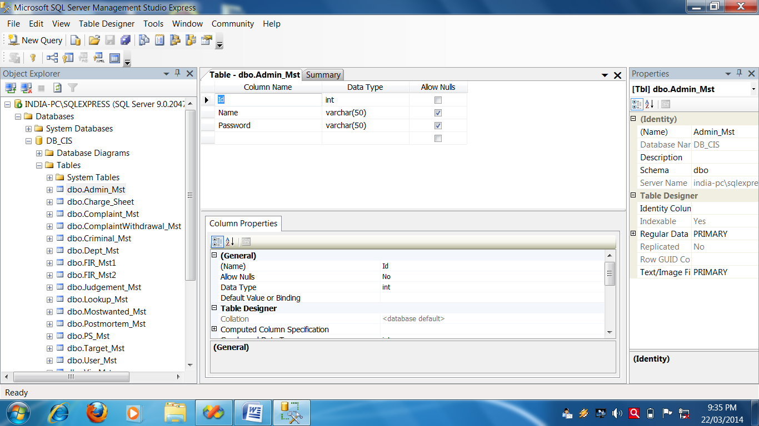**Admin Table**

**Complaint Table**

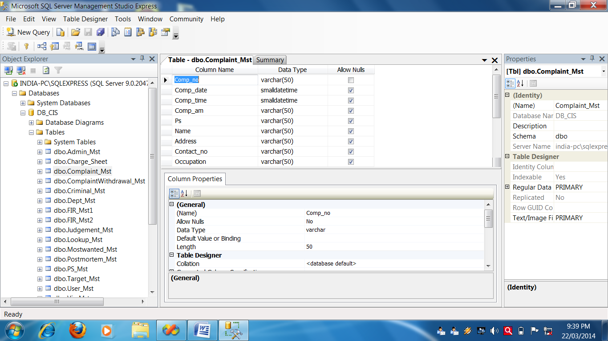

**Complaint WithDrawn Table**

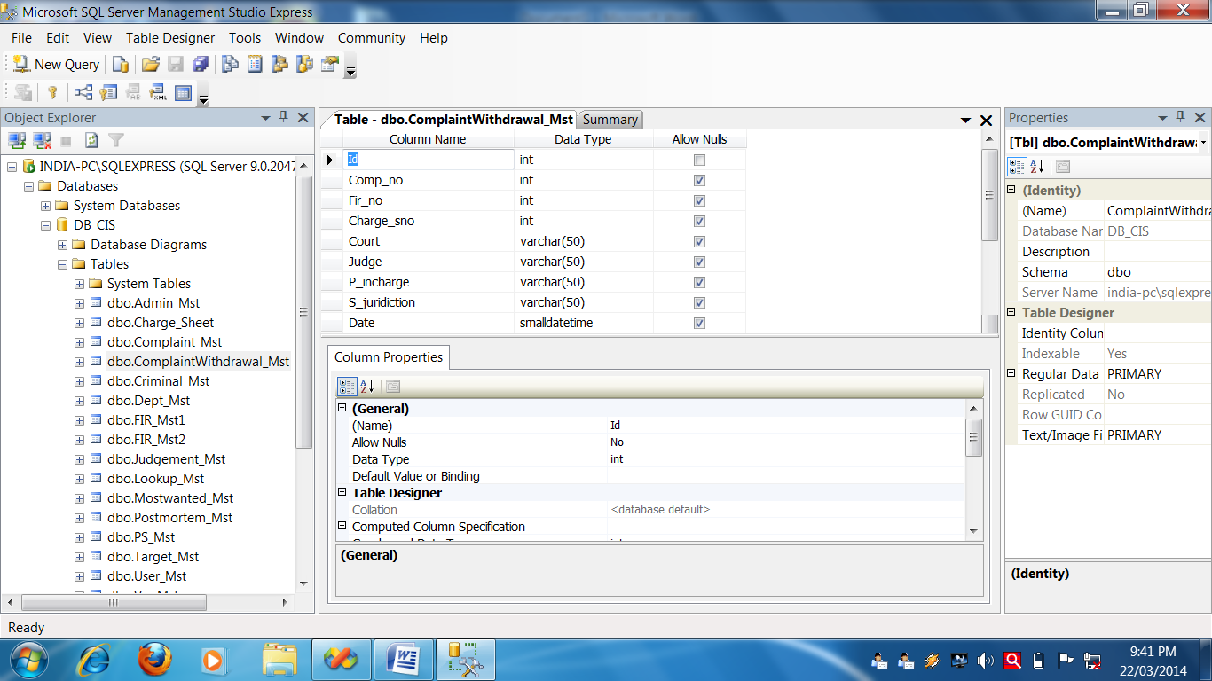

**Criminal Table**

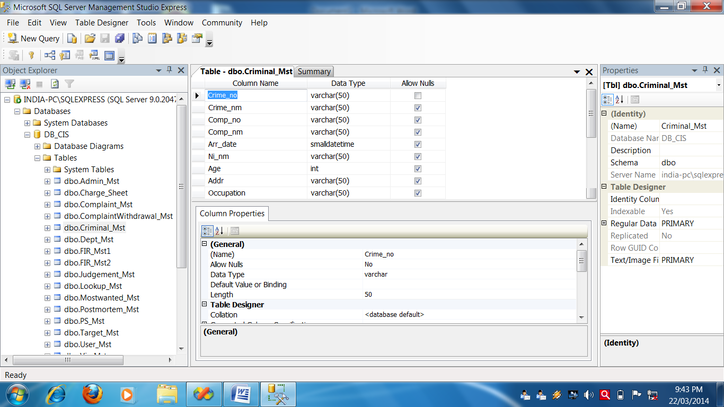

**Department Table**

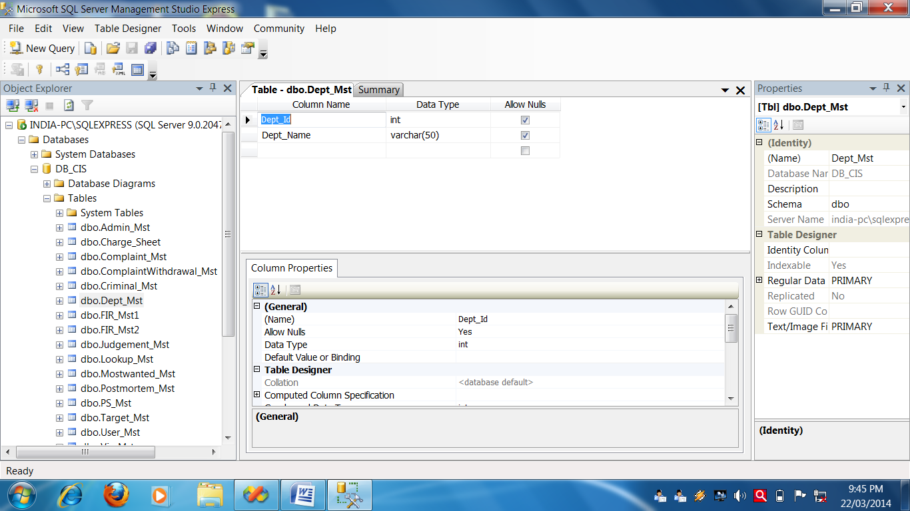

**FIR 1 Table**

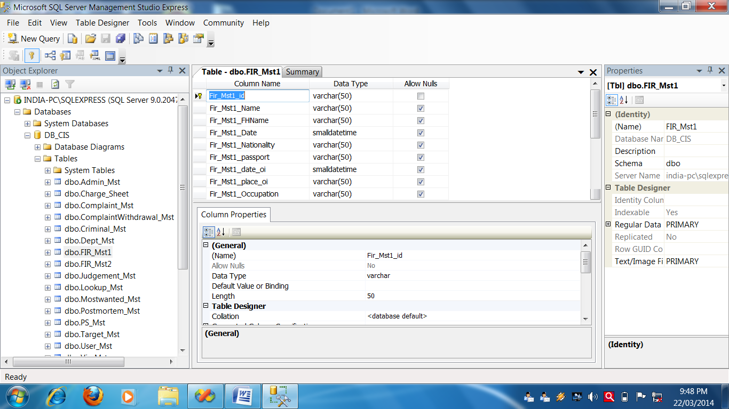

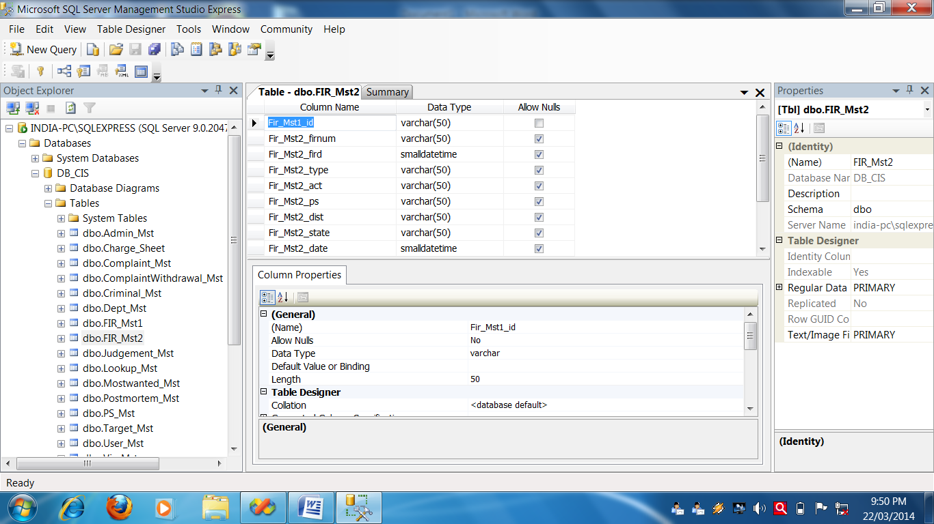**FIR 2 Table**

**Judgement Table**

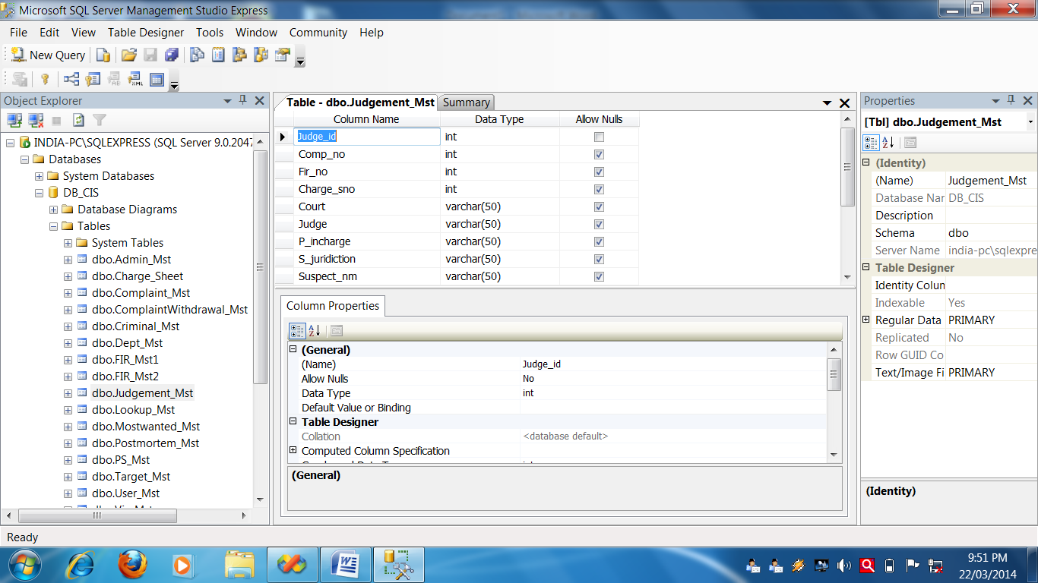

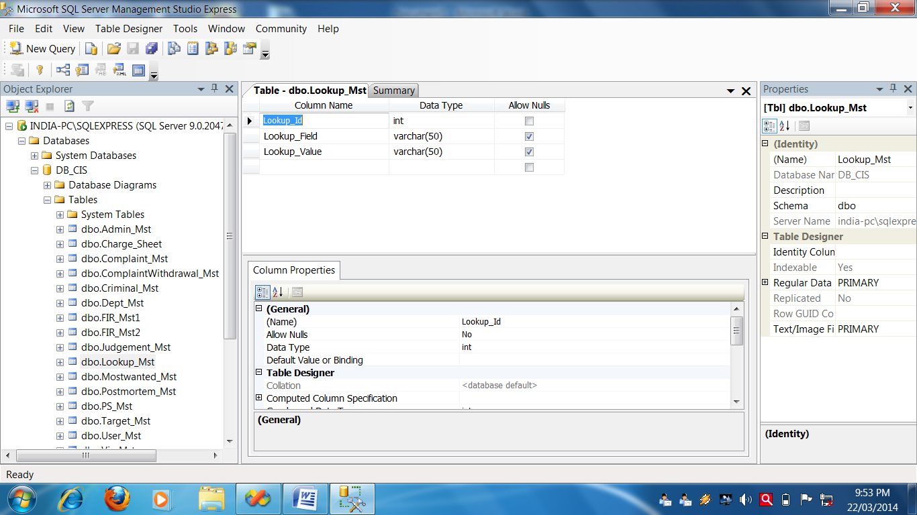**Lookup Table**

**Most Wanted Table**

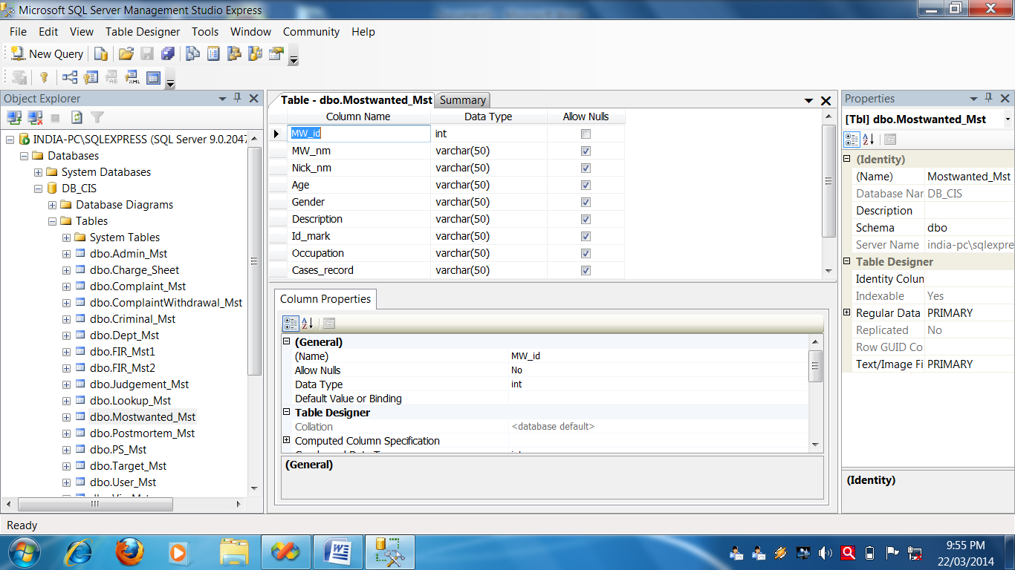

**Post MortemTable**

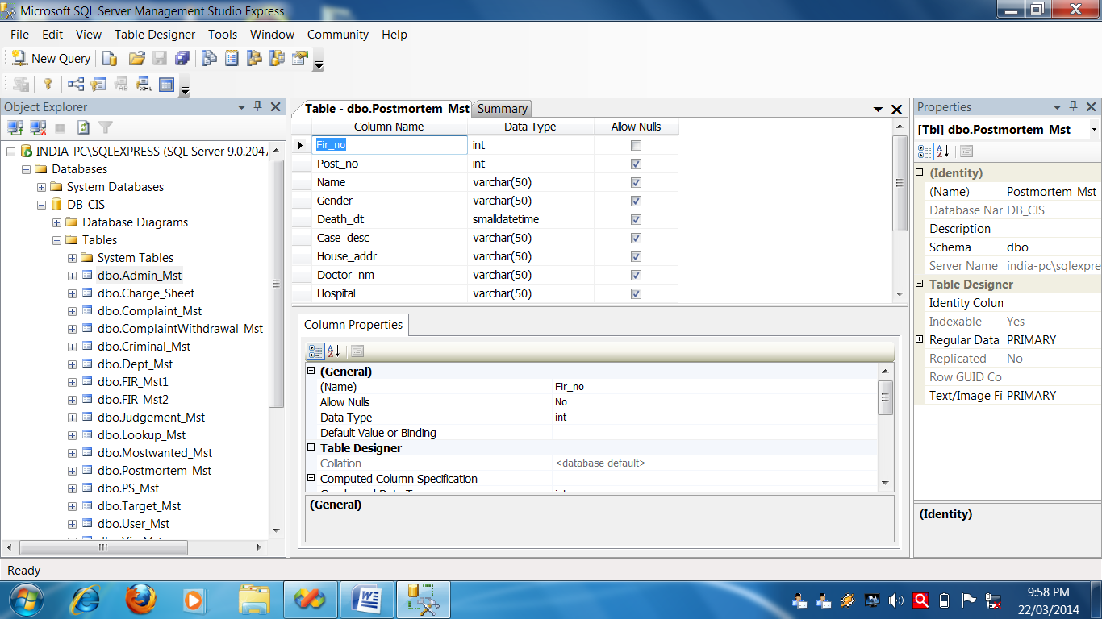

**Police Station Table**

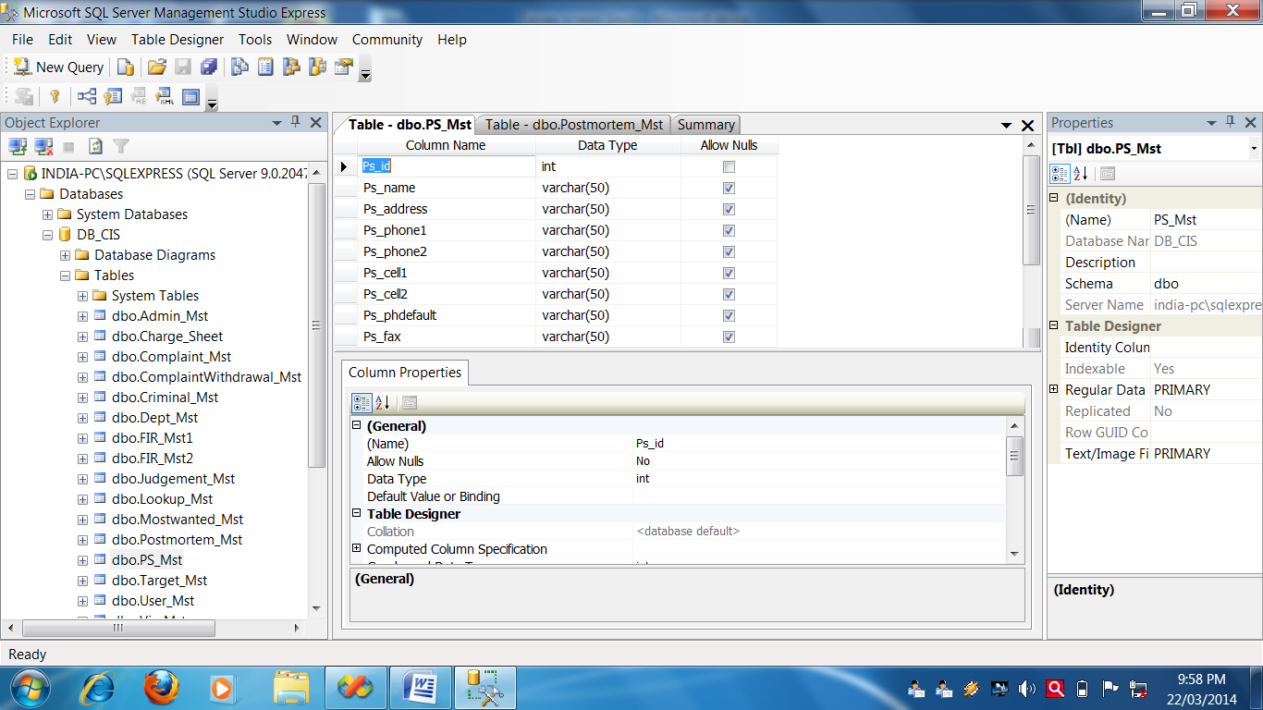

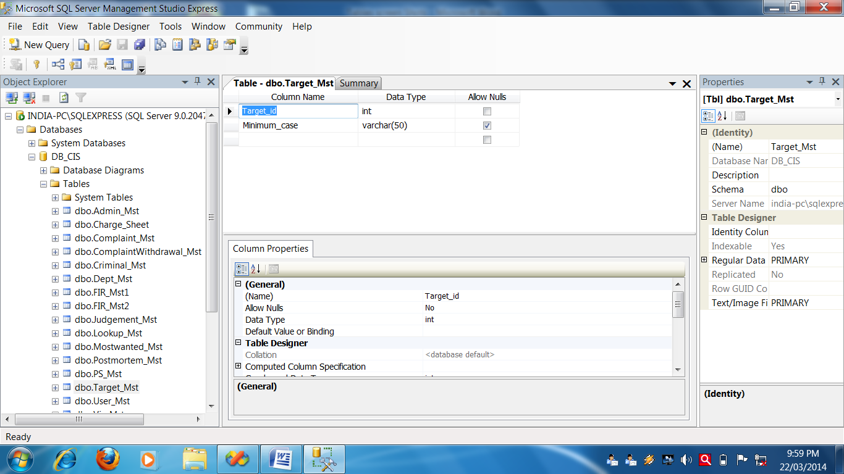**Target Cases Table**

**User Table**

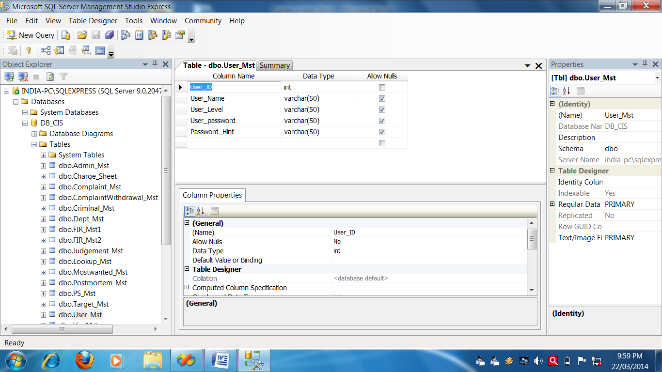

**Year Table**

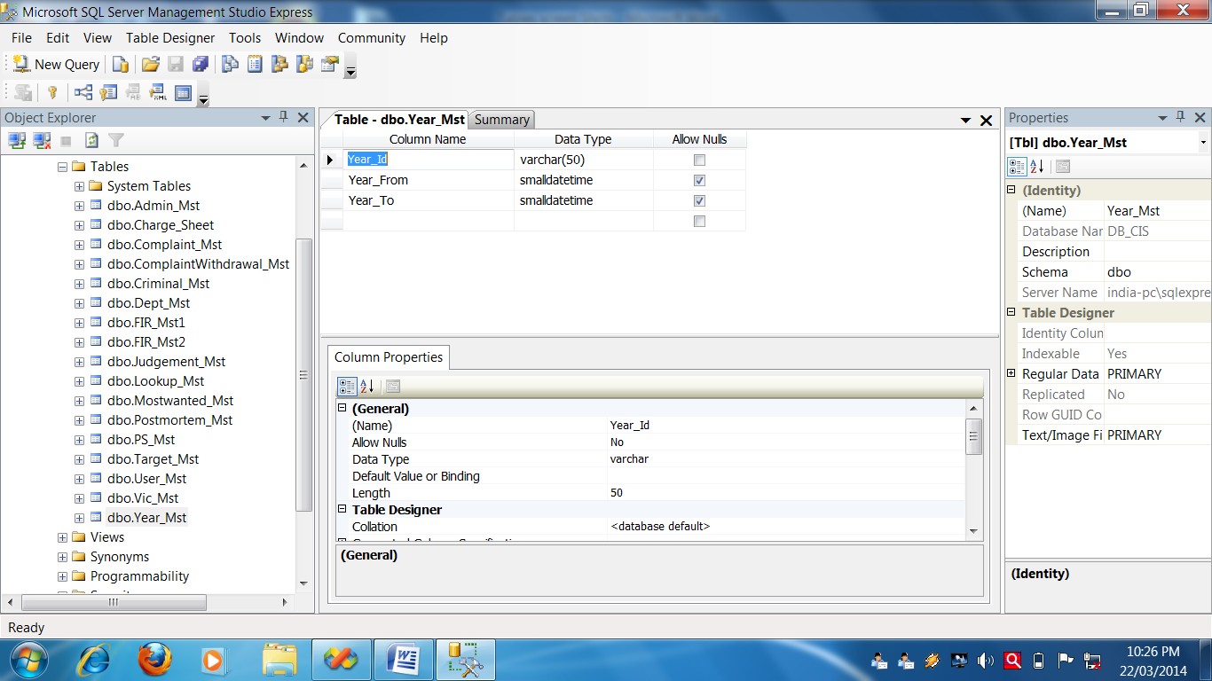

**Splash Form**

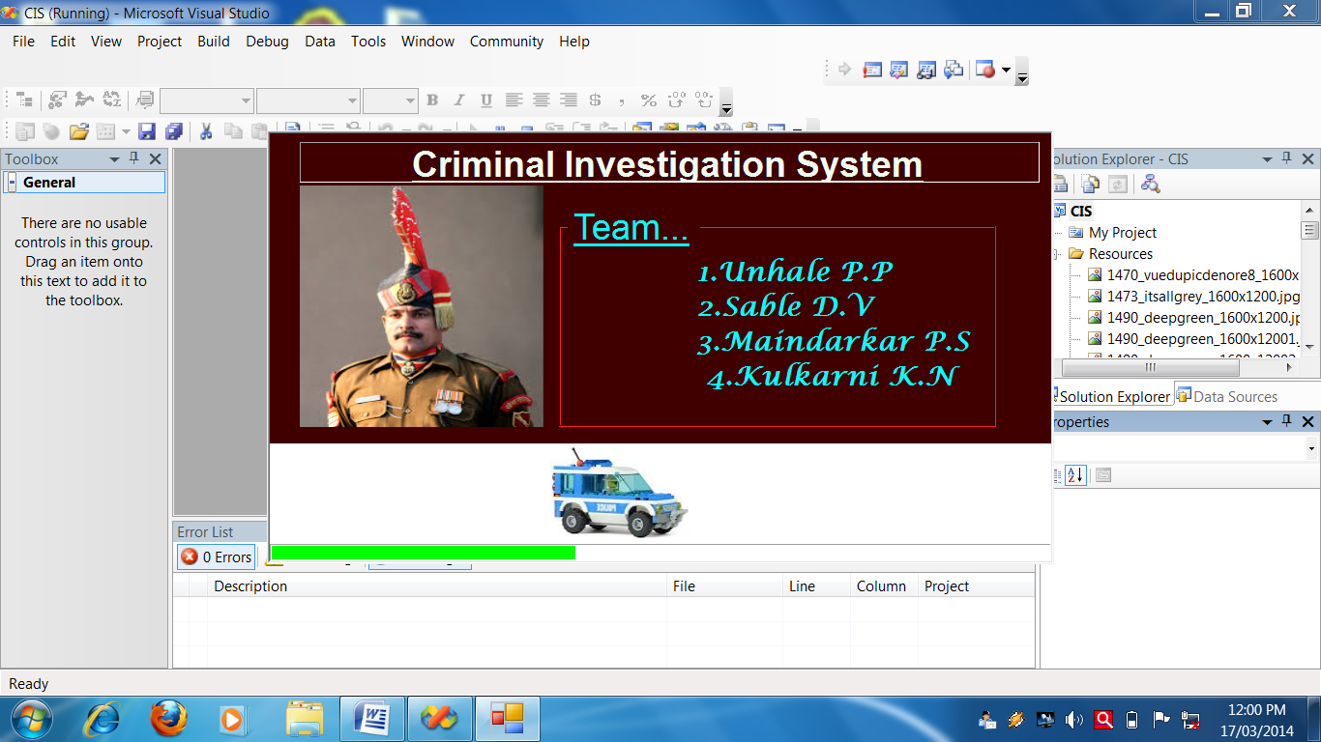

**Splash Screen Source Code**

Public Class FrmSplash

Private Sub Form1_Load(ByVal sender As System.Object, ByVal e As System.EventArgs) Handles MyBase.Load

Me.PictureBox1.Left = -100

End Sub

Private Sub Timer1_Tick(ByVal sender As System.Object, ByVal e As System.EventArgs) Handles Timer1.Tick

If pb.Value < 100 Then

pb.Value = pb.Value + 1

Me.PictureBox1.Left = Me.PictureBox1.Left + 10

If pb.Value = 10 Then Me.lblpn.ForeColor = Color.RosyBrown

If pb.Value = 20 Then Me.lblpn.ForeColor = Color.PowderBlue

If pb.Value = 30 Then Me.lblpn.ForeColor = Color.Honeydew

If pb.Value = 40 Then Me.lblpn.ForeColor = Color.Aqua

Else

Timer1.Stop()

Me.Hide()

If CheckRecord("User_Mst") Then

Main_Form.Show()

Else

AdminForm.Show()

End If

End If

End Sub

End Class

**.**

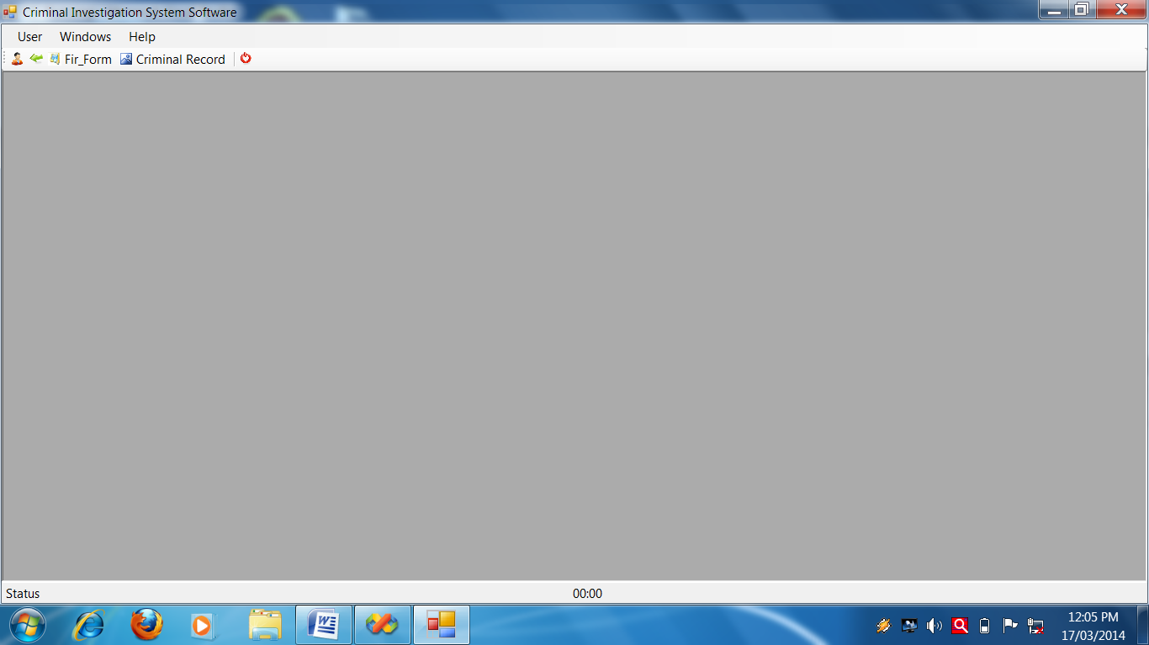**Main Form**

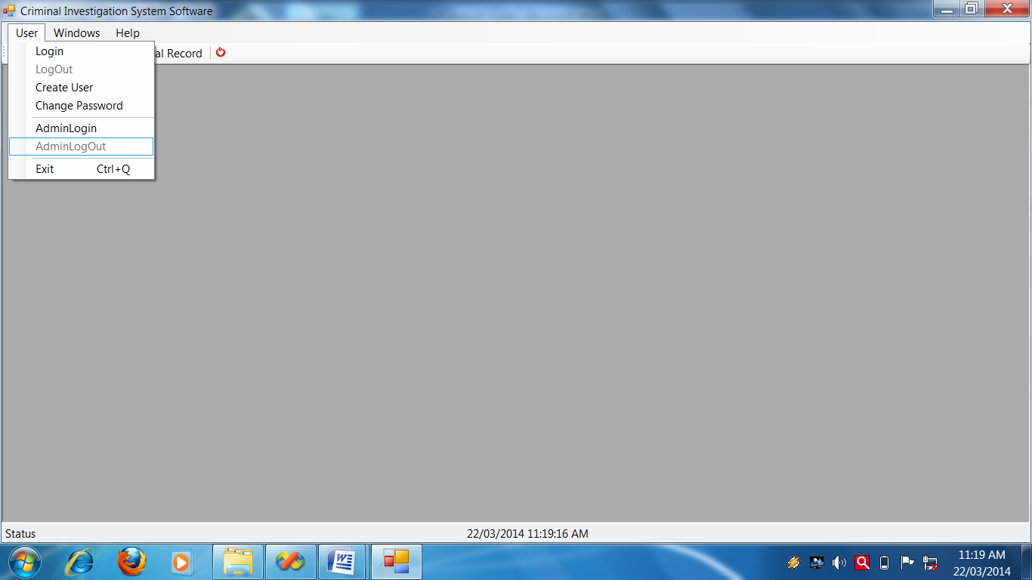

Select your MenuHere!

**Main Form Source Code**

Imports System.Windows.Forms

Public Class Main_Form

Private Sub ShowNewForm(ByVal sender As Object, ByVal e As EventArgs) Handles NewWindowToolStripMenuItem.Click

' Create a new instance of the child form.

Dim ChildForm As New System.Windows.Forms.Form

' Make it a child of this MDI form before showing it.

ChildForm.MdiParent = Me

m_ChildFormNumber += 1

ChildForm.Text = "Window " & m_ChildFormNumber

ChildForm.Show()

End Sub

Private Sub OpenFile(ByVal sender As Object, ByVal e As EventArgs)

Dim OpenFileDialog As New OpenFileDialog

OpenFileDialog.InitialDirectory = My.Computer.FileSystem.SpecialDirectories.MyDocuments

OpenFileDialog.Filter = "Text Files (*.txt)|*.txt|All Files (*.*)|*.*"

If (OpenFileDialog.ShowDialog(Me) = System.Windows.Forms.DialogResult.OK) Then

Dim FileName As String = OpenFileDialog.FileName

' TODO: Add code here to open the file.

End If

End Sub

Private Sub SaveAsToolStripMenuItem_Click(ByVal sender As Object, ByVal e As EventArgs)

Dim SaveFileDialog As New SaveFileDialog

SaveFileDialog.InitialDirectory = My.Computer.FileSystem.SpecialDirectories.MyDocuments

SaveFileDialog.Filter = "Text Files (*.txt)|*.txt|All Files (*.*)|*.*"

If (SaveFileDialog.ShowDialog(Me) = System.Windows.Forms.DialogResult.OK) Then

Dim FileName As String = SaveFileDialog.FileName

' TODO: Add code here to save the current contents of the form to file.

End If

End Sub

Private Sub ExitToolsStripMenuItem_Click(ByVal sender As Object, ByVal e As EventArgs)

Global.System.Windows.Forms.Application.Exit()

End Sub

Private Sub CutToolStripMenuItem_Click(ByVal sender As Object, ByVal e As EventArgs)

' Use My.Computer.Clipboard to insert the selected text or images into the clipboard

End Sub

Private Sub CopyToolStripMenuItem_Click(ByVal sender As Object, ByVal e As EventArgs)

' Use My.Computer.Clipboard to insert the selected text or images into the clipboard

End Sub

Private Sub PasteToolStripMenuItem_Click(ByVal sender As Object, ByVal e As EventArgs)

'Use My.Computer.Clipboard.GetText() or My.Computer.Clipboard.GetData to retrieve information from the clipboard.

End Sub

Private Sub CascadeToolStripMenuItem_Click(ByVal sender As Object, ByVal e As EventArgs) Handles CascadeToolStripMenuItem.Click

Me.LayoutMdi(MdiLayout.Cascade)

End Sub

Private Sub TileVerticleToolStripMenuItem_Click(ByVal sender As Object, ByVal e As EventArgs) Handles TileVerticalToolStripMenuItem.Click

Me.LayoutMdi(MdiLayout.TileVertical)

End Sub

Private Sub TileHorizontalToolStripMenuItem_Click(ByVal sender As Object, ByVal e As EventArgs) Handles TileHorizontalToolStripMenuItem.Click

Me.LayoutMdi(MdiLayout.TileHorizontal)

End Sub

Private Sub ArrangeIconsToolStripMenuItem_Click(ByVal sender As Object, ByVal e As EventArgs) Handles ArrangeIconsToolStripMenuItem.Click

Me.LayoutMdi(MdiLayout.ArrangeIcons)

End Sub

Private Sub CloseAllToolStripMenuItem_Click(ByVal sender As Object, ByVal e As EventArgs) Handles CloseAllToolStripMenuItem.Click

' Close all child forms of the parent.

For Each ChildForm As Form In Me.MdiChildren

ChildForm.Close()

Next

End Sub

Private m_ChildFormNumber As Integer = 0

Private Sub mnuItemULogin_Click(ByVal sender As System.Object, ByVal e As System.EventArgs) Handles mnuItemULogin.Click

FrmLogin.Show()

FrmLogin.MdiParent = Me

End Sub

Private Sub mnuItemLogin_Click(ByVal sender As System.Object, ByVal e As System.EventArgs) Handles mnuItemLogin.Click

FrmLogin.ShowDialog()

FrmLogin.MdiParent = Me

End Sub

Private Sub mnuItemUExit_Click(ByVal sender As System.Object, ByVal e As System.EventArgs) Handles mnuItemUExit.Click

If MessageBox.Show("Are you sure?", "Exit This Application?", MessageBoxButtons.YesNo, MessageBoxIcon.Question, MessageBoxDefaultButton.Button2) = Windows.Forms.DialogResult.Yes Then

Application.Exit()

End If

End Sub

Private Sub Timer1_Tick(ByVal sender As System.Object, ByVal e As System.EventArgs) Handles Timer1.Tick

Me.lblStatusDateTime.Text = Now

End Sub

Private Sub mnuItemFIRDetails_Click(ByVal sender As System.Object, ByVal e As System.EventArgs) Handles mnuItemFIRDetails.Click

FIR_Details.Show()

FIR_Details.MdiParent = Me

End Sub

Private Sub mnusearch_Click(ByVal sender As System.Object, ByVal e As System.EventArgs) Handles mnusearch.Click

Search_form.Show()

Search_form.MdiParent = Me

End Sub

Private Sub mnuItemChargeSheet_Click(ByVal sender As System.Object, ByVal e As System.EventArgs) Handles mnuItemChargeSheet.Click

Charge_Sheet.Show()

Charge_Sheet.MdiParent = Me

End Sub

Private Sub mnuItemComplaint_Click(ByVal sender As System.Object, ByVal e As System.EventArgs)

Complaint_Form.Show()

Complaint_Form.MdiParent = Me

End Sub

Private Sub mnuItemCriminalRecord_Click(ByVal sender As System.Object, ByVal e As System.EventArgs)

Criminal_Record.Show()

Criminal_Record.MdiParent = Me

End Sub

Private Sub mnuItemPostmortem_Click(ByVal sender As System.Object, ByVal e As System.EventArgs) Handles mnuItemPostmortem.Click

Post_Mortem.Show()

Post_Mortem.MdiParent = Me

End Sub

Private Sub mnuItemJudgement_Click(ByVal sender As System.Object, ByVal e As System.EventArgs) Handles mnuItemJudgement.Click

Judgement_Details.Show()

Judgement_Details.MdiParent = Me

End Sub

Private Sub mnuItemMostwanted_Click(ByVal sender As System.Object, ByVal e As System.EventArgs)

Most_Wanted.Show()

Most_Wanted.MdiParent = Me

End Sub

Private Sub mnuItemTargetCases_Click(ByVal sender As System.Object, ByVal e As System.EventArgs)

Target_cases.Show()

Target_cases.MdiParent = Me

End Sub

Private Sub mnuItemComplaintwithdrawn_Click(ByVal sender As System.Object, ByVal e As System.EventArgs) Handles mnuItemComplaintwithdrawn.Click

Complaint_with_drawn.Show()

Complaint_with_drawn.MdiParent = Me

End Sub

Private Sub mnuItemCreateUser_Click(ByVal sender As System.Object, ByVal e As System.EventArgs) Handles mnuItemCreateUser.Click

FrmUserInfo.Show()

FrmUserInfo.MdiParent = Me

End Sub

Private Sub mnuItemAdmin_Click(ByVal sender As System.Object, ByVal e As System.EventArgs) Handles mnuItemAdmin.Click

Admin_Login.Show()

Admin_Login.MdiParent = Me

End Sub

Private Sub mnuItemCtreatePassword_Click(ByVal sender As System.Object, ByVal e As System.EventArgs) Handles mnuItemCtreatePassword.Click

FrmUserInfo.Show()

FrmUserInfo.MdiParent = Me

End Sub

Private Sub mnuExit_Click(ByVal sender As System.Object, ByVal e As System.EventArgs) Handles mnuExit.Click

If MessageBox.Show("Are you sure ?", "Exit This Application?", MessageBoxButtons.YesNo, MessageBoxIcon.Question, MessageBoxDefaultButton.Button2) = Windows.Forms.DialogResult.Yes Then

Application.Exit()

End If

End Sub

Private Sub mnuItemYear_Click(ByVal sender As System.Object, ByVal e As System.EventArgs) Handles mnuItemYear.Click

Year_Details.Show()

Year_Details.MdiParent = Me

End Sub

Private Sub mnuItemPolicestation_Click(ByVal sender As System.Object, ByVal e As System.EventArgs) Handles mnuItemPolicestation.Click

Police_station.Show()

Police_station.MdiParent = Me

End Sub

Private Sub mnuItemLookup_Click_1(ByVal sender As System.Object, ByVal e As System.EventArgs) Handles mnuItemLookup.Click

Lookup_Info.Show()

Lookup_Info.MdiParent = Me

End Sub

Private Sub mnuItemDept_Click_1(ByVal sender As System.Object, ByVal e As System.EventArgs) Handles mnuItemDept.Click

Dept_Info.Show()

Dept_Info.MdiParent = Me

End Sub

Private Sub AboutToolStripMenuItem_Click(ByVal sender As Object, ByVal e As System.EventArgs) Handles AboutToolStripMenuItem.Click

FrmAbout.Show()

FrmAbout.MdiParent = Me

End Sub

Private Sub mnuItemTargetCases_Click_1(ByVal sender As System.Object, ByVal e As System.EventArgs) Handles mnuItemTargetCases.Click

Target_cases.Show()

Target_cases.MdiParent = Me

End Sub

Private Sub mnuItemMostWanted_Click_1(ByVal sender As System.Object, ByVal e As System.EventArgs) Handles mnuItemMostWanted.Click

Most_Wanted.Show()

Most_Wanted.MdiParent = Me

End Sub

Private Sub mnuItemCriminalRecord_Click_1(ByVal sender As System.Object, ByVal e As System.EventArgs) Handles mnuItemCriminalRecord.Click

Criminal_Record.Show()

Criminal_Record.MdiParent = Me

End Sub

Private Sub mnuAdminLogin_Click(ByVal sender As System.Object, ByVal e As System.EventArgs) Handles mnuAdminLogin.Click

Admin_Login.Show()

Admin_Login.MdiParent = Me

End Sub

Private Sub mnuLogOut_Click(ByVal sender As System.Object, ByVal e As System.EventArgs) Handles mnuLogOut.Click

Call UserLogin(False)

End Sub

Private Sub mnuAdminLogOut_Click(ByVal sender As System.Object, ByVal e As System.EventArgs) Handles mnuAdminLogOut.Click

Call AdminLogin(False)

End Sub

Private Sub ExitButton_Click(ByVal sender As System.Object, ByVal e As System.EventArgs) Handles ExitButton.Click

If MessageBox.Show("Are you sure?", "Exit This Application?", MessageBoxButtons.YesNo, MessageBoxIcon.Question, MessageBoxDefaultButton.Button2) = Windows.Forms.DialogResult.Yes Then

Application.Exit()

End If

End Sub

Private Sub mnuItemCalci_Click(ByVal sender As System.Object, ByVal e As System.EventArgs) Handles mnuItemCalci.Click

Dim strcalci As System.Diagnostics.ProcessStartInfo

strcalci = New System.Diagnostics.ProcessStartInfo("c:\windows\System32\calc.exe")

Dim calcistart As New System.Diagnostics.Process

calcistart.StartInfo = strcalci

calcistart.Start()

calcistart.WaitForExit()

End Sub

Private Sub LoginButton_Click(ByVal sender As System.Object, ByVal e As System.EventArgs) Handles LoginButton.Click

FrmLogin.Show()

FrmLogin.MdiParent = Me

End Sub

Private Sub LogoutButton_Click(ByVal sender As System.Object, ByVal e As System.EventArgs) Handles LogoutButton.Click

Call UserLogin(False)

End Sub

Private Sub firformButton_Click(ByVal sender As System.Object, ByVal e As System.EventArgs) Handles firformButton.Click

FIR_Details.Show()

FIR_Details.MdiParent = Me

End Sub

Private Sub CriminalRecordButton_Click(ByVal sender As System.Object, ByVal e As System.EventArgs) Handles CriminalRecordButton.Click

Criminal_Record.Show()

Criminal_Record.MdiParent = Me

End Sub

Private Sub MediaPlayerToolStripMenuItem_Click(ByVal sender As System.Object, ByVal e As System.EventArgs) Handles MediaPlayerToolStripMenuItem.Click

Dim strcalci As System.Diagnostics.ProcessStartInfo

strcalci = New System.Diagnostics.ProcessStartInfo("C:\Program Files (x86)\Windows Media Player\wMPlayer.exe")

Dim calcistart As New System.Diagnostics.Process

calcistart.StartInfo = strcalci

calcistart.Start()

calcistart.WaitForExit()

End Sub

Private Sub mnufir_Click(ByVal sender As System.Object, ByVal e As System.EventArgs) Handles mnufir.Click

FIRReport.Show()

FIRReport.MdiParent = Me

End Sub

Private Sub mnucriminal_Click(ByVal sender As System.Object, ByVal e As System.EventArgs) Handles mnucriminal.Click

ReportCriminal.Show()

ReportCriminal.MdiParent = Me

End Sub

Private Sub mnumostwanted_Click(ByVal sender As System.Object, ByVal e As System.EventArgs) Handles mnumostwanted.Click

ReportMostwanted.Show()

ReportMostwanted.MdiParent = Me

End Sub

Private Sub mnucomplaint_Click(ByVal sender As System.Object, ByVal e As System.EventArgs) Handles mnucomplaint.Click

ReportComplaintWithDrawn.Show()

ReportComplaintWithDrawn.MdiParent = Me

End Sub

Private Sub mnuChargesheet_Click(ByVal sender As System.Object, ByVal e As System.EventArgs) Handles mnuChargesheet.Click

ReportChargeSheet.Show()

ReportChargeSheet.MdiParent = Me

End Sub

End Class

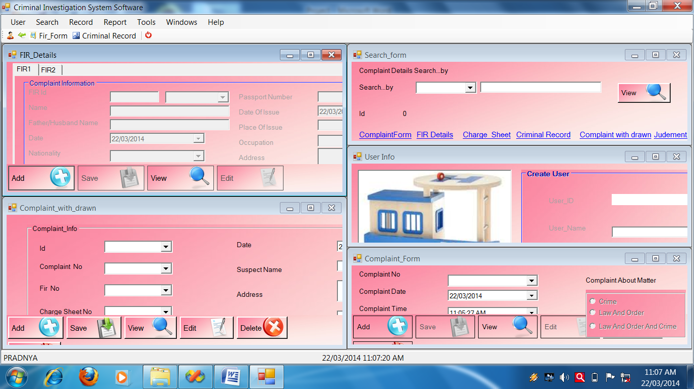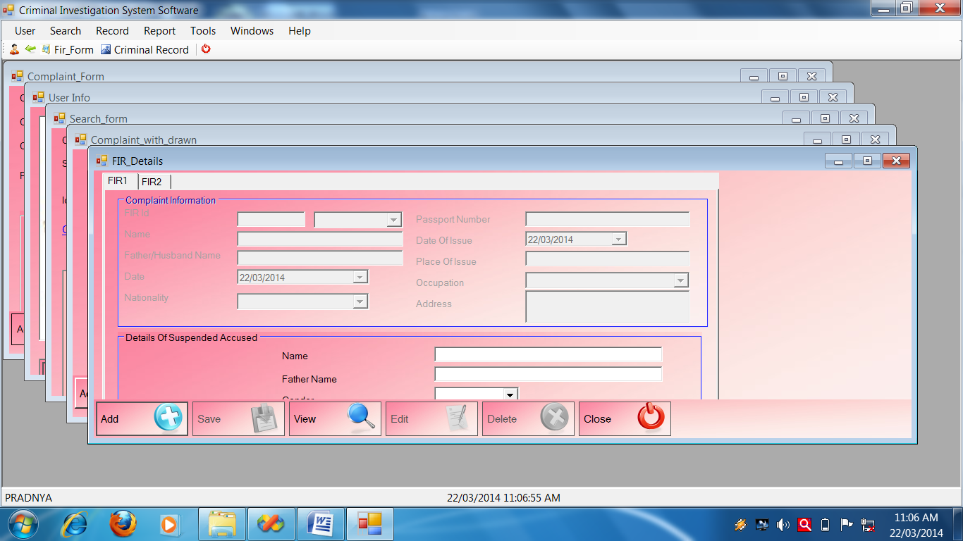

**Login Form**

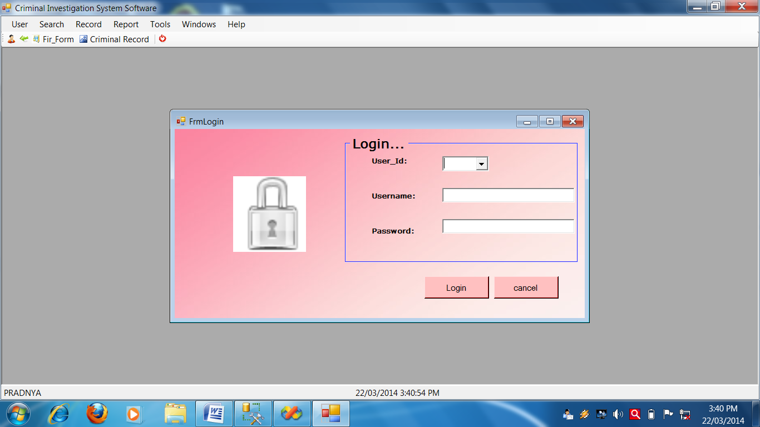

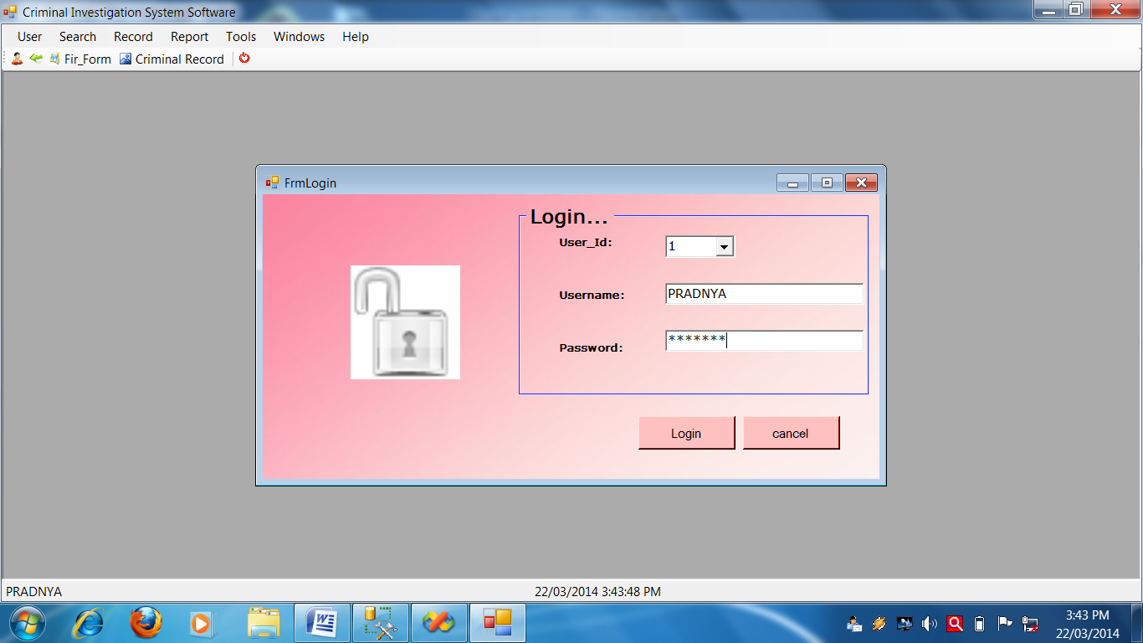

**Login Form Source code**

Public Class FrmLogin

Private Sub btncancel_Click_1(ByVal sender As System.Object, ByVal e As System.EventArgs) Handles btncancel.Click

Me.Close()

End Sub

Private Sub btnlogin_Click(ByVal sender As System.Object, ByVal e As System.EventArgs) Handles btnlogin.Click

If CheckPassword(Me.cmbUser_Id.Text, Me.txtpassword.Text) Then

Main_Form.Show()

Call UserLogin(True)

Me.PictureBox1.Load("C:\CIS\Icons\Lock_Open_48.png")

Main_Form.ToolStripStatusLabel.Text = Me.txtusername.Text

Me.Close()

Else

Call UserLogin(False)

Me.PictureBox1.Load("C:\CIS\Icons\Lock_48.png")

MessageBox.Show("Wrong Password !", "Password Error!", MessageBoxButtons.OK, MessageBoxIcon.Error)

End If

End Sub

Private Sub FrmLogin_Load(ByVal sender As System.Object, ByVal e As System.EventArgs) Handles MyBase.Load

Me.PictureBox1.Load("C:\CIS\Icons\Lock_48.png")

Call FillCombo(Me.cmbUser_Id, "User_Id", "User_Mst")

End Sub

Private Sub txtpassword_TextChanged(ByVal sender As System.Object, ByVal e As System.EventArgs) Handles txtpassword.TextChanged

If CheckPassword(Me.cmbUser_Id.Text, Me.txtpassword.Text) Then

Me.PictureBox1.Load("C:\CIS\Icons\Lock_Open_48.png")

Else

Me.PictureBox1.Load("C:\CIS\Icons\Lock_48.png")

End If

End Sub

Private Sub cmbUser_Id_SelectedIndexChanged(ByVal sender As System.Object, ByVal e As System.EventArgs) Handles cmbUser_Id.SelectedIndexChanged

Me.txtusername.Text = GetVal("User_Mst", "User_Id", Me.cmbUser_Id.Text, "User_Name"

End Sub

End Class

**Complaint Form**

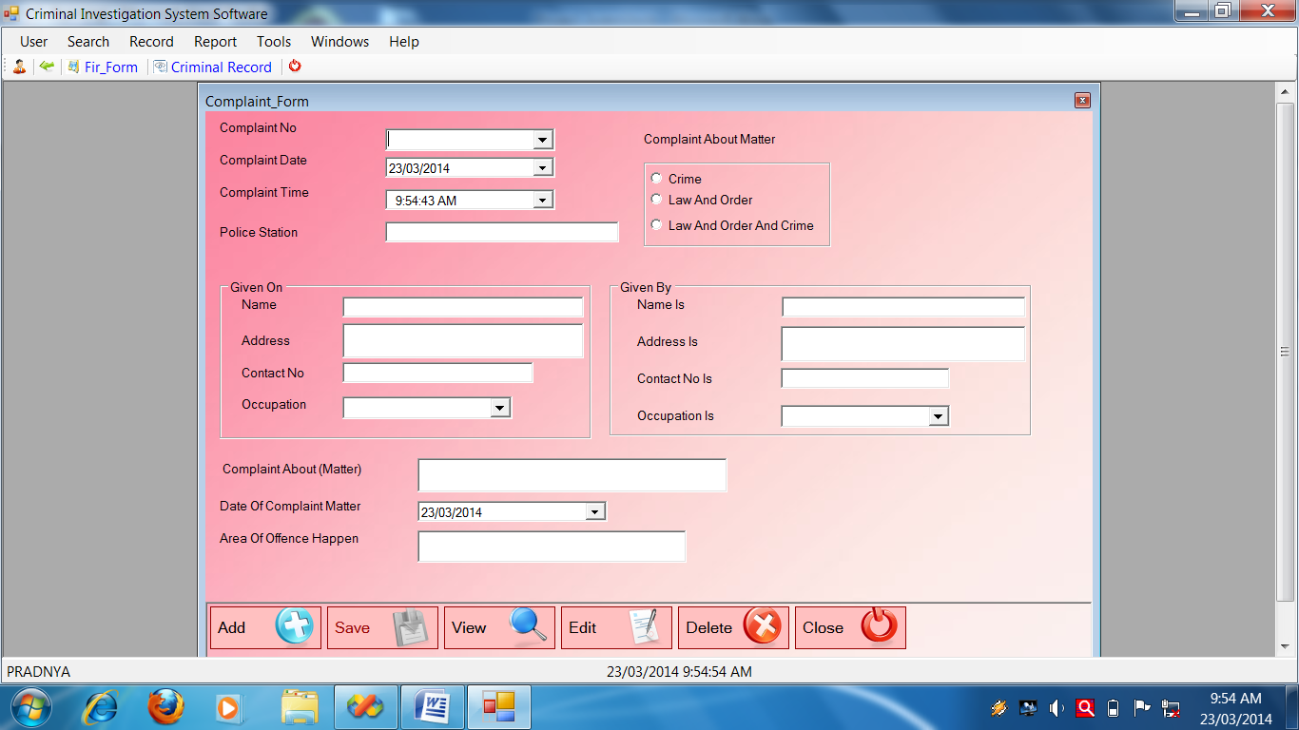

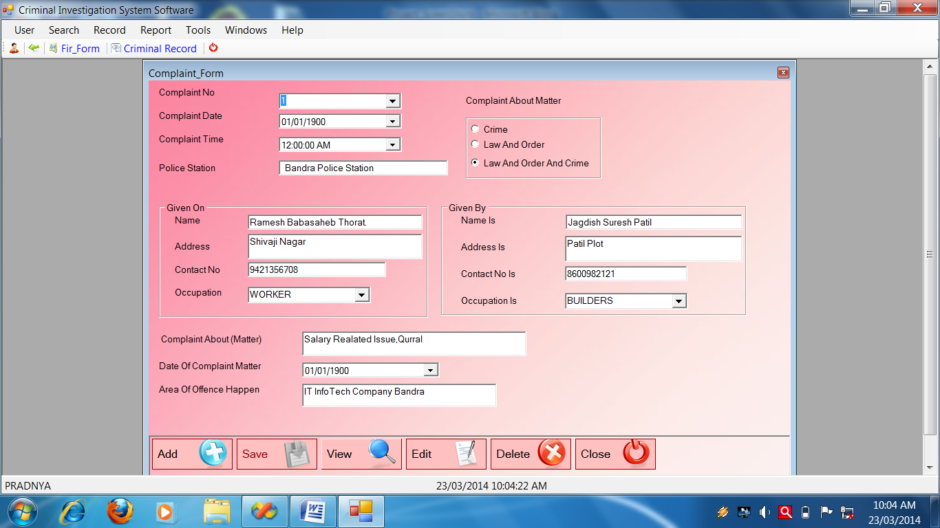

**Complaint Form Source Code**

Public Class Complaint_Form

Dim CAM As String

Private Sub Complaint_Form_Load(ByVal sender As System.Object, ByVal e As System.EventArgs) Handles MyBase.Load

Call setmode("NoMode")

Call FillCombo(Me.cmbo, "LookUp_Field", "OCCUPATION", "Lookup_Value", "Lookup_Mst")

Call FillCombo(Me.cmboi, "LookUp_Field", "OCCUPATION", "Lookup_Value", "Lookup_Mst")

End Sub

Private Sub btnadd_Click(ByVal sender As System.Object, ByVal e As System.EventArgs) Handles btnadd.Click

Call setmode("AddMode")

Call clearall()

' Me.cmbcn.ReadOnly = True

Me.cmbcn.Text = GenerateNewId("Comp_no", "Complaint_Mst")

End Sub

********************SaveComplaint_Mst()********************************

Private Sub SaveComplaint_Form()

Try

Call setmode("NoMode")

Call OpenDB()

Dim SqlString As String

SqlString = "INSERT INTO

Complaint_Mst(Comp_no,Comp_date,Comp_time,Comp_am,Ps,Name,Address,Contact_no,Occupation,Name_is,Address_is,Contact_ni,Occupation_is,Comp_about,Date_ocm,Area_ooh)VALUES('" & cmbcn.Text & "'," & dtpcd.Value.Date & "," & dtpct.Value & ",'" & CAM & "','" & txtps.Text.Trim & "','" & txtn.Text.Trim & "','" & txta.Text.Trim & "' ,'" & txtcon.Text.Trim & "','" & cmbo.Text & "','" & txtni.Text.Trim & "','" & txtai.Text.Trim & "','" & txtconi.Text.Trim & "','" & cmboi.Text.Trim & "','" & txtca.Text.Trim & "'," & dtpdoc.Value.Date & ",'" & txtaooh.Text.Trim & "');"

MsgBox(SqlString)

Cmd = GetCmd(SqlString)

If Cmd.ExecuteNonQuery Then

MessageBox.Show("Record Save Successflly")

Else

MessageBox.Show("Fail To Save Record")

End If

CloseDB()

Catch ex As Exception

MessageBox.Show(ex.Message)

End Try

End Sub

Private Sub btnsave_Click(ByVal sender As System.Object, ByVal e As System.EventArgs) Handles btnsave.Click

Call SaveComplaint_Form()

End Sub

'********************View methods*******************************

Private Sub ViewComplaint_Form()

Try

OpenDB()

Dim sqlString As String

sqlString = "SELECT * FROM Complaint_Mst where Comp_no='" & Me.cmbcn.Text & "';"

'MsgBox(sqlString)

Cmd = GetCmd(sqlString)

Dr = Cmd.ExecuteReader

Do While Dr.Read

With Me

.cmbcn.Text = Dr.Item("Comp_no")

.dtpcd.Value = Dr.Item("Comp_date")

.dtpct.Value = Dr.Item("Comp_time")

CAM = Dr.Item("Comp_am")

If CAM = "Crime" Then

Me.rdoc.Checked = True

ElseIf CAM = "Law And Order" Then

Me.rdolo.Checked = True

Else

Me.rdoloc.Checked = True

End If

.txtps.Text = Dr.Item("Ps")

.txtn.Text = Dr.Item("Name")

.txta.Text = Dr.Item("Address")

.txtcon.Text = Dr.Item("Contact_no")

.cmbo.Text = Dr.Item("Occupation")

.txtni.Text = Dr.Item("Name_is")

.txtai.Text = Dr.Item("Address_is")

.txtconi.Text = Dr.Item("Contact_ni")

.cmboi.Text = Dr.Item("Occupation_is")

.txtca.Text = Dr.Item("Comp_about")

.dtpdoc.Value = Dr.Item("Date_ocm")

.txtaooh.Text = Dr.Item("Area_ooh")

End With

Loop

CloseDB()

Catch ex As Exception

MessageBox.Show("VIEW Record:" + ex.Message)

End Try

End Sub

Private Sub btnview_Click(ByVal sender As System.Object, ByVal e As System.EventArgs) Handles btnview.Click

Call setmode("ViewMode")

Me.cmbcn.Focus()

' Me.cmbcn.ReadOnly = False

FillCombo(Me.cmbcn, "Comp_no", "Complaint_Mst")

End Sub

'*********************Delete method********************************

Private Sub DeleteComplaint_Form()

Try

Call OpenDB()

Dim sqlString As String

sqlString = "DELETE FROM Complaint_Mst WHERE Comp_no='" & Me.cmbcn.Text & "';"

Cmd = GetCmd(sqlString)

If Cmd.ExecuteNonQuery Then

MessageBox.Show("Record deleted successfully")

Else

MessageBox.Show("Fail to delete")

End If

Call CloseDB()

Catch ex As Exception

End Try

End Sub

Private Sub btndelete_Click(ByVal sender As System.Object, ByVal e As System.EventArgs) Handles btndelete.Click

If MessageBox.Show("Are you sure?", "Delete?", MessageBoxButtons.YesNo, MessageBoxIcon.Question, MessageBoxDefaultButton.Button2) = Windows.Forms.DialogResult.Yes Then

Call DeleteComplaint_Form()

End If

End Sub

'****************************Edit method***************************

Private Sub EditComplaint_Form()

Try

OpenDB()

Dim SqlString As String

SqlString = "UPDATE Complaint_Mst SET Comp_no='" & Me.cmbcn.Text & "',Comp_date='" & Me.dtpcd.Value & "',Comp_time='" & Me.dtpct.Value & "',Ps=' " & Me.txtps.Text & "',Name='" & Me.txtn.Text & "',Address ='" & Me.txta.Text & "',Contact_no='" & Me.txtcon.Text & "',Occupation='" & Me.cmbo.Text & "',Name_is='" & Me.txtni.Text & "',Address_is='" & Me.txtai.Text & _

"',Contact_ni='" & Me.txtconi.Text & "', Occupation_is='" & Me.cmboi.Text & "',Comp_about='" & Me.txtca.Text & "',Date_ocm='" & Me.dtpdoc.Value & "',Area_ooh= '" & Me.txtaooh.Text & "' where Comp_no='" & Me.cmbcn.Text & "';"

MsgBox(SqlString)

Cmd = GetCmd(SqlString)

If Cmd.ExecuteNonQuery Then

MessageBox.Show("Edited successfully")

Else

MessageBox.Show("faild to edit")

End If

CloseDB()

Catch ex As Exception

MessageBox.Show(ex.Message)

End Try

End Sub

Private Sub clearall()

With Me

.cmbcn.Text = ""

.dtpcd.Value = Today

.dtpct.Value = Today

'.txt.Text = ""

'.cmbdist.Text = ""

'.txtia.Text = ""

.txtps.Text = ""

.txtn.Text = ""

.txta.Text = ""

.txtcon.Text = ""

.cmbo.Text = ""

.txtni.Text = ""

.txtai.Text = ""

.txtconi.Text = ""

.cmboi.Text = ""

.txtca.Text = ""

.dtpdoc.Value = Today

.txtaooh.Text = ""

End With

End Sub

Private Sub btnedit_Click(ByVal sender As System.Object, ByVal e As System.EventArgs) Handles btnedit.Click

Call EditComplaint_Form()

End Sub

'**************************SETMODE***********************************

Private Sub setmode(ByVal strmode As String)

Select Case strmode

Case "NoMode"

With Me

.GroupBox1.Enabled = False

.btnadd.Enabled = True

.btnsave.Enabled = False

.btnview.Enabled = True

.btndelete.Enabled = False

.btnedit.Enabled = False

End With

Case "AddMode"

With Me

.GroupBox1.Enabled = True

.btnadd.Enabled = False

.btnsave.Enabled = True

.btnview.Enabled = True

.btndelete.Enabled = False

.btnedit.Enabled = False

End With

Case "ViewMode"

With Me

.GroupBox1.Enabled = True

.btnadd.Enabled = True

.btnsave.Enabled = False

.btnview.Enabled = True

.btndelete.Enabled = True

.btnedit.Enabled = True

End With

End Select

End Sub

Private Sub Complaint_Form_KeyPress(ByVal sender As Object, ByVal e As System.Windows.Forms.KeyPressEventArgs) Handles Me.KeyPress

If Asc(e.KeyChar) = 13 Then

SendKeys.Send("{TAB}")

End If

End Sub

Private Sub rdoc_CheckedChanged(ByVal sender As System.Object, ByVal e As System.EventArgs) Handles rdoc.CheckedChanged

If Me.rdoc.Checked = True Then

CAM = Me.rdoc.Text

ElseIf Me.rdolo.Checked = True Then

CAM = Me.rdolo.Text

ElseIf Me.rdoloc.Checked = True Then

CAM = Me.rdoloc.Text

End If

End Sub

Private Sub btnclose_Click(ByVal sender As System.Object, ByVal e As System.EventArgs) Handles btnclose.Click

Me.Close()

End Sub

Private Sub cmbcn_SelectedIndexChanged(ByVal sender As System.Object, ByVal e As System.EventArgs) Handles cmbcn.SelectedIndexChanged

Call ViewComplaint_Form()

End Sub

End Class

**Complaint With Drawn Form**

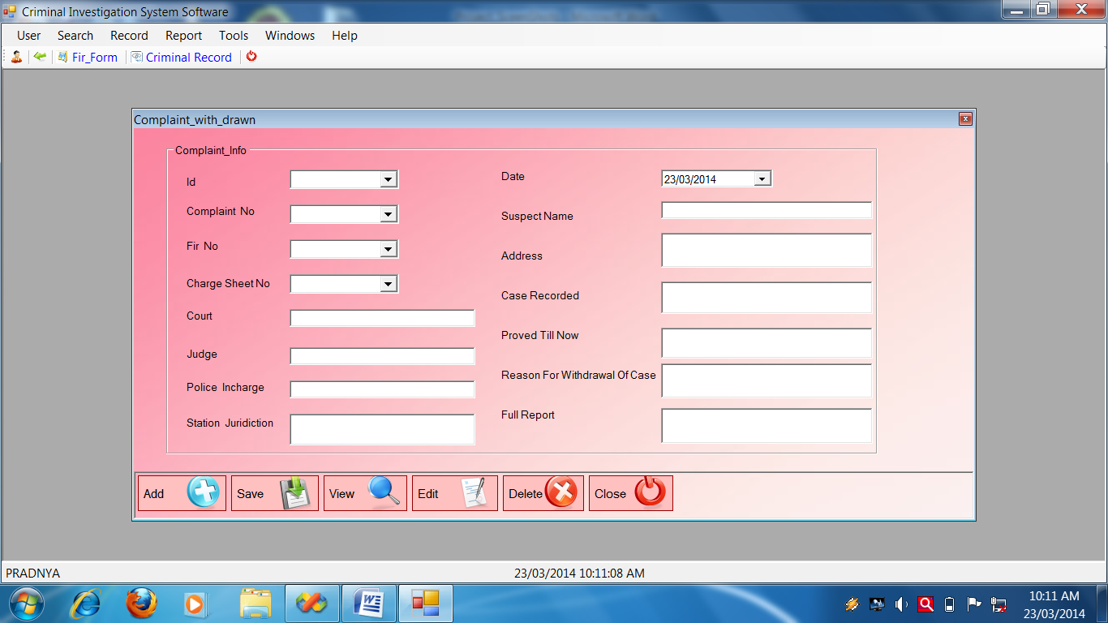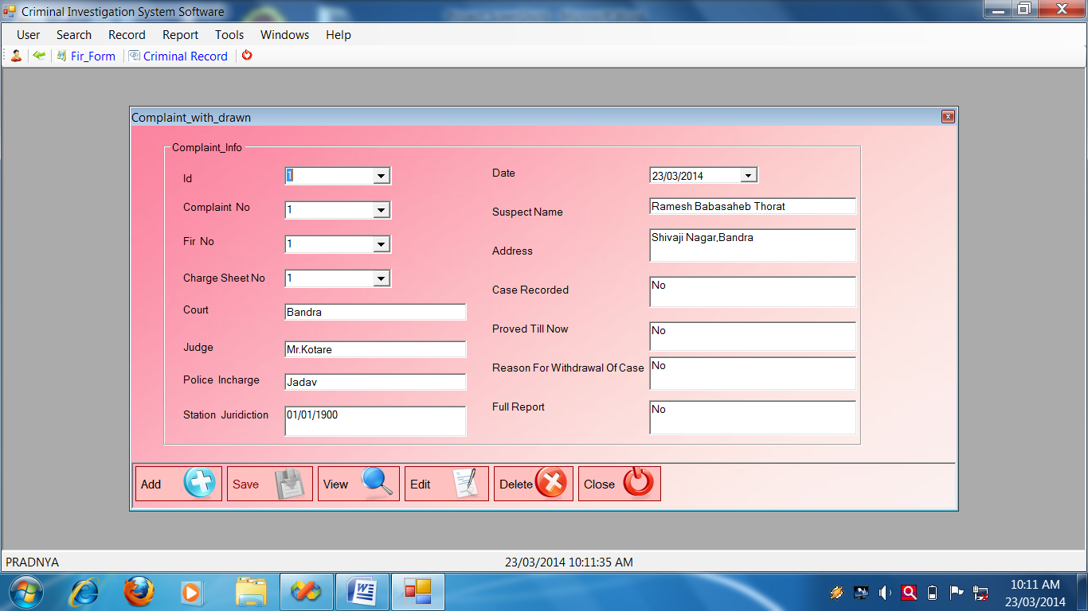

**Complaint With Drawn Source Code**

Public Class Complaint_with_drawn

Private Sub Complaint_with_drawn_KeyPress(ByVal sender As Object, ByVal e As System.Windows.Forms.KeyPressEventArgs) Handles Me.KeyPress

If Asc(e.KeyChar) = 13 Then

SendKeys.Send("{TAB}")

End If

End Sub

Private Sub Complaint_with_drawn_Load(ByVal sender As System.Object, ByVal e As System.EventArgs) Handles MyBase.Load

Call setmode("nomode")

End Sub

'*************************addbtn***************************************

Private Sub btnadd_Click(ByVal sender As System.Object, ByVal e As System.EventArgs) Handles btnadd.Click

Call setmode("AddMode")

Call clearall()

' Me.cmbid.ReadOnly = True

Me.cmbid.Text = GenerateNewId("Id", "ComplaintWithdrawal_Mst")

End Sub

'******************************Savemethod***************************

Private Sub SaveComplaint_with_drawn()

Try

Call setmode("NoMode")

Call OpenDB()

Dim SqlString As String

SqlString = "INSERT INTO ComplaintWithdrawal_Mst(Id,Comp_no,Fir_no,Charge_sno,Court,Judge,P_incharge,S_juridiction,Date,Suspect_nm,Address,Case_record,Proved_till_now,Reason_for_withdrawal_case,Full_report)VALUES(' " & cmbid.Text & " ',' " & cmbno.Text & " ','" & cmbfirno.Text & " ',' " & cmbcsno.Text & " ','" & Me.txtc.Text & "' ,'" & Me.txtj.Text.Trim & "','" & Me.txtpi.Text.Trim & "','" & Me.txtsj.Text.Trim & "'," & Me.dtpd.Value.Date & ", '" & Me.txtsn.Text & "','" & Me.txta.Text & "','" & Me.txtcr.Text & "','" & Me.txtp.Text & "','" & Me.txtrf.Text & "','" & Me.txtfr.Text & "' );"

'MsgBox(SqlString)

Cmd = GetCmd(SqlString)

If Cmd.ExecuteNonQuery Then

MessageBox.Show("Record Save Successflly")

Else

MessageBox.Show("Fail To Save Record")

End If

CloseDB()

Catch ex As Exception

MessageBox.Show(ex.Message)

End Try

End Sub

'************************ Call SaveComplaint_with_drawn()****************

Private Sub btnsave_Click(ByVal sender As System.Object, ByVal e As System.EventArgs) Handles btnsave.Click

Call SaveComplaint_with_drawn()

End Sub

'***************************call FillCombo************************

Private Sub btnview_Click(ByVal sender As System.Object, ByVal e As System.EventArgs) Handles btnview.Click

FillCombo(Me.cmbid, "Id", "ComplaintWithdrawal_Mst")

Call setmode("ViewMode")

Me.cmbid.Focus()

End Sub

'************************View method******************************

Private Sub ViewComplaint_with_drawn()

Try

OpenDB()

Dim sqlString As String

sqlString = "SELECT * FROM ComplaintWithdrawal_Mst Where Id='" & Me.cmbid.Text & "';"

Cmd = GetCmd(sqlString)

Dr = Cmd.ExecuteReader

Do While Dr.Read

With Me

.cmbid.Text = Dr.Item("Id")

.cmbno.Text = Dr.Item("Comp_no")

.cmbfirno.Text = Dr.Item("Fir_no")

.cmbcsno.Text = Dr.Item("Charge_sno")

.txtc.Text = Dr.Item("Court")

.txtj.Text = Dr.Item("Judge")

.txtpi.Text = Dr.Item("P_incharge")

.txtsj.Text = Dr.Item("S_juridiction")

.txtsj.Text = Dr.Item("Date")

.txtsn.Text = Dr.Item("Suspect_nm")

.txta.Text = Dr.Item("Address")

.txtcr.Text = Dr.Item("Case_record")

.txtp.Text = Dr.Item("Proved_till_now")

.txtrf.Text = Dr.Item("Reason_for_withdrawal_case")

.txtfr.Text = Dr.Item("Full_report")

End With

Loop

CloseDB()

Catch ex As Exception

MessageBox.Show("VIEW Record:" + ex.Message)

End Try

End Sub

'****************************Edit method*******************************

Private Sub EditComplaint_with_drawn()

Try

OpenDB()

Dim sqlstring As String

sqlstring = "update ComplaintWithdrawal_Mst set Comp_no='" & Me.cmbno.Text & "',Fir_no='" & Me.cmbfirno.Text & "',Charge_sno= '" & Me.cmbcsno.Text & "',Court= '" & Me.txtc.Text & "',Judge='" & Me.txtj.Text & "',P_incharge= '" & Me.txtpi.Text & "',S_juridiction= '" & Me.txtsj.Text & "',Date= " & Me.dtpd.Value.Date & ",Suspect_nm= '" & Me.txtsn.Text & "',Address= '" & Me.txta.Text & "',Case_record= '" & Me.txtcr.Text & "',Proved_till_now= '" & Me.txtp.Text & "',Reason_for_withdrawal_case= '" & Me.txtrf.Text & "',Full_report= '" & Me.txtfr.Text & "' WHERE Id='" & Me.cmbid.Text & "';"

MsgBox(sqlstring)

Cmd = GetCmd(sqlstring)

If Cmd.ExecuteNonQuery Then

MessageBox.Show("Edited successfully")

Else

MessageBox.Show("faild to edit")

End If

CloseDB()

Catch ex As Exception

MessageBox.Show(ex.Message)

End Try

End Sub '******************************************clearall()*********************

Private Sub clearall()

With Me

.cmbid.Text = ""

.cmbno.Text = ""

.cmbfirno.Text = ""

.cmbcsno.Text = ""

.txtc.Text = ""

.txtj.Text = ""

.txtpi.Text = ""

.txtsj.Text = ""

.dtpd.Value = Today

.txtsn.Text = ""

.txta.Text = ""

.txtcr.Text = ""

.txtp.Text = ""

.txtrf.Text = ""

.txtfr.Text = ""

End With

End Sub

'******************************Call EditComplaint_with_drawn()**********

Private Sub btnedit_Click(ByVal sender As System.Object, ByVal e As System.EventArgs) Handles btnedit.Click

Call EditComplaint_with_drawn()

End Sub

'****************************Delete methode**************************

Private Sub DeleteComplaint_with_drawn()

Try

Call OpenDB()

Dim sqlString As String

sqlString = "DELETE FROM ComplaintWithdrawal_Mst WHERE Id='" & Me.cmbid.Text & "';"

Cmd = GetCmd(sqlString)

If Cmd.ExecuteNonQuery Then

MessageBox.Show("Record deleted successfully")

Else

MessageBox.Show("Fail to delete")

End If

Call CloseDB()

Catch ex As Exception

End Try

End Sub

'*******************Call DeleteComplaint_with_drawn()***************

Private Sub btndelete_Click(ByVal sender As System.Object, ByVal e As System.EventArgs) Handles btndelete.Click

If MessageBox.Show("Are you sure?", "Delete?", MessageBoxButtons.YesNo, MessageBoxIcon.Question, MessageBoxDefaultButton.Button2) = Windows.Forms.DialogResult.Yes Then

Call DeleteComplaint_with_drawn()

End If

End Sub

'***********************************call close()***********************

Private Sub btnclose_Click(ByVal sender As System.Object, ByVal e As System.EventArgs) Handles btnclose.Click

Me.Close()

End Sub

'**************************Call ViewComplaint_with_drawn()**********

Private Sub cmbid_SelectedIndexChanged(ByVal sender As System.Object, ByVal e As System.EventArgs) Handles cmbid.SelectedIndexChanged

Call ViewComplaint_with_drawn()

End Sub

'******************************call setmode()********************

Private Sub setmode(ByVal strmode As String)

Select Case strmode

Case "NoMode"

With Me

.GroupBox1.Enabled = False

.btnadd.Enabled = True

.btnsave.Enabled = False

.btnview.Enabled = True

.btndelete.Enabled = False

.btnedit.Enabled = False

End With

Case "AddMode"

With Me

.GroupBox1.Enabled = True

.btnadd.Enabled = False

.btnsave.Enabled = True

.btnview.Enabled = True

.btndelete.Enabled = False

.btnedit.Enabled = False

End With

Case "ViewMode"

With Me

.GroupBox1.Enabled = True

.btnadd.Enabled = True

.btnsave.Enabled = False

.btnview.Enabled = True

.btndelete.Enabled = True

.btnedit.Enabled = True

End With

End Select

End Sub

End Class

**FIR Form 1**

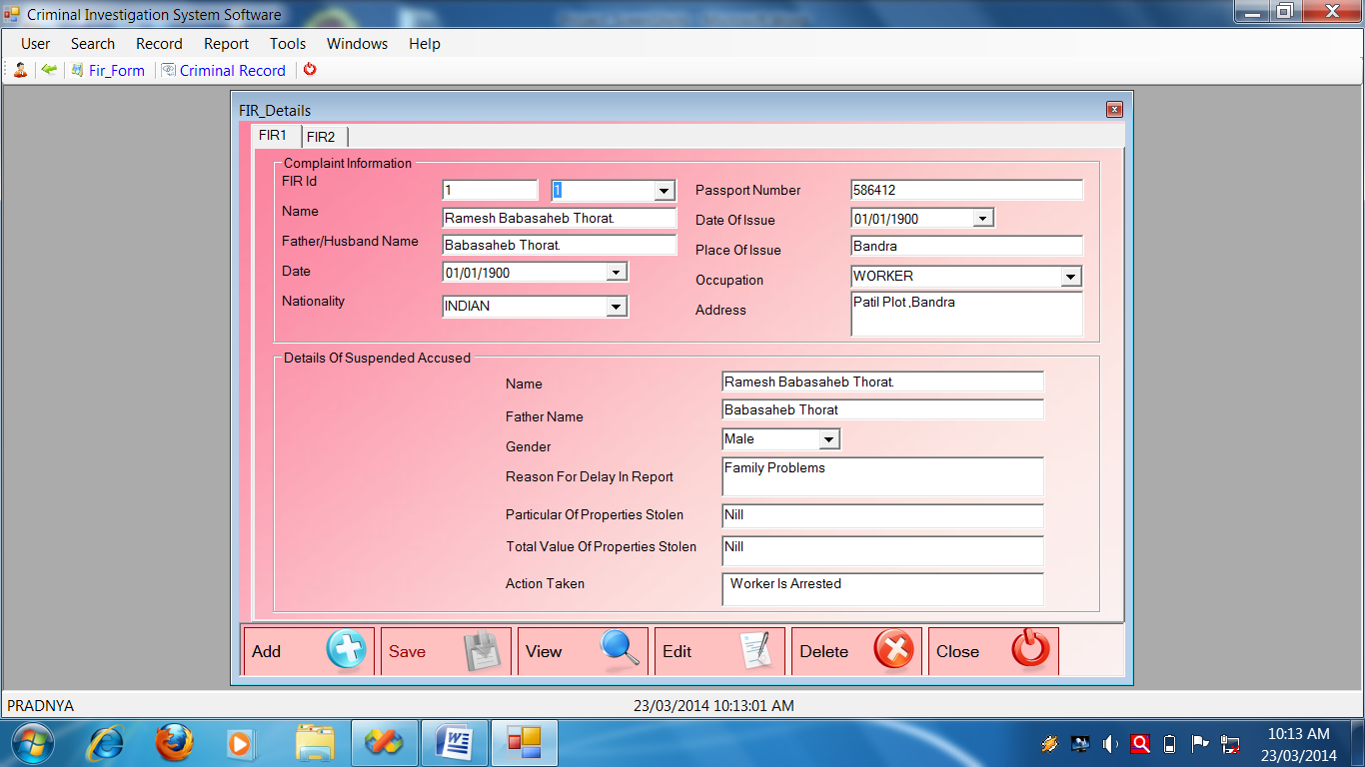

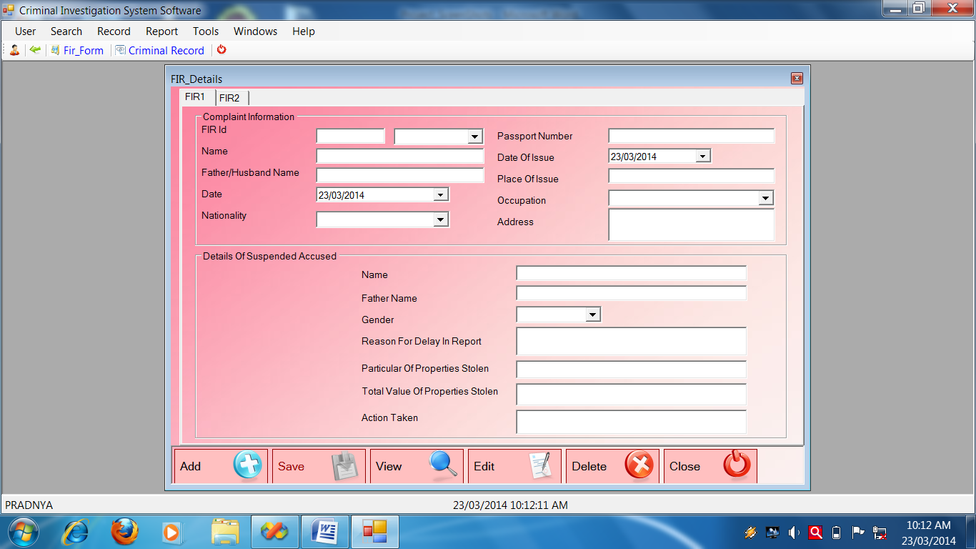

**FIR Form 2**

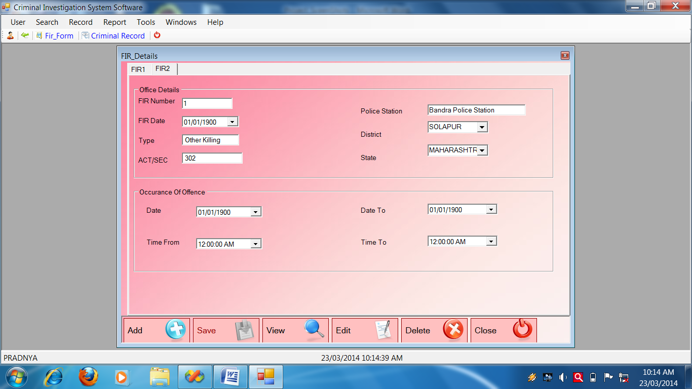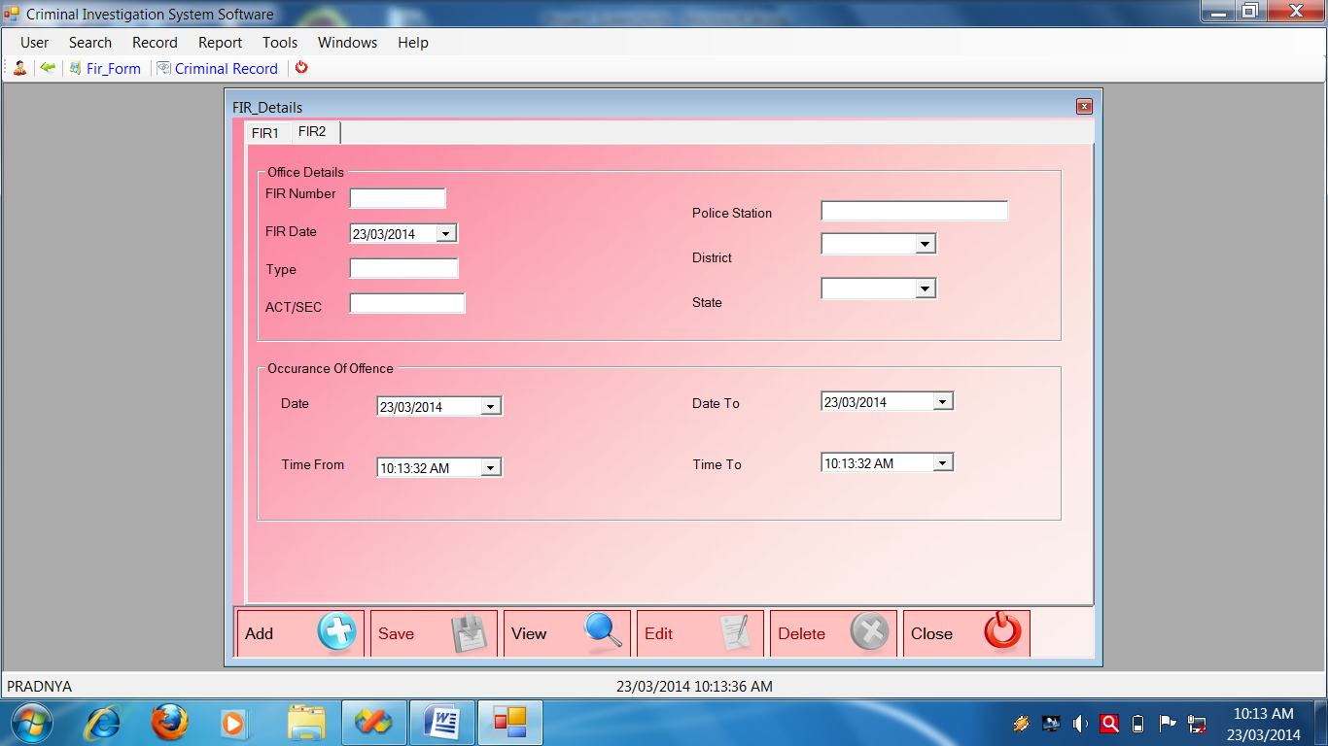

**FIR Form Source Code**

Public Class FIR_Details

Dim SaveFlag As Boolean

Private Sub FIR_Details_KeyPress(ByVal sender As Object, ByVal e As System.Windows.Forms.KeyPressEventArgs) Handles Me.KeyPress

If Asc(e.KeyChar) = 13 Then

SendKeys.Send("{TAB}"

End If

End Sub

Private Sub FIR_Details_Load(ByVal sender As System.Object, ByVal e As System.EventArgs) Handles MyBase.Load

Call setmode("NoMode")

Call FillCombo(Me.cmbn, "LookUp_Field", "Nationality", "Lookup_Value", "Lookup_Mst")

Call FillCombo(Me.cmbo, "LookUp_Field", "Occupation", "Lookup_Value", "Lookup_Mst")

Call FillCombo(Me.cmbdist, "LookUp_Field", "District", "Lookup_Value", "Lookup_Mst")

Call FillCombo(Me.cmbstate, "LookUp_Field", "state", "Lookup_Value", "Lookup_Mst")

Call FillCombo(Me.cmbFId, "Fir_Mst1_Id", "FIR_Mst1")

End Sub

Private Sub btnadd_Click(ByVal sender As System.Object, ByVal e As System.EventArgs) Handles btnadd.Click

Call setmode("AddMode")

Call clearall1()

Call clearall2()

Me.txtid.ReadOnly = True

Me.txtid.Text = GenerateNewId("Fir_Mst1_id", "FIR_Mst1")

End Sub

'*********************'To clearall FIR_Mst1'*******************

Private Sub clearall1()

With Me

.txtid.Text = ""

.txtnm.Text = ""

.txtf.Text = ""

.dtpd.Value = Today

.cmbn.Text = ""

.txtp.Text = ""

.dtpdoi.Value = Today

.txtpoi.Text = ""

.cmbo.Text = ""

.txta.Text = ""

.txtname.Text = " "

.cmbg.Text = ""

.txtfn.Text = ""

.txtrfd.Text = ""

.txtpop.Text = ""

.txttv.Text = ""

.txtat.Text = ""

End With

'******************* To clear all for FIR_Mst2 ********************

Private Sub clearall2()

With Me

.txtfirn.Text = ""

.dtpfird.Value = Today

.txttype.Text = ""

.txtas.Text = " "

.txtps.Text = ""

.cmbdist.Text = ""

.cmbstate.Text = ""

.dtpdt.Value = Today

.dtpdto.Value = Today

.dtptf.Value = Today

.dtptt.Value = Today

End With

End Sub

Private Sub setmode(ByVal strmode As String)

Select Case strmode

Case "NoMode"

With Me

.GroupBox1.Enabled = False

.btnAdd.Enabled = True

.btnSave.Enabled = False

.btnView.Enabled = True

.btnDelete.Enabled = False

.btnEdit.Enabled = False

End With

Case "AddMode"

With Me

.GroupBox1.Enabled = True

.btnAdd.Enabled = False

.btnSave.Enabled = True

.btnView.Enabled = True

.btnDelete.Enabled = False

.btnEdit.Enabled = False

End With

Case "ViewMode"

With Me

.GroupBox1.Enabled = True

.btnAdd.Enabled = True

.btnSave.Enabled = False

.btnView.Enabled = True

.btnDelete.Enabled = True

.btnEdit.Enabled = True

End With

End Select

End Sub

*******************Save Method FIR1***************************

Private Sub Save_FIR_Mst1()

Try

Call setmode("NoMode")

Call OpenDB()

Dim SqlString As String

SqlString = "INSERT INTO FIR_Mst1(" _

& "Fir_Mst1_Id,Fir_Mst1_name,Fir_Mst1_fhname," _

& "Fir_Mst1_date,Fir_Mst1_nationality,Fir_Mst1_passport," _

& "Fir_Mst1_date_oi,Fir_Mst1_place_oi,Fir_Mst1_occupation," _

& "Fir_Mst1_address,Fir_Mst1_nm,Fir_Mst1_fn,Fir_Mst1_gender,”_

& "Fir_Mst1_rfd,Fir_Mst1_pop,Fir_Mst1_tvops,Fir_Mst1_at)VALUES ('" _

& Me.txtid.Text & "','" & Me.txtnm.Text & "','" & Me.txtf.Text & "'," & Me.dtpd.Value.Date & ",'" _

& Me.cmbn.Text & "','" & Me.txtp.Text & "'," & Me.dtpdoi.Value.Date & ",'" _

& Me.txtpoi.Text & "','" & Me.cmbo.Text & "','" & Me.txta.Text & "','" _

& Me.txtname.Text & "','" & Me.txtfn.Text & "','" & Me.cmbg.Text & "','" _

& Me.txtrfd.Text & "','" & Me.txtpop.Text & "','" & Me.txttv.Text & "','" _

& Me.txtat.Text & "');"

MsgBox(SqlString)

Cmd = GetCmd(SqlString)

If Cmd.ExecuteNonQuery Then

SaveFlag = True

'MessageBox.Show("Record Save Successflly")

Else

SaveFlag = False

' MessageBox.Show("Fail To Save Record")

End If

CloseDB()

Catch ex As Exception

MessageBox.Show(ex.Message)

End Try

End Sub

'*******************Save Method FIR2******************************

Private Sub Save_FIR_Mst2()

Try

Call setmode("NoMode")

Call OpenDB()

Dim SqlString As String

SqlString = "INSERT INTO FIR_Mst2(Fir_Mst1_Id," _

& "Fir_Mst2_firnum,Fir_Mst2_fird,Fir_Mst2_type," _

& "Fir_Mst2_act,Fir_Mst2_ps,Fir_Mst2_dist," _

& "Fir_Mst2_state,Fir_Mst2_date," _

& "Fir_Mst2_date_to,Fir_Mst2_time_from,Fir_Mst2_time_to) VALUES ('" _

& Me.txtid.Text & "','" & Me.txtfirn.Text & "'," & Me.dtpfird.Value.Date & ",'" & Me.txttype.Text & "','" _

& Me.txtas.Text & "','" & Me.txtps.Text & "','" & Me.cmbdist.Text & "','" _

& Me.cmbstate.Text & "'," & Me.dtpdt.Value.Date & "," & Me.dtpdto.Value.Date & "," _

& Me.dtptf.Value.Date & "," & Me.dtptt.Value.Date & ");"

MsgBox(SqlString)

Cmd = GetCmd(SqlString)

If SaveFlag = True And Cmd.ExecuteNonQuery Then

MessageBox.Show("Record Save Successflly")

Else

MessageBox.Show("Fail To Save Record")

End If

CloseDB()

Catch ex As Exception

MessageBox.Show(ex.Message)

End Try

End Sub

Private Sub btnsave_Click(ByVal sender As System.Object, ByVal e As System.EventArgs) Handles btnsave.Click

Call Save_FIR_Mst1()

Call Save_FIR_Mst2()

End Sub

'**********************View FIR_Mst1**********************

Private Sub View_FIR_Mst1()

Try

OpenDB()

Dim sqlString As String

sqlString = "SELECT * FROM FIR_Mst1 Where Fir_Mst1_id='" & Me.txtid.Text.Trim & "';"

Cmd = GetCmd(sqlString)

Dr = Cmd.ExecuteReader

Do While Dr.Read

With Me

.txtnm.Text = Dr.Item("Fir_Mst1_name")

.txtf.Text = Dr.Item("Fir_Mst1_fhname")

.dtpd.Value = Dr.Item("Fir_Mst1_date")

.cmbn.Text = Dr.Item("Fir_Mst1_nationality")

.txtp.Text = Dr.Item("Fir_Mst1_passport")

.dtpdoi.Value = Dr.Item("Fir_Mst1_date_oi")

.txtpoi.Text = Dr.Item("Fir_Mst1_place_oi")

.cmbo.Text = Dr.Item("Fir_Mst1_occupation")

.txta.Text = Dr.Item("Fir_Mst1_address")

.txtname.Text = Dr.Item("Fir_Mst1_name")

.txtfn.Text = Dr.Item("Fir_Mst1_fn")

.cmbg.Text = Dr.Item("Fir_Mst1_gender")

.txtrfd.Text = Dr.Item("Fir_Mst1_rfd")

.txtpop.Text = Dr.Item("Fir_Mst1_pop")

.txttv.Text = Dr.Item("Fir_Mst1_tvops")

.txtat.Text = Dr.Item("Fir_Mst1_at")

End With

Loop

CloseDB()

Catch ex As Exception

MessageBox.Show("VIEW Record_Mst1:" + ex.Message)

End Try

End Sub

'**********************View FIR_Mst2**********************

Private Sub View_FIR_Mst2()

Try

OpenDB()

Dim sqlString As String

sqlString = "SELECT * FROM FIR_Mst2 Where Fir_Mst1_id='" & Me.txtid.Text.Trim & "';"

Cmd = GetCmd(sqlString)

Dr = Cmd.ExecuteReader

Do While Dr.Read

With Me

.txtfirn.Text = Dr.Item("Fir_Mst2_firnum")

.dtpfird.Value = Dr.Item("Fir_Mst2_fird")

.txttype.Text = Dr.Item("Fir_Mst2_type")

.txtas.Text = Dr.Item("Fir_Mst2_act")

.txtps.Text = Dr.Item("Fir_Mst2_ps")

.cmbdist.Text = Dr.Item("Fir_Mst2_dist")

.cmbstate.Text = Dr.Item("Fir_Mst2_state")

.dtpdt.Value = Dr.Item("Fir_Mst2_date")

.dtpdto.Value = Dr.Item("Fir_Mst2_date_to")

.dtptf.Value = Dr.Item("Fir_Mst2_time_from")

.dtptt.Value = Dr.Item("Fir_Mst2_time_to")

End With

Loop

CloseDB()

Catch ex As Exception

MessageBox.Show("VIEW Record Mst2:" + ex.Message)

End Try

End Sub

'*******************************EditFIR_Mst1****************

Private Sub Edit_FIR_Mst1()

Try

OpenDB()

Dim sqlstring As String

sqlstring = "UPDATE FIR_Mst1 set Fir_Mst1_Name='" & Me.txtnm.Text & "',Fir_Mst1_FHName='" & Me.txtf.Text & "',Fir_Mst1_Date=" & Me.dtpd.Value.Date & ",Fir_Mst1_Nationality='" & cmbn.Text & "',Fir_Mst1_passport='" & txtp.Text & "',Fir_Mst1_date_oi=" & dtpdoi.Value.Date & ",Fir_Mst1_place_oi='" & txtpoi.Text & "',Fir_Mst1_Occupation='" & cmbo.Text & "',Fir_Mst1_address='" & txta.Text & "',Fir_Mst1_nm='" & txtname.Text & "',Fir_Mst1_fn='" & txtfn.Text & "',Fir_Mst1_gender='" & cmbg.Text & "',Fir_Mst1_rfd='" & txtrfd.Text & "',Fir_Mst1_pop='" & txtpop.Text & "',Fir_Mst1_tvops='" & txttv.Text & "',Fir_Mst1_at='" & txtat.Text & "' where Fir_Mst1_id='" & Me.txtid.Text.Trim & "';"

MsgBox(sqlstring)

Cmd = GetCmd(sqlstring)

If Cmd.ExecuteNonQuery Then

MessageBox.Show("Edited successfully")

Else

MessageBox.Show("faild to edit")

End If

CloseDB()

Catch ex As Exception

MessageBox.Show(ex.Message)

End Try

End Sub

'*******************************EditFIR_Mst2****************

Private Sub Edit_FIR_Mst2()

Try

OpenDB()

Dim sqlstring As String

sqlstring = "update FIR_Mst2 set Fir_Mst2_firnum='" & Me.txtfirn.Text & "',Fir_Mst2_fird=" & Me.dtpfird.Value.Date & ",Fir_Mst2_type=' " & Me.txttype.Text & "' ,Fir_Mst2_act='" & txtas.Text & "',Fir_Mst2_ps='" & txtps.Text & "',Fir_Mst2_dist='" & cmbdist.Text & "',Fir_Mst2_state='" & cmbstate.Text & "',Fir_Mst2_date=" & dtpdt.Value.Date & ",Fir_Mst2_date_to=" & dtpdto.Value & ", Fir_Mst2_time_from=" & dtptf.Value & ", Fir_Mst2_time_to=" & dtptt.Value & " where Fir_Mst1_id='" & Me.txtid.Text.Trim & "';"

MsgBox(sqlstring)

Cmd = GetCmd(sqlstring)

If Cmd.ExecuteNonQuery Then

MessageBox.Show("Edited successfully")

Else

MessageBox.Show("faild to edit")

End If

CloseDB()

Catch ex As Exception

MessageBox.Show(ex.Message)

End Try

End Sub

'***************************Delete FIR_Mst1*************************

Private Sub Delete_FIR_Mst1()

Try

Call OpenDB()

Dim sqlString As String

sqlString = "DELETE FROM FIR_Mst1 WHERE Fir_Mst1_id='" & Me.txtid.Text & "';"

Cmd = GetCmd(sqlString)

If Cmd.ExecuteNonQuery Then

MessageBox.Show("Record deleted successfully")

Else

MessageBox.Show("Fail to delete")

End If

Call CloseDB()

Catch ex As Exception

End Try

End Sub

'***************************Delete FIR_Mst2********************

Private Sub Delete_FIR_Mst2()

Try

Call OpenDB()

Dim sqlString As String

sqlString = "DELETE FROM FIR_Mst2 WHERE Fir_Mst1_id='" & Me.txtid.Text & "';"

Cmd = GetCmd(sqlString)

If Cmd.ExecuteNonQuery Then

MessageBox.Show("Record deleted successfully")

Else

MessageBox.Show("Fail to delete")

End If

Call CloseDB()

Catch ex As Exception

End Try

End Sub

Private Sub btnclose_Click(ByVal sender As System.Object, ByVal e As System.EventArgs) Handles btnclose.Click

Me.Close()

End Sub

Private Sub btnview_Click(ByVal sender As System.Object, ByVal e As System.EventArgs) Handles btnview.Click

Call setmode("ViewMode")

Me.txtid.Focus()

Me.txtid.ReadOnly = False

End Sub

Private Sub txtid_TextChanged(ByVal sender As System.Object, ByVal e As System.EventArgs) Handles txtid.TextChanged

Call View_FIR_Mst1()

Call View_FIR_Mst2()

End Sub

Private Sub btnedit_Click(ByVal sender As System.Object, ByVal e As System.EventArgs) Handles btnedit.Click

Call Edit_FIR_Mst1()

Call Edit_FIR_Mst2()

End Sub

Private Sub btndelete_Click(ByVal sender As System.Object, ByVal e As System.EventArgs) Handles btndelete.Click

If MessageBox.Show("Are you sure?", "Delete?", MessageBoxButtons.YesNo, MessageBoxIcon.Question, MessageBoxDefaultButton.Button2) = Windows.Forms.DialogResult.Yes Then

Call Delete_FIR_Mst1()

Call Delete_FIR_Mst2()

End If

End Sub

Private Sub cmbFId_SelectedIndexChanged(ByVal sender As System.Object, ByVal e As System.EventArgs) Handles cmbFId.SelectedIndexChanged

Me.txtid.Text = Me.cmbFId.Text

Call View_FIR_Mst1()

End Sub

End Class

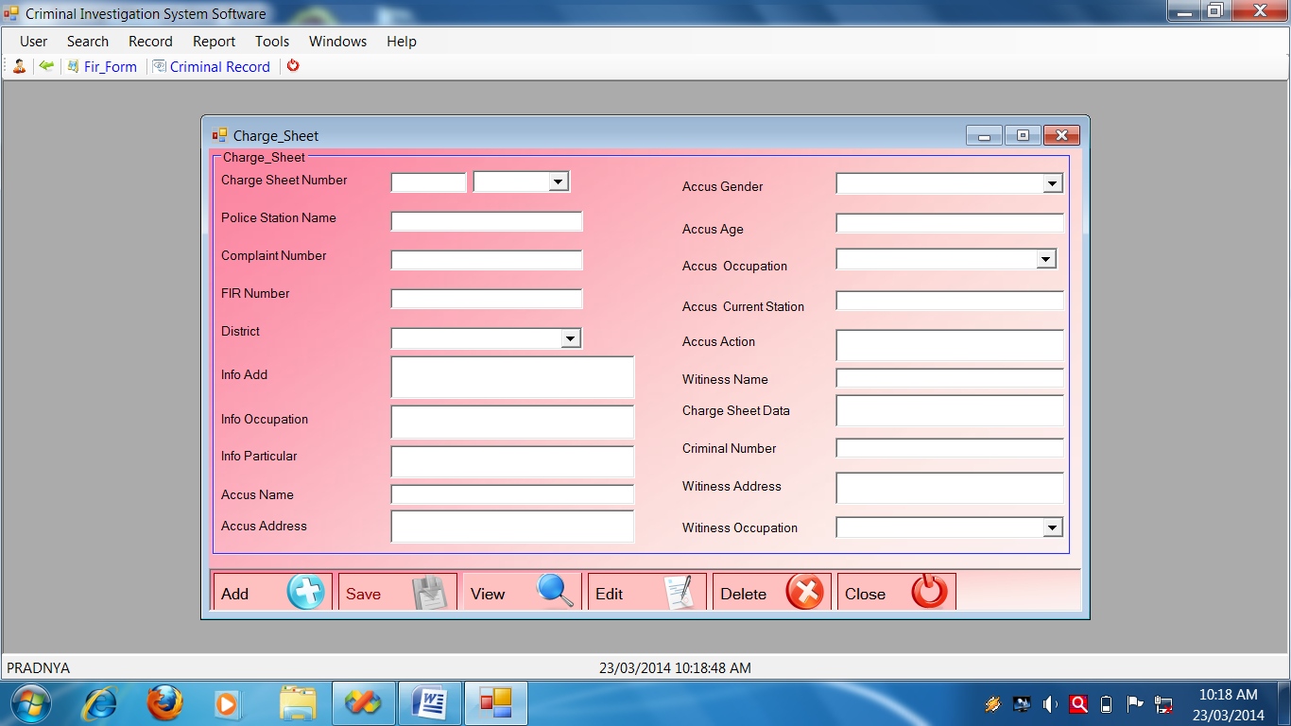**Charge SheetForm**

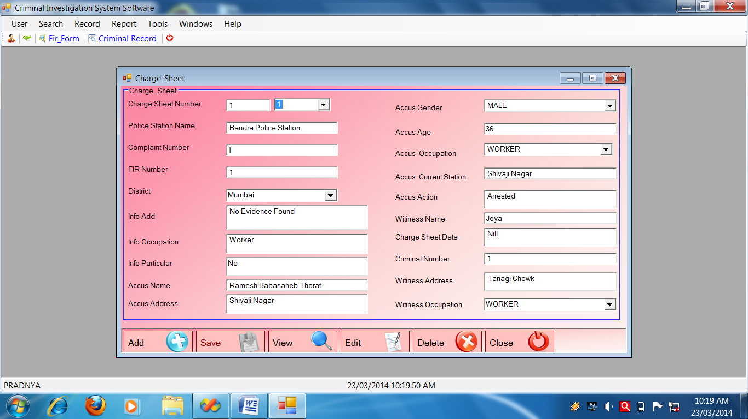

**Charge Sheet Source**

Public Class Charge_Sheet

Private Sub Charge_Sheet_KeyPress(ByVal sender As Object, ByVal e As System.Windows.Forms.KeyPressEventArgs) Handles Me.KeyPress

If Asc(e.KeyChar) = 13 Then

SendKeys.Send("{TAB}")

End If

End Sub

'*****************************************************************

Private Sub Charge_Sheet_Load(ByVal sender As System.Object, ByVal e As System.EventArgs) Handles MyBase.Load

Call setmode("NoMode")

Call FillCombo(Me.cmbdist, "LookUp_Field", "DISTRICT", "Lookup_Value", "Lookup_Mst")

Call FillCombo(Me.cmbag, "LookUp_Field", "GENDER", "Lookup_Value", "Lookup_Mst")

Call FillCombo(Me.cmbao, "LookUp_Field", "OCCUPATION", "Lookup_Value", "Lookup_Mst")

Call FillCombo(Me.cmbwo, "LookUp_Field", "OCCUPATION", "Lookup_Value", "Lookup_Mst")

End Sub

Private Sub btnadd_Click(ByVal sender As System.Object, ByVal e As System.EventArgs) Handles btnadd.Click

Call setmode("AddMode")

Call clearall()

Me.txtcsn.ReadOnly = True

Me.txtcsn.Text = GenerateNewId("Ch_no", "Charge_Sheet")

End Sub

'******************************Save_Charge_Sheet()***************

Private Sub Save_Charge_Sheet()

Try

Call setmode("NoMode")

Call OpenDB()

Dim SqlString As String

SqlString = "INSERT INTO Charge_Sheet(Ch_no,Ps_name,Cmpt_no,Fir_no,Dist,In_add,In_occupation,In_prtr,Acc_name,Acc_address,Acc_g,Acc_age,Acc_occupation,Acc_cs,Acc_action,Witi_name,Ch_data,Crim_no,Witi_addr,Witi_occupation)VALUES(' " & txtcsn.Text.Trim & " ',' " & txtpsn.Text.Trim & " ','" & txtcn.Text.Trim & " ',' " & txtfn.Text.Trim & " ','" & Me.cmbdist.Text & "',' " & txtia.Text.Trim & " ',' " & txtio.Text.Trim & " ','" & txtip.Text.Trim & " ',' " & txtan.Text.Trim & " ' ,' " & txtaa.Text.Trim & " ',' " & cmbag.Text & " ','" & txtage.Text.Trim & " ',' " & cmbao.Text.Trim & " ',' " & txtacs.Text.Trim & " ',' " & txtaction.Text.Trim & " ','" & txtwn.Text.Trim & " ',' " & txtcsd.Text.Trim & " ',' " & txtcnum.Text.Trim & " ',' " & txtwa.Text.Trim & " ','" & cmbwo.Text.Trim & "');"

'MsgBox(SqlString)

Cmd = GetCmd(SqlString)

If Cmd.ExecuteNonQuery Then

MessageBox.Show("Record Save Successflly")

Else

MessageBox.Show("Fail To Save Record")

End If

CloseDB()

Catch ex As Exception

MessageBox.Show(ex.Message)

End Try

End Sub

'**********************Save_Charge_Sheet()*************************

Private Sub btnsave_Click(ByVal sender As System.Object, ByVal e As System.EventArgs) Handles btnsave.Click

Call Save_Charge_Sheet()

End Sub

'********************View methods*******************************

Private Sub View_Charge_Sheet()

Try

OpenDB()

Dim sqlString As String

sqlString = "SELECT * FROM Charge_Sheet where Ch_no='" & Me.cmbCsnId.Text & "';"

'MsgBox(sqlString)

Cmd = GetCmd(sqlString)

Dr = Cmd.ExecuteReader

Do While Dr.Read

With Me

.txtcsn.Text = Dr.Item("Ch_no")

.txtpsn.Text = Dr.Item("Ps_name")

.txtcn.Text = Dr.Item("Cmpt_no")

.txtfn.Text = Dr.Item("Fir_no")

.cmbdist.Text = Dr.Item("Dist")

.txtia.Text = Dr.Item("In_add")

.txtio.Text = Dr.Item("In_occupation")

.txtip.Text = Dr.Item("In_prtr")

.txtan.Text = Dr.Item("Acc_name")

.txtaa.Text = Dr.Item("Acc_address")

.cmbag.Text = Dr.Item("Acc_g")

.txtage.Text = Dr.Item("Acc_age")

.cmbao.Text = Dr.Item("Acc_occupation")

.txtacs.Text = Dr.Item("Acc_cs")

.txtaction.Text = Dr.Item("Acc_action")

.txtwn.Text = Dr.Item("Witi_name")

.txtcsd.Text = Dr.Item("Ch_data")

.txtcnum.Text = Dr.Item("Crim_no")

.txtwa.Text = Dr.Item("Witi_addr")

.cmbwo.Text = Dr.Item("Witi_occupation")

End With

Loop

CloseDB()

Catch ex As Exception

MessageBox.Show("VIEW Record:" + ex.Message)

End Try

End Sub

'****************************View_Charge_sheet()******************

Private Sub btnview_Click(ByVal sender As System.Object, ByVal e As System.EventArgs) Handles btnview.Click

Call setmode("ViewMode")

Me.txtcsn.Focus()

Me.txtcsn.ReadOnly = False

FillCombo(Me.cmbCsnId, "Ch_No", "Charge_Sheet")

End Sub

'*********************Delete method********************************

Private Sub Delete_Charge_Sheet()

Try

Call OpenDB()

Dim sqlString As String

sqlString = "DELETE FROM Charge_Sheet WHERE Ch_no='" & Me.txtcsn.Text & "';"

Cmd = GetCmd(sqlString)

If Cmd.ExecuteNonQuery The

MessageBox.Show("Record deleted successfully")

Else

MessageBox.Show("Fail to delete")

End If

Call CloseDB()

Catch ex As Exception

End Try

End Sub

'*************************edit_charge_sheet()***********************

Private Sub btnedit_Click(ByVal sender As System.Object, ByVal e As System.EventArgs) Handles btnedit.Click

Call Edit_Charge_Sheet()

End Sub

'**********************************Delete_Charge_Sheet*****************

Private Sub btndelete_Click(ByVal sender As System.Object, ByVal e As System.EventArgs) Handles btndelete.Click

If MessageBox.Show("Are you sure?", "Delete?", MessageBoxButtons.YesNo, MessageBoxIcon.Question, MessageBoxDefaultButton.Button2) = Windows.Forms.DialogResult.Yes Then

Call Delete_Charge_Sheet()

End If

End Sub

'*******************************Close methods************************

Private Sub Close_Charge_Sheet()

Try

OpenDB()

Dim sqlstring As String

sqlstring = "close from Charge_Sheet where Ch_no='" & txtcsn.Text & " ' ; "

Cmd = GetCmd(sqlstring)

If Cmd.ExecuteNonQuery Then

MessageBox.Show("fail to close")

End If

CloseDB()

Catch ex As Exception

MessageBox.Show(ex.Message)

End Try

End Sub

'*****************************Close_Charge_Sheet***********************

Private Sub btnclose_Click(ByVal sender As System.Object, ByVal e As System.EventArgs) Handles btnclose.Click

Me.Close()

End Sub

'************************************Edit method****************

Private Sub Edit_Charge_Sheet()

Try

OpenDB()

Dim SqlString As String

SqlString = "UPDATE Charge_Sheet SET Ch_no='" & Me.txtcsn.Text & "',Ps_name='" & Me.txtpsn.Text & "',Cmpt_no='" & Me.txtcn.Text & "',Fir_no=' " & Me.txtfn.Text & "',Dist='" & Me.cmbdist.Text & "',In_add ='" & Me.txtia.Text & "',In_occupation='" & Me.txtio.Text & "',In_prtr='" & Me.txtip.Text & "',ACC_name='" & Me.txtan.Text & "',Acc_address='" & Me.txtaa.Text & _

"',Acc_g='" & Me.cmbag.Text & "', Acc_age='" & Me.txtage.Text & "',Acc_occupation='" & Me.cmbao.Text & "',Acc_cs='" & Me.txtacs.Text & "',Acc_action= '" & Me.txtaction.Text & "',Witi_name= '" & Me.txtwn.Text & "', Ch_data = '" & Me.txtcsd.Text & "', Crim_no='" & Me.txtcnum.Text & "', Witi_addr='" & Me.txtwa.Text & "', Witi_occupation ='" & Me.cmbwo.Text & "' where Ch_no='" & Me.cmbCsnId.Text & "';"

MsgBox(SqlString)

Cmd = GetCmd(SqlString)

If Cmd.ExecuteNonQuery Then

MessageBox.Show("Edited successfully")

Else

MessageBox.Show("faild to edit")

End If

CloseDB()

Catch ex As Exception

MessageBox.Show(ex.Message)

End Try

End Sub

Private Sub clearall()

With Me

.txtcsn.Text = ""

.txtpsn.Text = ""

.txtcn.Text = ""

.txtfn.Text = ""

.cmbdist.Text = ""

.txtia.Text = ""

.txtio.Text = ""

.txtip.Text = ""

.txtan.Text = ""

.txtaa.Text = ""

.cmbag.Text = ""

.txtage.Text = ""

.cmbao.Text = ""

.txtacs.Text = ""

.txtaction.Text = ""

.txtwn.Text = ""

.txtcsd.Text = ""

.txtcnum.Text = ""

.txtwa.Text = ""

.cmbwo.Text = ""

End With

End Sub

'***********************************SET MODE**********************

Private Sub setmode(ByVal strmode As String)

Select Case strmode

Case "NoMode"

With Me

.GroupBox1.Enabled = False

.btnadd.Enabled = True

.btnsave.Enabled = False

.btnview.Enabled = True

.btndelete.Enabled = False

.btnedit.Enabled = False

End With

Case "AddMode"

With Me

.GroupBox1.Enabled = True

.btnadd.Enabled = False

.btnsave.Enabled = True

.btnview.Enabled = True

.btndelete.Enabled = False

.btnedit.Enabled = False

End With

Case "ViewMode"

With Me

.GroupBox1.Enabled = True

.btnadd.Enabled = True

.btnsave.Enabled = False

.btnview.Enabled = True

.btndelete.Enabled = True

.btnedit.Enabled = True

End With

End Select

End Sub

Private Sub cmbCsnId_SelectedIndexChanged(ByVal sender As System.Object, ByVal e As System.EventArgs) Handles cmbCsnId.SelectedIndexChanged

Call View_Charge_Sheet()

End Sub

End Class

**Judgement Form**

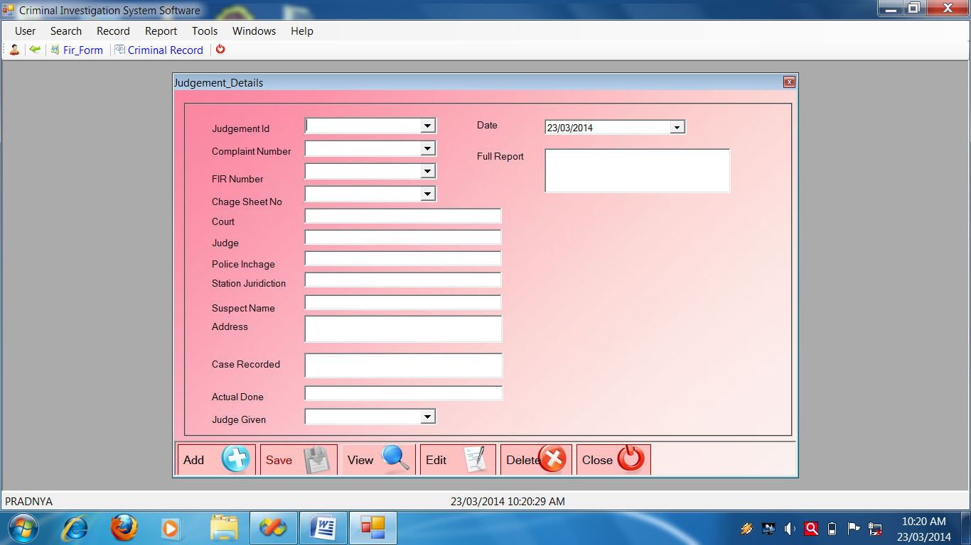

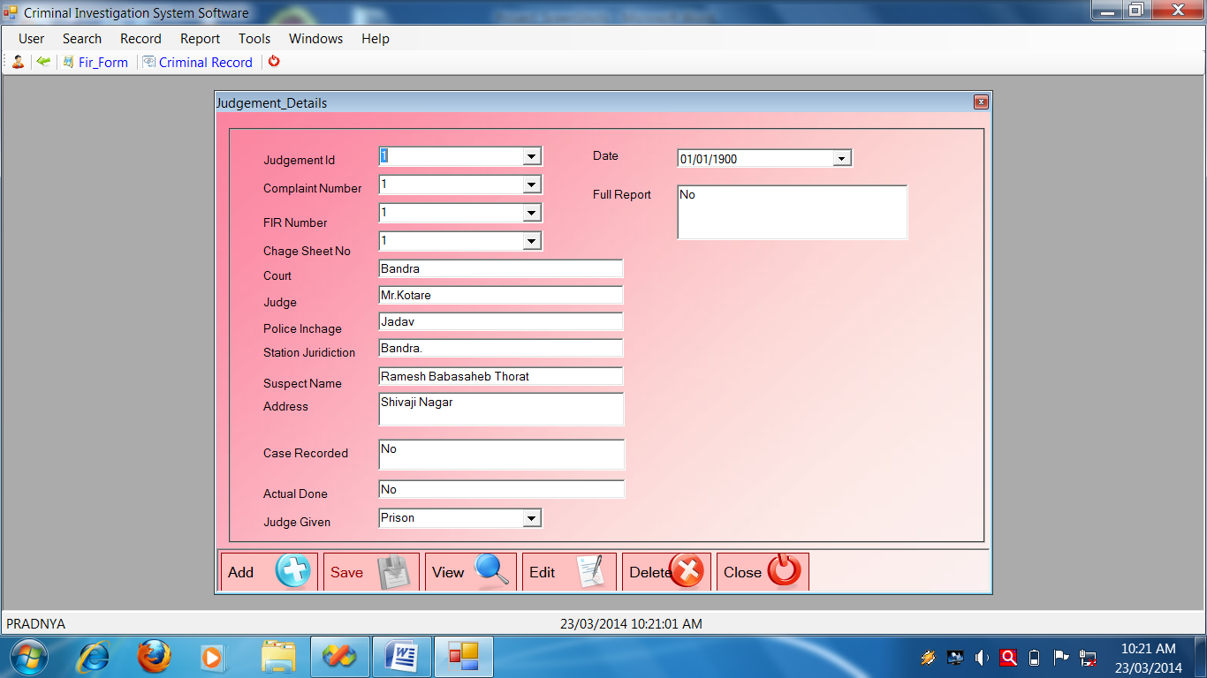

**Judgement Form Source Code**

Public Class Judgement_Details

Private Sub Judgement_Details_KeyPress(ByVal sender As Object, ByVal e As System.Windows.Forms.KeyPressEventArgs) Handles Me.KeyPress

If Asc(e.KeyChar) = 13 Then

SendKeys.Send("{TAB}")

End If

End Sub

***********************************************************************

Private Sub Judgement_Details_Load(ByVal sender As System.Object, ByVal e As System.EventArgs) Handles MyBase.Load

Call setmode("NoMode")

End Sub

Private Sub btnadd_Click(ByVal sender As System.Object, ByVal e As System.EventArgs) Handles btnadd.Click

Call setmode("AddMode")

Call clearall()

' Me.cmbid.ReadOnly = True

Me.cmbid.Text = GenerateNewId("Judge_id", "Judgement_Mst")

End Sub

Private Sub SaveJudgement_Details()

Try

Call setmode("NoMode")

Call OpenDB()

Dim SqlString As String

SqlString = "INSERT INTO Judgement_Mst(Judge_id,Comp_no,Fir_no,Charge_sno,Court,Judge,P_incharge,S_juridiction,Suspect_nm,Addr,Case_recorded,Actual_done,Judge_given,Date,Full_report)VALUES(' " & cmbid.Text & " ',' " & cmbno.Text & " ','" & cmbfirno.Text & " ',' " & cmbcsno.Text & " ','" & Me.txtc.Text & "' ,'" & Me.txtj.Text.Trim & "','" & Me.txtpi.Text.Trim & "','" & Me.txtsj.Text.Trim & "','" & Me.txtsn.Text & "','" & Me.txta.Text & "','" & Me.txtcr.Text & "','" & Me.txtad.Text & "','" & Me.cmbjg.Text & "'," & Me.dtpd.Value.Date & ",'" & Me.txtfr.Text & "' );"

'MsgBox(SqlString)

Cmd = GetCmd(SqlString)

If Cmd.ExecuteNonQuery Then

MessageBox.Show("Record Save Successflly")

Else

MessageBox.Show("Fail To Save Record")

End If

CloseDB()

Catch ex As Exception

MessageBox.Show(ex.Message)

End Try

End Sub

Private Sub btnsave_Click(ByVal sender As System.Object, ByVal e As System.EventArgs) Handles btnsave.Click

Call SaveJudgement_Details()

End Sub

Private Sub ViewJudgement_Details()

Try

OpenDB()

Dim sqlString As String

sqlString = "SELECT * FROM Judgement_Mst Where Judge_id='" & Me.cmbid.Text & "';"

Cmd = GetCmd(sqlString)

Dr = Cmd.ExecuteReader

Do While Dr.Read

With Me

.cmbid.Text = Dr.Item("Judge_id")

.cmbno.Text = Dr.Item("Comp_no")

.cmbfirno.Text = Dr.Item("Fir_no")

.cmbcsno.Text = Dr.Item("Charge_sno")

.txtc.Text = Dr.Item("Court")

.txtj.Text = Dr.Item("Judge")

.txtpi.Text = Dr.Item("P_incharge")

.txtsj.Text = Dr.Item("S_juridiction")

.txtsn.Text = Dr.Item("Suspect_nm")

.txta.Text = Dr.Item("Addr")

.txtcr.Text = Dr.Item("Case_recorded")

.txtad.Text = Dr.Item("Actual_done")

.cmbjg.Text = Dr.Item("Judge_given")

.dtpd.Value = Dr.Item("Date")

.txtfr.Text = Dr.Item("Full_report")

End With

Loop

CloseDB()

Catch ex As Exception

MessageBox.Show("VIEW Record:" + ex.Message)

End Try

End Sub

Private Sub btnview_Click(ByVal sender As System.Object, ByVal e As System.EventArgs) Handles btnview.Click

FillCombo(Me.cmbid, "Judge_id", "Judgement_Mst")

Call setmode("ViewMode")

Me.cmbid.Focus()

'Me.cmbid.ReadOnly = False

End Sub

Private Sub EditJudgement_Details()

Try

OpenDB()

Dim sqlstring As String

sqlstring = "update Judgement_Mst set Comp_no='" & Me.cmbno.Text & "',Fir_no='" & Me.cmbfirno.Text & "',Charge_sno= '" & Me.cmbcsno.Text & "',Court= '" & Me.txtc.Text & "',Judge='" & Me.txtj.Text & "',P_incharge= '" & Me.txtpi.Text & "',S_juridiction= '" & Me.txtsj.Text & "',Suspect_nm= '" & Me.txtsn.Text & "',Addr= '" & Me.txta.Text & "',Case_recorded= '" & Me.txtcr.Text & "',Actual_Done= '" & Me.txtad.Text & "',Judge_given= '" & Me.cmbjg.Text & "',Date= " & Me.dtpd.Value.Date & ",Full_report= '" & Me.txtfr.Text & "' WHERE Judge_id='" & Me.cmbid.Text & "';"

MsgBox(sqlstring)

Cmd = GetCmd(sqlstring)

If Cmd.ExecuteNonQuery Then

MessageBox.Show("Edited successfully")

Else

MessageBox.Show("faild to edit")

End If

CloseDB()

Catch ex As Exception

MessageBox.Show(ex.Message)

End Try

End Sub

Private Sub clearall()

With Me

.cmbid.Text = ""

.cmbno.Text = ""

.cmbfirno.Text = ""

.cmbcsno.Text = ""

.txtc.Text = ""

.txtj.Text = ""

.txtpi.Text = ""

.txtsj.Text = ""

.txtsn.Text = ""

.txta.Text = ""

.txtcr.Text = ""

.txtad.Text = ""

.cmbjg.Text = ""

.dtpd.Value = Today

.txtfr.Text = ""

End With

End Sub

Private Sub btnedit_Click(ByVal sender As System.Object, ByVal e As System.EventArgs) Handles btnedit.Click

Call EditJudgement_Details()

End Sub

Private Sub DeleteJudgement_Details()

Try

Call OpenDB()

Dim sqlString As String

sqlString = "DELETE FROM Judgement_Mst WHERE Judge_id='" & Me.cmbid.Text & "';"

Cmd = GetCmd(sqlString)

If Cmd.ExecuteNonQuery Then

MessageBox.Show("Record deleted successfully")

Else

MessageBox.Show("Fail to delete")

End If

Call CloseDB()

Catch ex As Exception

End Try

End Sub

Private Sub btndelete_Click(ByVal sender As System.Object, ByVal e As System.EventArgs) Handles btndelete.Click

If MessageBox.Show("Are you sure?", "Delete?", MessageBoxButtons.YesNo, MessageBoxIcon.Question, MessageBoxDefaultButton.Button2) = Windows.Forms.DialogResult.Yes Then

Call DeleteJudgement_Details()

End If

End Sub

Private Sub btnclose_Click(ByVal sender As System.Object, ByVal e As System.EventArgs) Handles btnclose.Click

Me.Close()

End Sub

Private Sub setmode(ByVal strmode As String)

Select Case strmode

Case "NoMode"

With Me

.GroupBox1.Enabled = False

.btnadd.Enabled = True

.btnsave.Enabled = False

.btnview.Enabled = True

.btndelete.Enabled = False

.btnedit.Enabled = False

End With

Case "AddMode"

With Me

.GroupBox1.Enabled = True

.btnadd.Enabled = False

.btnsave.Enabled = True

.btnview.Enabled = True

.btndelete.Enabled = False

.btnedit.Enabled = False

End With

Case "ViewMode"

With Me

.GroupBox1.Enabled = True

.btnadd.Enabled = True

.btnsave.Enabled = False

.btnview.Enabled = True

.btndelete.Enabled = True

.btnedit.Enabled = True

End With

End Select

End Sub

Private Sub cmbid_SelectedIndexChanged(ByVal sender As System.Object, ByVal e As System.EventArgs) Handles cmbid.SelectedIndexChanged

Call ViewJudgement_Details()

'FillCombo(Me.cmbid, "Judge_id", "Judgement_Mst")

End Sub

End Class

**Post Mortem Form**

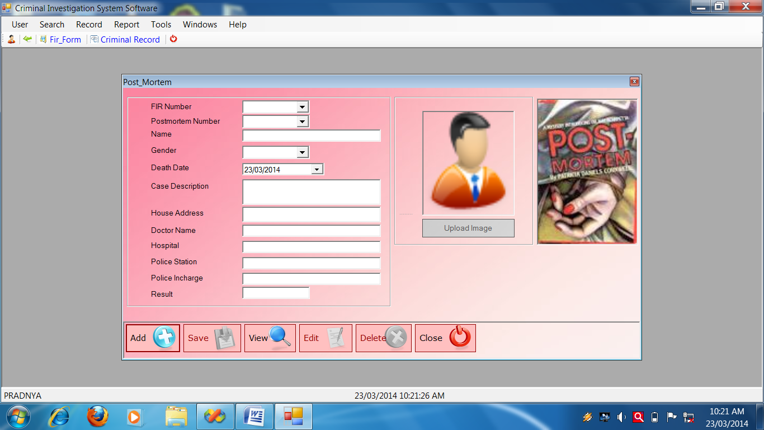

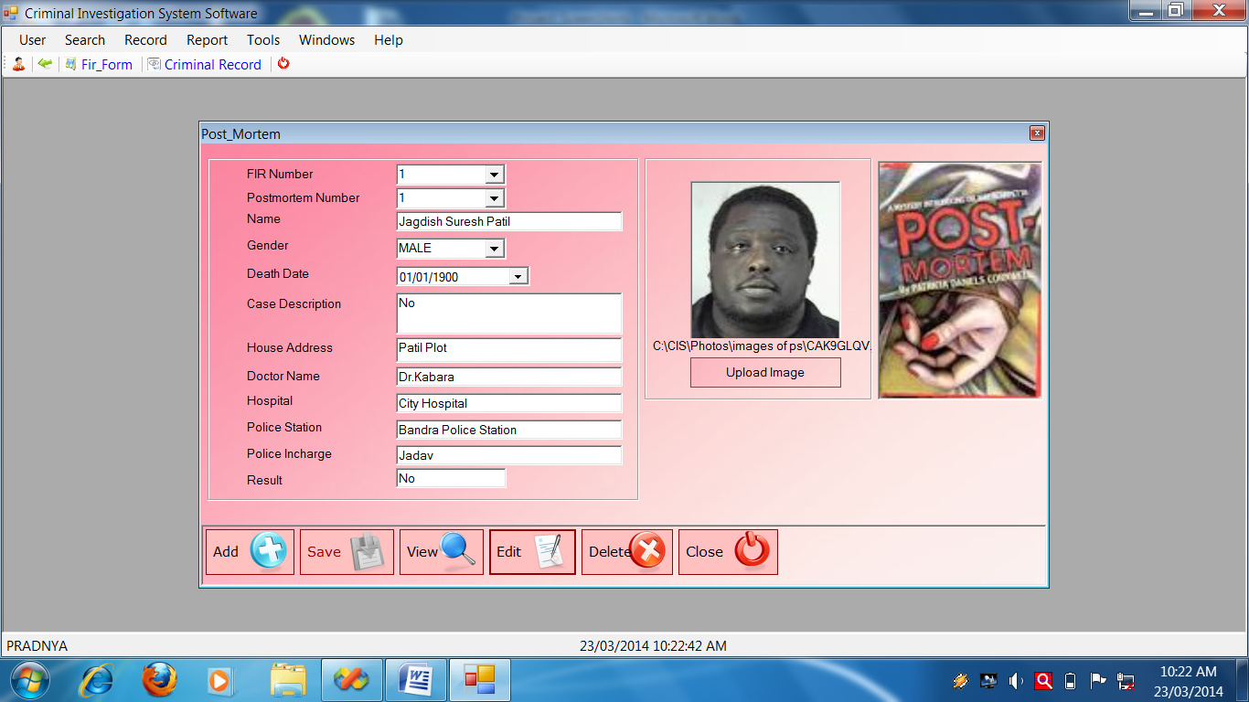

**Post Mortem Source Code**

Public Class Post_Mortem

Private Sub Post_Mortem_Load(ByVal sender As System.Object, ByVal e As System.EventArgs) Handles MyBase.Load

Call setmode("NoMode")

Call FillCombo(Me.cmbg, "LookUp_Field", "Gender", "Lookup_Value", "Lookup_Mst")

End Sub

Private Sub btnAdd_Click(ByVal sender As System.Object, ByVal e As System.EventArgs) Handles btnAdd.Click

Call setmode("AddMode")

Call clearall()

'Me.cmbfnm.ReadOnly = True

Me.cmbfnm.Text = GenerateNewId("Fir_no", "Postmortem_Mst")

End Sub

Private Sub btnSave_Click(ByVal sender As System.Object, ByVal e As System.EventArgs) Handles btnSave.Click

Call SavePost_Mortem()

End Sub

'***************************Save Post_Mostem**********************

Private Sub SavePost_Mortem()

Try

Call setmode("NoMode")

Call OpenDB()

Dim SqlString As String

SqlString = "INSERT INTO Postmortem_Mst(Fir_no,Post_no,Name,Gender,Death_dt,Case_desc,House_addr,Doctor_nm,Hospital,Police_st,Police_inch,Result,Photo_path)VALUES('" & Me.cmbfnm.Text & "','" & cmbpn.Text & "','" & txtn.Text.Trim & "','" & cmbg.Text & "'," & Me.dtpdd.Value.Date & ",'" & Me.txtcd.Text.Trim & "','" & txtha.Text.Trim & "','" & txtdn.Text.Trim & "','" & txth.Text & "','" & Me.txtps.Text.Trim & "','" & txtpi.Text.Trim & "','" & txtr.Text.Trim & "','" & PictureBox1.Text & "' );"

'MsgBox(SqlString)

Cmd = GetCmd(SqlString)

If Cmd.ExecuteNonQuery Then

MessageBox.Show("Record Save Successflly")

Else

MessageBox.Show("Fail To Save Record")

End If

CloseDB()

Catch ex As Exception

MessageBox.Show(ex.Message)

End Try

End Sub

'*************************************ViewPost_Mortem()***************

Private Sub ViewPost_Mortem()

Try

OpenDB()

Dim sqlString As String

sqlString = "SELECT * FROM Postmortem_Mst Where Fir_no='" & Me.cmbfnm.Text & "';"

Cmd = GetCmd(sqlString)

Dr = Cmd.ExecuteReader

Do While Dr.Read

With Me

.cmbfnm.Text = Dr.Item("Fir_no")

.cmbpn.Text = Dr.Item("Post_no")

.txtn.Text = Dr.Item("Name")

.cmbg.Text = Dr.Item("Gender")

.dtpdd.Value = Dr.Item("Death_dt")

.txtcd.Text = Dr.Item("Case_desc")

.txtha.Text = Dr.Item("House_addr")

.txtdn.Text = Dr.Item("Doctor_nm")

.txth.Text = Dr.Item("Hospital")

.txtps.Text = Dr.Item("Police_st")

.txtpi.Text = Dr.Item("Police_inch")

.txtr.Text = Dr.Item("Result")

.lblphotopath.Text = Dr.Item("Photo_Path")

.PictureBox1.Load(Me.lblphotopath.Text)

End With

Loop

CloseDB()

Catch ex As Exception

MessageBox.Show("VIEW Record:" + ex.Message)

End Try

End Sub

Private Sub btnView_Click(ByVal sender As System.Object, ByVal e As System.EventArgs) Handles btnView.Click

Me.cmbfnm.Focus()

' Me.cmbid.ReadOnly = False

Call FillCombo(Me.cmbfnm, "Fir_no", "Postmortem_Mst")

Call setmode("ViewMode")

End Sub

Private Sub cmbfnm_SelectedIndexChanged(ByVal sender As System.Object, ByVal e As System.EventArgs) Handles cmbfnm.SelectedIndexChanged

Call ViewPost_Mortem()

End Sub

'******************************EditPost_Mostem**********************

Private Sub EditPost_Mortem()

Try

OpenDB()

Dim sqlstring As String

sqlstring = "update Postmortem_Mst set Fir_no='" & Me.cmbfnm.Text & "',Post_no='" & Me.cmbpn.Text & "',Name='" & Me.txtn.Text & "',Gender='" & cmbg.Text & "',Death_dt=" & dtpdd.Value.Date & ",Case_desc='" & txtcd.Text & "',House_addr='" & txtha.Text & "',Doctor_nm='" & txtdn.Text & "',Hospital='" & txth.Text & "',Police_st='" & txtps.Text & "',Police_inch='" & txtpi.Text & "',Result='" & txtr.Text & "',Photo_path='" & Me.lblphotopath.Text & "' where Fir_no='" & Me.cmbfnm.Text & "';"

MsgBox(sqlstring)

Cmd = GetCmd(sqlstring)

If Cmd.ExecuteNonQuery Then

MessageBox.Show("Edited successfully")

Else

MessageBox.Show("faild to edit")

End If

CloseDB()

Catch ex As Exception

MessageBox.Show(ex.Message)

End Try

End Sub

'******************************Clearall Post_Mostem*******************

Private Sub clearall()

With Me

.cmbfnm.Text = ""

.cmbpn.Text = ""

.txtn.Text = ""

.cmbg.Text = ""

.dtpdd.Value = Today

.txtcd.Text = ""

.txtha.Text = ""

.txtdn.Text = ""

.txth.Text = ""

.txtps.Text = ""

.txtpi.Text = ""

.txtr.Text = ""

.PictureBox1.Text = ""

End With

End Sub

Private Sub btnEdit_Click(ByVal sender As System.Object, ByVal e As System.EventArgs) Handles btnEdit.Click

Call EditPost_Mortem()

End Sub

'******************************Delete Post_Mostem*****************

Private Sub DeletePost_Mortem()

Try

Call OpenDB()

Dim sqlString As String

sqlString = "DELETE FROM Postmortem_Mst WHERE Fir_no='" & Me.cmbfnm.Text & "';"

Cmd = GetCmd(sqlString)

If Cmd.ExecuteNonQuery Then

MessageBox.Show("Record deleted successfully")

Else

MessageBox.Show("Fail to delete")

End If

Call CloseDB()

Catch ex As Exception

End Try

End Sub

Private Sub btnDelete_Click(ByVal sender As System.Object, ByVal e As System.EventArgs) Handles btnDelete.Click

If MessageBox.Show("Are you sure?", "Delete?", MessageBoxButtons.YesNo, MessageBoxIcon.Question, MessageBoxDefaultButton.Button2) = Windows.Forms.DialogResult.Yes Then

Call DeletePost_Mortem()

End If

End Sub

Private Sub btnClose_Click(ByVal sender As System.Object, ByVal e As System.EventArgs) Handles btnClose.Click

Me.Close()

End Sub

'******************************Setmode Post_Mostem*****************

Private Sub setmode(ByVal strmode As String)

Select Case strmode

Case "NoMode"

With Me

.GroupBox1.Enabled = False

.btnAdd.Enabled = True

.btnSave.Enabled = False

.btnView.Enabled = True

.btnDelete.Enabled = False

.btnEdit.Enabled = False

End With

Case "AddMode"

With Me

.GroupBox1.Enabled = True

.btnAdd.Enabled = False

.btnSave.Enabled = True

.btnView.Enabled = True

.btnDelete.Enabled = False

.btnEdit.Enabled = False

End With

Case "ViewMode"

With Me

.GroupBox1.Enabled = True

.btnAdd.Enabled = True

.btnSave.Enabled = False

.btnView.Enabled = True

.btnDelete.Enabled = True

.btnEdit.Enabled = True

End With

End Select

End Sub

Private Sub btnui_Click(ByVal sender As System.Object, ByVal e As System.EventArgs) Handles btnui.Click

Try

Me.ofd.ShowDialog()

Me.lblphotopath.Text = Me.ofd.FileName

Me.PictureBox1.Load(Me.lblphotopath.Text)

Catch ex As Exception

MsgBox(ex.Message)

End Try

End Sub

Private Sub Timer1_Tick(ByVal sender As System.Object, ByVal e As System.EventArgs) Handles Timer1.Tick

If Me.Opacity > 0 Then

Me.Opacity = Me.Opacity - 0.1F

Else

Me.Timer1.Stop()

End If

End Sub

End Class

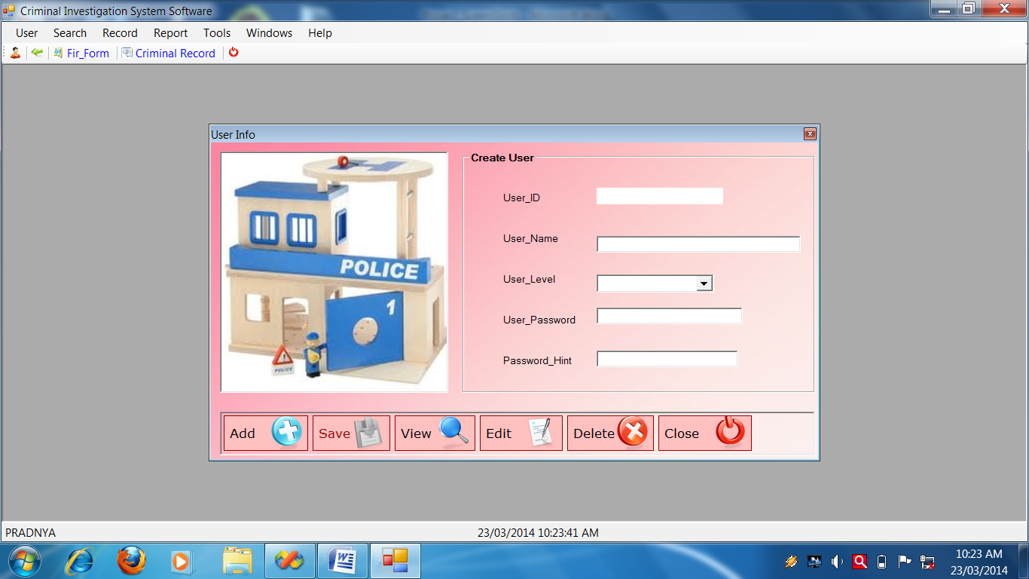**User Form**

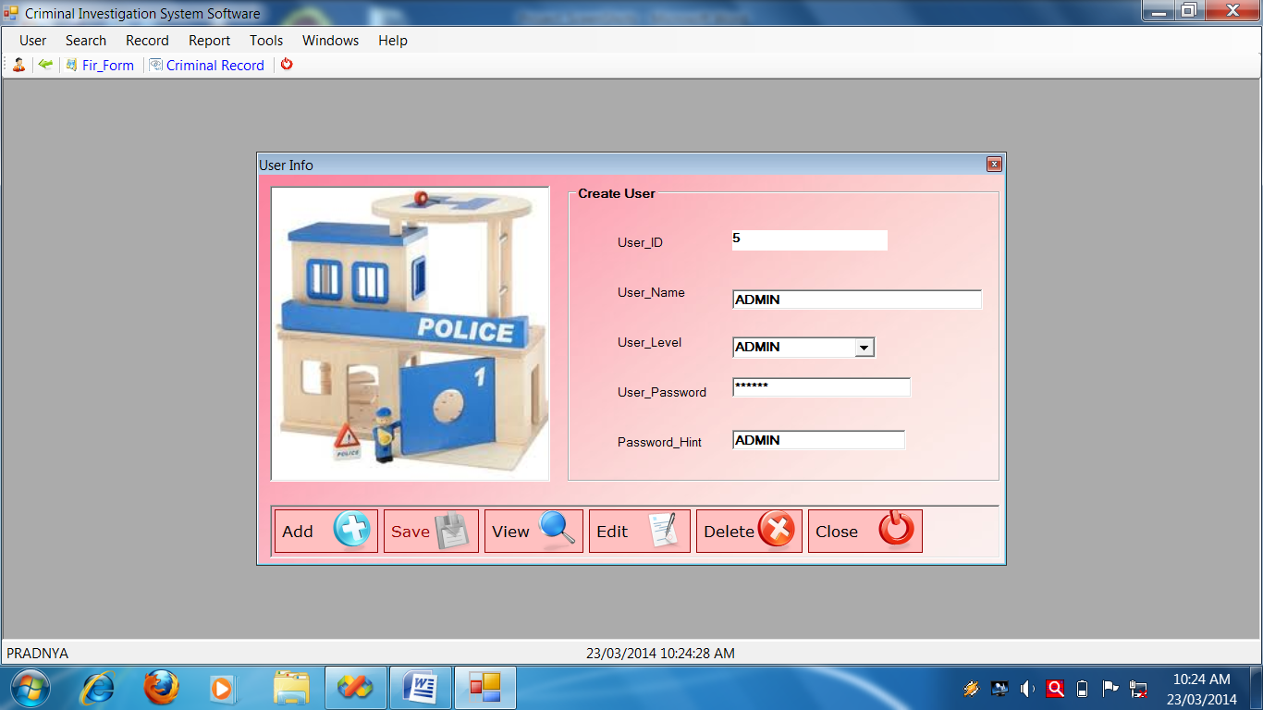

**User Form Source Code**

Public Class FrmUserInfo

Private Sub FrmUserInfo_KeyPress(ByVal sender As Object, ByVal e As System.Windows.Forms.KeyPressEventArgs) Handles Me.KeyPress

If Asc(e.KeyChar) = 13 Then

SendKeys.Send("{TAB}")

Else

e.KeyChar = MakeCapital(e.KeyChar)

End If

End Sub

Private Sub FrmUserInfo_Load(ByVal sender As System.Object, ByVal e As System.EventArgs) Handles MyBase.Load

Call setmode("NoMode")

End Sub

Private Sub btnAdd_Click(ByVal sender As System.Object, ByVal e As System.EventArgs) Handles btnAdd.Click

Call setmode("AddMode")

Call clearall()

Me.txtUser_ID.ReadOnly = True

Me.txtUser_ID.Text = GenerateNewId("User_ID", "User_Mst")

End Sub

Private Sub btnSave_Click(ByVal sender As System.Object, ByVal e As System.EventArgs) Handles btnSave.Click

Call SaveUserInfo()

End Sub

Private Sub SaveUserInfo()

Try

Call setmode("NoMode")

Call OpenDB()

Dim SqlString As String

SqlString = "INSERT INTO User_Mst(User_ID,User_Name,User_Level,User_Password,Password_Hint)VALUES(' " & txtUser_ID.Text.Trim & " ',' " & txtUser_Name.Text.Trim & " ','" & cmbUser_Level.Text.Trim & " ',' " & txtUser_Password.Text.Trim & " ','" & Me.txtPassword_Hint.Text & "' );"

'MsgBox(SqlString)

Cmd = GetCmd(SqlString)

If Cmd.ExecuteNonQuery Then

MessageBox.Show("Record Save Successflly")

Else

MessageBox.Show("Fail To Save Record")

End If

CloseDB()

Catch ex As Exception

MessageBox.Show(ex.Message)

End Try

End Sub

Private Sub btnView_Click(ByVal sender As System.Object, ByVal e As System.EventArgs) Handles btnView.Click

Call setmode("ViewMode")

Me.txtUser_ID.Focus()

Me.txtUser_ID.ReadOnly = False

End Sub

Private Sub ViewUserinfo()

Try

OpenDB()

Dim sqlString As String

sqlString = "SELECT * FROM User_Mst Where USER_ID='" & Me.txtUser_ID.Text.Trim & "';"

Cmd = GetCmd(sqlString)

Dr = Cmd.ExecuteReader

Do While Dr.Read

With Me

.txtUser_ID.Text = Dr.Item("User_ID")

.txtUser_Name.Text = Dr.Item("User_Name")

.cmbUser_Level.Text = Dr.Item("User_Level")

.txtUser_Password.Text = Dr.Item("User_Password")

.txtPassword_Hint.Text = Dr.Item("Password_Hint")

End With

Loop

CloseDB()

Catch ex As Exception

MessageBox.Show("VIEW Record:" + ex.Message)

End Try

End Sub

Private Sub btnEdit_Click(ByVal sender As System.Object, ByVal e As System.EventArgs) Handles btnEdit.Click

Call EditUserInfo()

End Sub

Private Sub DeleteUserinfo()

Try

Call OpenDB()

Dim sqlString As String

sqlString = "DELETE FROM USER_Mst WHERE USER_ID='" & Me.txtUser_ID.Text & "';"

Cmd = GetCmd(sqlString)

If Cmd.ExecuteNonQuery Then

MessageBox.Show("Record deleted successfully")

Else

MessageBox.Show("Fail to delete")

End If

Call CloseDB()

Catch ex As Exception

End Try

End Sub

Private Sub btnDelete_Click(ByVal sender As System.Object, ByVal e As System.EventArgs) Handles btnDelete.Click

If MessageBox.Show("Are you sure?", "Delete?", MessageBoxButtons.YesNo, MessageBoxIcon.Question, MessageBoxDefaultButton.Button2) = Windows.Forms.DialogResult.Yes Then

Call DeleteUserinfo()

End If

End Sub

Private Sub btnClose_Click(ByVal sender As System.Object, ByVal e As System.EventArgs) Handles btnClose.Click

Me.Close()

End Sub

Private Sub CloseUserInfo()

Try

OpenDB()

Dim sqlstring As String

sqlstring = "close from User_Mst where User_ID='" & txtUser_ID.Text & " ' ; "

Cmd = GetCmd(sqlstring)

If Cmd.ExecuteNonQuery Then

MessageBox.Show("fail to close")

End If

CloseDB()

Catch ex As Exception

MessageBox.Show(ex.Message)

End Try

End Sub

Private Sub EditUserInfo()

Try

OpenDB()

Dim sqlstring As String

sqlstring = "update user_Mst set User_Name='" & Me.txtUser_Name.Text & "',User_Level='" & Me.cmbUser_Level.Text & "',User_Password=' " & Me.txtUser_Password.Text & "' where User_ID='" & Me.txtUser_ID.Text.Trim & "';"

MsgBox(sqlstring)

Cmd = GetCmd(sqlstring)

If Cmd.ExecuteNonQuery Then

MessageBox.Show("Edited successfully")

Else

MessageBox.Show("faild to edit")

End If

CloseDB()

Catch ex As Exception

MessageBox.Show(ex.Message)

End Try

End Sub

Private Sub clearall()

With Me

.txtUser_ID.Text = ""

.txtUser_Name.Text = ""

.cmbUser_Level.Text = ""

.txtUser_Password.Text = ""

.txtPassword_Hint.Text = ""

End With

End Sub

Private Sub setmode(ByVal strmode As String)

Select Case strmode

Case "NoMode"

With Me

.GroupBox1.Enabled = False

.btnAdd.Enabled = True

.btnSave.Enabled = False

.btnView.Enabled = True

.btnDelete.Enabled = False

.btnEdit.Enabled = False

End With

Case "AddMode"

With Me

.GroupBox1.Enabled = True

.btnAdd.Enabled = False

.btnSave.Enabled = True

.btnView.Enabled = True

.btnDelete.Enabled = False

.btnEdit.Enabled = False

End With

Case "ViewMode"

With Me

.GroupBox1.Enabled = True

.btnAdd.Enabled = True

.btnSave.Enabled = False

.btnView.Enabled = True

.btnDelete.Enabled = True

.btnEdit.Enabled = True

End With

End Select

End Sub

Private Sub cmbUser_ID_SelectedIndexChanged(ByVal sender As System.Object, ByVal e As System.EventArgs)

Call ViewUserinfo()

End Sub

Private Sub txtUser_ID_TextChanged(ByVal sender As System.Object, ByVal e As System.EventArgs) Handles txtUser_ID.TextChanged

Call ViewUserinfo()

End Sub

Private Sub txtUser_Name_Validating(ByVal sender As Object, ByVal e As System.ComponentModel.CancelEventArgs) Handles txtUser_Name.Validating

If IsDuplicate("User_Mst", "User_Name", Me.txtUser_Name.Text) Then

MessageBox.Show(" Duplicated Name!", "Error", MessageBoxButtons.OK, MessageBoxIcon.Error)

lblmessage.Text = "User Name Is Already Exist!!"

Me.txtUser_Name.Text = ""

e.Cancel = True

ElseIf Me.txtUser_Name.Text = "" Then

e.Cancel = True

Else

lblmessage.Text = ""

e.Cancel = False

End If

If Me.txtUser_Name.Text = "" Then

ep.SetError(Me.txtUser_Name, "This Field Is Compalsary Filled !!!!")

Else

ep.SetError(Me.txtUser_Name, "")

End If

End Sub

End Class

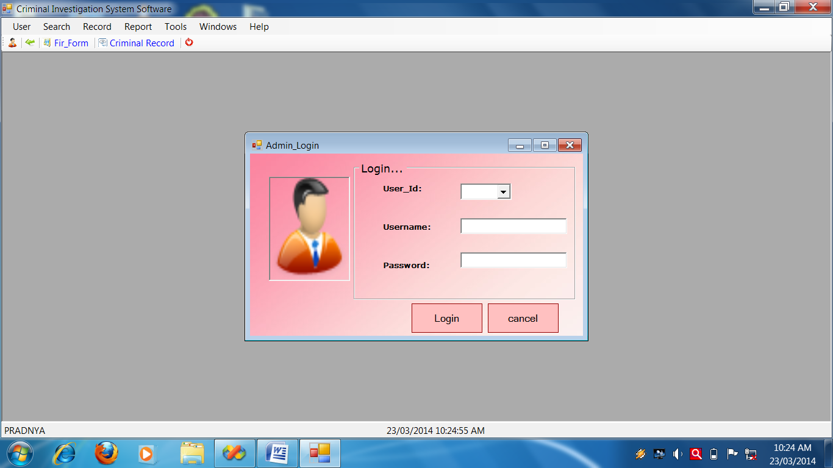**Admin Form**

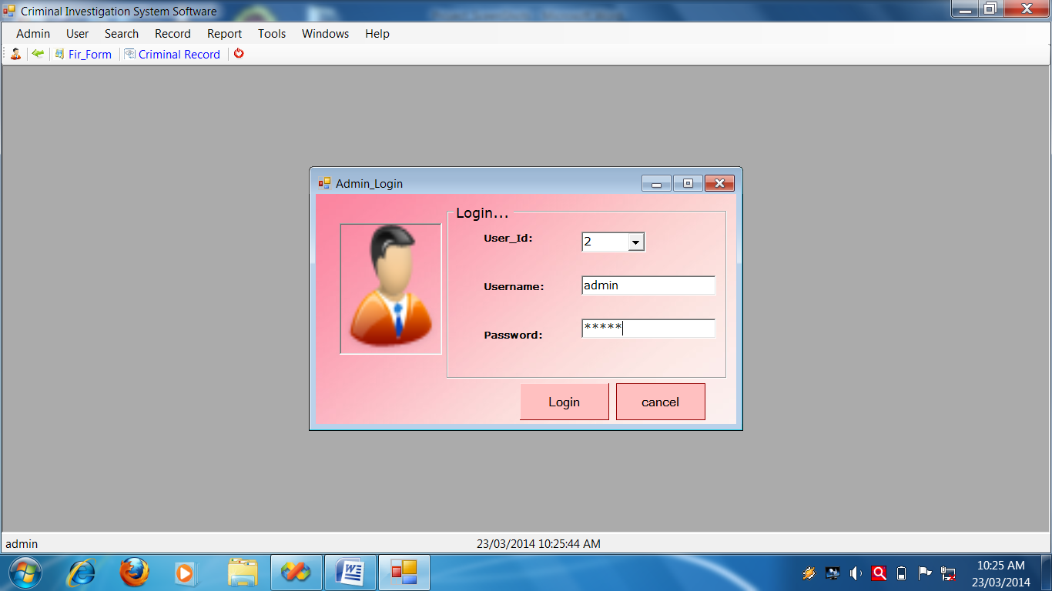

**Admin Form Source Code**

Public Class AdminForm

Private Sub btnAdd_Click(ByVal sender As System.Object, ByVal e As System.EventArgs) Handles btnAdd.Click

Call setmode("AddMode")

Call clearall()

'Me.cmbsn.ReadOnly = True

Me.cmbId.Text = GenerateNewId("Id", "Admin_Mst")

End Sub

*****************************************************************

Private Sub setmode(ByVal strmode As String)

Select Case strmode

Case "NoMode"

With Me

.GroupBox1.Enabled = False

.btnAdd.Enabled = True

.btnSave.Enabled = False

.btnView.Enabled = True

.btnDelete.Enabled = False

.btnEdit.Enabled = False

End With

Case "AddMode"

With Me

.GroupBox1.Enabled = True

.btnAdd.Enabled = False

.btnSave.Enabled = True

.btnView.Enabled = True

.btnDelete.Enabled = False

.btnEdit.Enabled = False

End With

Case "ViewMode"

With Me

.GroupBox1.Enabled = True

.btnAdd.Enabled = True

.btnSave.Enabled = False

.btnView.Enabled = True

.btnDelete.Enabled = True

.btnEdit.Enabled = True

End With

End Select

End Sub

*********************************************************************

Private Sub DeleteAdminform()

Try

Call OpenDB()

Dim sqlString As String

sqlString = "DELETE FROM Admin_Mst WHERE SL_no='" & Me.cmbId.Text & "';"

Cmd = GetCmd(sqlString)

If Cmd.ExecuteNonQuery Then

MessageBox.Show("Record deleted successfully")

Else

MessageBox.Show("Fail to delete")

End If

Call CloseDB()

Catch ex As Exception

End Try

End Sub

******************************************************************

Private Sub SaveAdminform()

Try

Call setmode("NoMode")

Call OpenDB()

Dim SqlString As String

SqlString = "INSERT INTO Admin_Mst(Id,Name,Password)VALUES('" & cmbId.Text & "','" & txtName.Text.Trim & "','" & txtPassword.Text.Trim & "');"

'MsgBox(SqlString)

Cmd = GetCmd(SqlString)

If Cmd.ExecuteNonQuery Then

MessageBox.Show("Record Save Successflly")

Else

MessageBox.Show("Fail To Save Record")

End If

CloseDB()

Catch ex As Exception

MessageBox.Show(ex.Message)

End Try

End Sub

***************************************************************

Private Sub ViewAdminform()

Try

OpenDB()

Dim sqlString As String

sqlString = "SELECT * FROM Admin_Mst Where Id='" & Me.cmbId.Text & "';"

Cmd = GetCmd(sqlString)

Dr = Cmd.ExecuteReader

Do While Dr.Read

With Me

.txtName.Text = Dr.Item("Name")

.txtPassword.Text = Dr.Item("Password")

End With

Loop

CloseDB()

Catch ex As Exception

MessageBox.Show("VIEW Record:" + ex.Message)

End Try

End Sub

*************************************************************

Private Sub EditAdminform()

Try

OpenDB()

Dim sqlstring As String

sqlstring = "update Admin_Mst set Name='" & Me.txtName.Text & "',Password='" & Me.txtPassword.Text & "' where Id='" & Me.cmbId.Text & "';"

MsgBox(sqlstring)

Cmd = GetCmd(sqlstring)

If Cmd.ExecuteNonQuery Then

MessageBox.Show("Edited successfully")

Else

MessageBox.Show("faild to edit")

End If

CloseDB()

Catch ex As Exception

MessageBox.Show(ex.Message)

End Try

End Sub

Private Sub clearall()

With Me

.cmbId.Text = ""

.txtName.Text = ""

.txtPassword.Text = ""

End With

End Sub

*****************************************************************

Private Sub btnSave_Click(ByVal sender As System.Object, ByVal e As System.EventArgs) Handles btnSave.Click

Call SaveAdminform()

End Sub

******************************************************************

Private Sub btnView_Click(ByVal sender As System.Object, ByVal e As System.EventArgs) Handles btnView.Click

Call setmode("ViewMode")

Me.cmbId.Focus()

'Call FillCombo(Me.cmbsn, "SL_no", "Admin_Mst")

'Me.cmbsn.ReadOnly = False

End Sub

*****************************************************************

Private Sub btnEdit_Click(ByVal sender As System.Object, ByVal e As System.EventArgs) Handles btnEdit.Click

Call EditAdminform()

End Sub

***************************************************************

Private Sub btnDelete_Click(ByVal sender As System.Object, ByVal e As System.EventArgs) Handles btnDelete.Click

If MessageBox.Show("Are you sure?", "Delete?", MessageBoxButtons.YesNo, MessageBoxIcon.Question, MessageBoxDefaultButton.Button2) = Windows.Forms.DialogResult.Yes Then

Call DeleteAdminform()

End If

End Sub

.*******************************************************************

Private Sub btnClose_Click(ByVal sender As System.Object, ByVal e As System.EventArgs) Handles btnClose.Click

Me.Close()

End Sub

**********************************************************************

Private Sub cmbsn_SelectedIndexChanged(ByVal sender As System.Object, ByVal e As System.EventArgs) Handles cmbId.SelectedIndexChanged

Call FillCombo(Me.cmbId, "SL_no", "Admin_Mst")

End Sub

End Class

Admin Menu come When

Admin Login

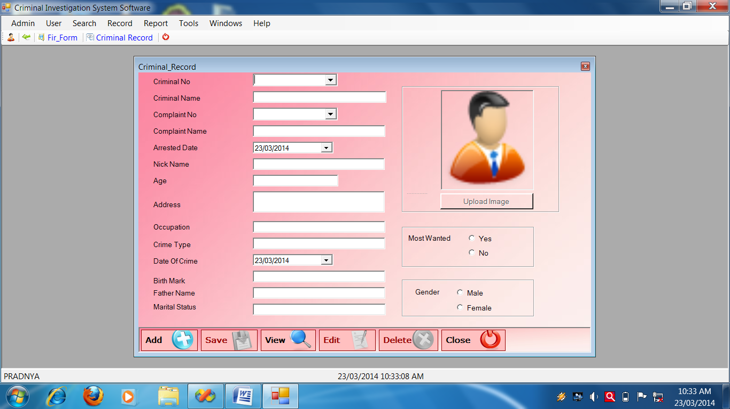**Criminal Record Form**

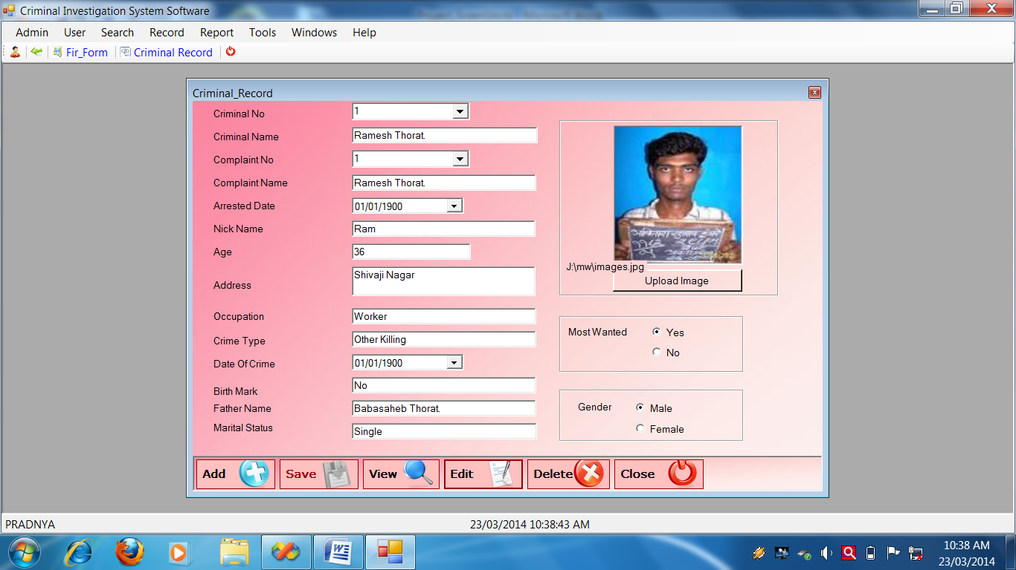

**Criminal Record Source Code**

Public Class Criminal_Record

Private Sub Criminal_Record_KeyPress(ByVal sender As Object, ByVal e As System.Windows.Forms.KeyPressEventArgs) Handles Me.KeyPress

If Asc(e.KeyChar) = 13 Then

SendKeys.Send("{TAB}")

End If

End Sub

'***********************************************************************

Private Sub Criminal_Record_Load(ByVal sender As System.Object, ByVal e As System.EventArgs) Handles MyBase.Load

Call setmode("NoMode")

End Sub

'**********************************************************************

Private Sub btnAdd_Click(ByVal sender As System.Object, ByVal e As System.EventArgs) Handles btnAdd.Click

Call setmode("AddMode")

Call clearall()

'Me.cmbn.ReadOnly = True

Me.cmbcn.Text = GenerateNewId("Crime_no", "Criminal_Mst")

End Sub

'******************************************SaveCriminal_Record()**********

Private Sub SaveCriminal_Record()

Try

Call setmode("NoMode")

Call OpenDB()

Dim SqlString As String

Dim gen As String

If Me.rdof.Checked = True Then

gen = "Female"

Else

gen = "Male"

End If

Dim mw As String

If Me.rdoy.Checked = True Then

mw = "Yes"

Else

mw = "No"

End If

SqlString = "INSERT INTO Criminal_Mst(Crime_no,Crime_nm,Comp_no,Comp_nm,Arr_date,Ni_nm,Age,Addr,Occupation,Crime_type,Dt_Crime,Birth_mk,Father_nm,Marital_st,Photo_path,Most_want,Gender)VALUES('" & cmbcn.Text & "','" & txtc.Text & "','" & cmbcompno.Text & "','" & txtcmpn.Text.Trim & "'," & dtpad.Value.Date & ",'" & Me.txtnn.Text & "','" & txtage.Text.Trim & "','" & txta.Text.Trim & "','" & txto.Text.Trim & "','" & txtct.Text.Trim & "' ," & dtpdoc.Value.Date & ",'" & txtbm.Text.Trim & "','" & txtfn.Text.Trim & "','" & txtms.Text.Trim & "','" & Me.lblPhotoPath.Text & "','" & mw & "','" & gen & "');"

MsgBox(SqlString)

Cmd = GetCmd(SqlString)

If Cmd.ExecuteNonQuery Then

MessageBox.Show("Record Save Successflly")

Else

MessageBox.Show("Fail To Save Record")

End If

CloseDB()

Catch ex As Exception

MessageBox.Show(ex.Message)

End Try

End Sub

'***********************************************************************

Private Sub btnSave_Click(ByVal sender As System.Object, ByVal e As System.EventArgs) Handles btnSave.Click

Call SaveCriminal_Record()

End Sub

'**********************View Criminal_Record**********************

Private Sub ViewCriminal_Record()

Try

OpenDB()

Dim sqlString As String

sqlString = "SELECT * FROM Criminal_Mst Where Crime_no='" & Me.cmbcn.Text & "';"

Cmd = GetCmd(sqlString)

Dr = Cmd.ExecuteReader

Do While Dr.Read

With Me

.cmbcn.Text = Dr.Item("Crime_no")

.txtc.Text = Dr.Item("Crime_nm")

.cmbcompno.Text = Dr.Item("Comp_no")

.txtcmpn.Text = Dr.Item("Comp_nm")

.dtpad.Value = Dr.Item("Arr_date")

.txtnn.Text = Dr.Item("Ni_nm")

.txtage.Text = Dr.Item("Age")

.txta.Text = Dr.Item("Addr")

.txto.Text = Dr.Item("Occupation")

.txtct.Text = Dr.Item("Crime_type")

.dtpdoc.Value = Dr.Item("Dt_crime")

.txtbm.Text = Dr.Item("Birth_mk")

.txtfn.Text = Dr.Item("Father_nm")

.txtms.Text = Dr.Item("Marital_st")

'.txtpop.Text = Dr.Item("Fir_Mst1_pp")

.lblPhotoPath.Text = Dr.Item("Photo_Path")

.PictureBox1.Load(.lblPhotoPath.Text)

Dim mw As String = Dr.Item("Most_want")

If mw = "Yes" Then

Me.rdoy.Checked = True

Else

Me.rdon.Checked = True

End If

Dim gen As String = Dr.Item("Gender")

' MsgBox(gen)

If gen = "Female" Then

Me.rdof.Checked = True

Else

Me.rdom.Checked = True

End If

End With

Loop

CloseDB()

Catch ex As Exception

MessageBox.Show("VIEW Record_Mst:" + ex.Message)

End Try

End Sub

'*******************************EditCriminal_Record****************

Private Sub EditCriminal_Record()

Try

OpenDB()

Dim sqlstring As String

Dim Most_want As String = ""

If Me.rdoy.Checked = True Then

Most_want = "Yes"

Else

Most_want = "No"

End If

Dim Gen As String

If Me.rdom.Checked = True Then

Gen = "Male"

Else

Gen = "Female"

End If

sqlstring = "UPDATE Criminal_Mst set Crime_no='" & Me.cmbcn.Text & "', Crime_nm='" & txtc.Text & "',Comp_no='" & Me.cmbcompno.Text & "',Comp_nm= '" & Me.txtcmpn.Text & "' ,Arr_date= " & dtpad.Value.Date & ",Ni_nm='" & txtnn.Text & "',Age='" & txtage.Text & "',Addr='" & txta.Text & "',Occupation='" & txto.Text & "',Crime_type='" & txtct.Text & "',Dt_crime=" & dtpdoc.Value.Date & ",Birth_mk='" & txtbm.Text & "',Father_nm='" & txtfn.Text & "',Marital_st='" & txtms.Text & "',Photo_Path='" & Me.lblPhotoPath.Text & "',Most_Want='" & Most_want & "',Gender='" & Gen & "' where Crime_no='" & Me.cmbcn.Text & "';"

MsgBox(sqlstring)

Cmd = GetCmd(sqlstring)

If Cmd.ExecuteNonQuery Then

MessageBox.Show("Edited successfully")

Else

MessageBox.Show("faild to edit")

End If

CloseDB()

Catch ex As Exception

MessageBox.Show(ex.Message)

End Try

End Sub

'***************** 'To clear all for Criminal_Record**************************

Private Sub clearall()

With Me

.cmbcn.Text = ""

.txtc.Text = ""

.cmbcompno.Text = ""

.txtcmpn.Text = ""

.dtpad.Value = Today

.txtnn.Text = ""

.txtage.Text = ""

.txta.Text = ""

.txto.Text = ""

.txtct.Text = ""

.dtpdoc.Value = Today

.txtbm.Text = ""

.txtfn.Text = ""

.txtms.Text = ""

End With

End Sub

'*********************Delete method********************************

Private Sub DeleteCriminal_Record()

Try

Call OpenDB()

Dim sqlString As String

sqlString = "DELETE FROM Criminal_Mst WHERE Crime_no='" & Me.cmbcn.Text & "';"

Cmd = GetCmd(sqlString)

If Cmd.ExecuteNonQuery Then

MessageBox.Show("Record deleted successfully")

Else

MessageBox.Show("Fail to delete")

End If

Call CloseDB()

Catch ex As Exception

End Try

End Sub

'******************************************************************

Private Sub cmbcn_SelectedIndexChanged(ByVal sender As System.Object, ByVal e As System.EventArgs) Handles cmbcn.SelectedIndexChanged

Call ViewCriminal_Record()

End Sub

'***********************************************************************

Private Sub btnEdit_Click(ByVal sender As System.Object, ByVal e As System.EventArgs) Handles btnEdit.Click

Call EditCriminal_Record()

End Sub

'**********************************************************************

Private Sub btnDelete_Click(ByVal sender As System.Object, ByVal e As System.EventArgs) Handles btnDelete.Click

If MessageBox.Show("Are you sure?", "Delete?", MessageBoxButtons.YesNo, MessageBoxIcon.Question, MessageBoxDefaultButton.Button2) = Windows.Forms.DialogResult.Yes Then

Call DeleteCriminal_Record()

End If

End Sub

'**********************************************************************

Private Sub btnClose_Click(ByVal sender As System.Object, ByVal e As System.EventArgs) Handles btnClose.Click

Me.Close()

End Sub

'****************************************************************

Private Sub setmode(ByVal strmode As String)

Select Case strmode

Case "NoMode"

With Me

.GroupBox1.Enabled = False

.btnAdd.Enabled = True

.btnSave.Enabled = False

.btnView.Enabled = True

.btnDelete.Enabled = False

.btnEdit.Enabled = False

End With

Case "AddMode"

With Me

.GroupBox1.Enabled = True

.btnAdd.Enabled = False

.btnSave.Enabled = True

.btnView.Enabled = True

.btnDelete.Enabled = False

.btnEdit.Enabled = False

End With

Case "ViewMode"

With Me

.GroupBox1.Enabled = True

.btnAdd.Enabled = True

.btnSave.Enabled = False

.btnView.Enabled = True

.btnDelete.Enabled = True

.btnEdit.Enabled = True

End With

End Select

End Sub

'********************************************************************

Private Sub Button1_Click(ByVal sender As System.Object, ByVal e As System.EventArgs) Handles Button1.Click

Me.Ofd.ShowDialog()

Me.lblPhotoPath.Text = Me.Ofd.FileName

Me.PictureBox1.Load(Me.lblPhotoPath.Text)

End Sub

'********************************************************************

Private Sub btnView_Click(ByVal sender As System.Object, ByVal e As System.EventArgs) Handles btnView.Click

Call FillCombo(Me.cmbcn, "Crime_No", "Criminal_Mst")

Call setmode("ViewMode")

End Sub

End Class

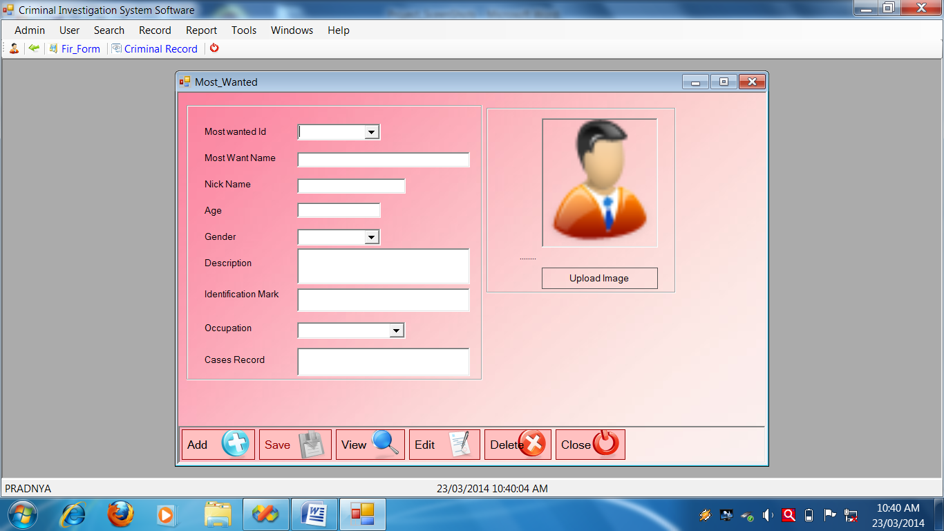**Most Wanted Form**

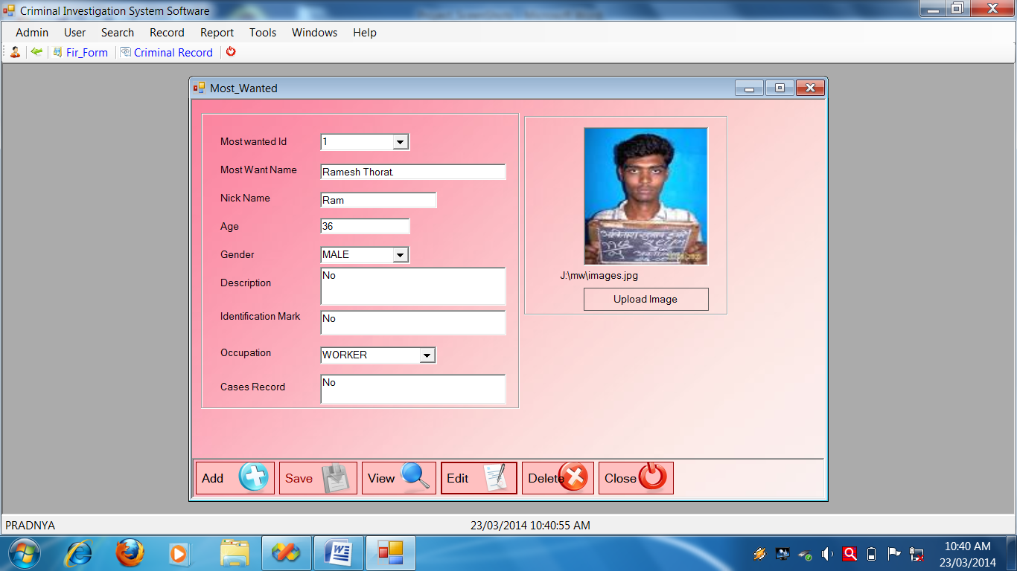

**Most Wanted Form Source Code**

Public Class Most_Wanted

Private Sub Most_Wanted_KeyPress(ByVal sender As Object, ByVal e As System.Windows.Forms.KeyPressEventArgs) Handles Me.KeyPress

If Asc(e.KeyChar) = 13 Then

SendKeys.Send("{TAB}")

End If

End Sub

'**********************************************************************

Private Sub Most_Wanted_Load(ByVal sender As System.Object, ByVal e As System.EventArgs) Handles MyBase.Load

Call setmode("NoMode")

Call FillCombo(Me.cmbg, "LookUp_Field", "GENDER", "Lookup_Value", "Lookup_Mst")

Call FillCombo(Me.cmbo, "LookUp_Field", "OCCUPATION", "Lookup_Value", "Lookup_Mst")

End Sub

'**********************************************************************

Private Sub btnadd_Click(ByVal sender As System.Object, ByVal e As System.EventArgs) Handles btnadd.Click

Call setmode("AddMode")

Call clearall()

' Me.txtUser_ID.ReadOnly = True

Me.cmbid.Text = GenerateNewId("MW_id", "Mostwanted_Mst")

End Sub

Private Sub SaveMost_Wanted()

Try

Call setmode("NoMode")

Call OpenDB()

Dim SqlString As String

SqlString = "INSERT INTO Mostwanted_Mst(MW_id,MW_nm,Nick_nm,Age,Gender,Description,Id_mark,Occupation,Cases_record,photo) VALUES ('" & cmbid.Text & "','" & txtn.Text.Trim & "','" & txtnn.Text.Trim & "','" & txta.Text.Trim & "','" & Me.cmbg.Text & "','" & txtd.Text.Trim & "','" & txtim.Text.Trim & "','" & cmbo.Text.Trim & "','" & txtcr.Text.Trim & "','" & lblphotopath.Text & "');"

'MsgBox(SqlString)

Cmd = GetCmd(SqlString)

If Cmd.ExecuteNonQuery Then

MessageBox.Show("Record Save Successflly")

Else

MessageBox.Show("Fail To Save Record")

End If

CloseDB()

Catch ex As Exception

MessageBox.Show(ex.Message)

End Try

End Sub

'**********************************************************************

Private Sub btnsave_Click(ByVal sender As System.Object, ByVal e As System.EventArgs) Handles btnsave.Click

Call SaveMost_Wanted()

End Sub

'**********************************************************************

Private Sub ViewMost_Wanted()

Try

OpenDB()

Dim sqlString As String

sqlString = "SELECT * FROM Mostwanted_Mst Where MW_id='" & Me.cmbid.Text & "';"

Cmd = GetCmd(sqlString)

Dr = Cmd.ExecuteReader

Do While Dr.Read

With Me

.cmbid.Text = Dr.Item("MW_id")

.txtn.Text = Dr.Item("MW_nm")

.txtnn.Text = Dr.Item("Nick_nm")

.txta.Text = Dr.Item("Age")

.cmbg.Text = Dr.Item("Gender")

.txtd.Text = Dr.Item("Description")

.txtim.Text = Dr.Item("Id_mark")

.cmbo.Text = Dr.Item("Occupation")

.txtcr.Text = Dr.Item("Cases_record")

.lblphotopath.Text = Dr.Item("Photo")

.PictureBox1.Load(.lblphotopath.Text)

End With

Loop

CloseDB()

Catch ex As Exception

MessageBox.Show("VIEW Record:" + ex.Message)

End Try

End Sub

'**********************************************************************

Private Sub btnview_Click(ByVal sender As System.Object, ByVal e As System.EventArgs) Handles btnview.Click

Call setmode("ViewMode")

Me.cmbid.Focus()

' Me.cmbid.ReadOnly = False

Call FillCombo(Me.cmbid, "MW_id", "Mostwanted_Mst")

End Sub

'********************************************************************* Private Sub EditMost_Wanted()

Try

OpenDB()

Dim sqlstring As String

sqlstring = "update Mostwanted_Mst SET MW_nm= '" & Me.txtn.Text & "',Nick_nm='" & Me.txtnn.Text & "',Age='" & Me.txta.Text & "',Gender= '" & cmbg.Text & "',Description= '" & txtd.Text & "',Id_mark= '" & txtim.Text & "',Occupation= '" & cmbo.Text & "',Cases_record= '" & txtcr.Text & "',Photo= '" & lblphotopath.Text & "' where MW_id='" & Me.cmbid.Text & "';"

MsgBox(sqlstring)

Cmd = GetCmd(sqlstring)

If Cmd.ExecuteNonQuery Then

MessageBox.Show("Edited successfully")

Else

MessageBox.Show("faild to edit")

End If

CloseDB()

Catch ex As Exception

MessageBox.Show(ex.Message)

End Try

End Sub

'**********************************************************************

Private Sub clearall()

With Me

.cmbid.Text = ""

.txtn.Text = ""

.txtnn.Text = ""

.txta.Text = ""

.cmbg.Text = ""

.txtd.Text = ""

.txtim.Text = ""

.cmbo.Text = ""

.txtcr.Text = ""

.lblphotopath.Text = ""

End With

End Sub

'*******************************************************************

Private Sub btnedit_Click(ByVal sender As System.Object, ByVal e As System.EventArgs) Handles btnedit.Click

Call EditMost_Wanted()

End Sub

'**********************************************************************

Private Sub DeleteMost_Wanted()

Try

Call OpenDB()

Dim sqlString As String

sqlString = "DELETE FROM Mostwanted_Mst WHERE MW_id='" & Me.cmbid.Text & "';"

Cmd = GetCmd(sqlString)

If Cmd.ExecuteNonQuery Then

MessageBox.Show("Record deleted successfully")

Else

MessageBox.Show("Fail to delete")

End If

Call CloseDB()

Catch ex As Exception

End Try

End Sub

'**********************************************************************

Private Sub btndelete_Click(ByVal sender As System.Object, ByVal e As System.EventArgs) Handles btndelete.Click

If MessageBox.Show("Are you sure?", "Delete?", MessageBoxButtons.YesNo, MessageBoxIcon.Question, MessageBoxDefaultButton.Button2) = Windows.Forms.DialogResult.Yes Then

Call DeleteMost_Wanted()

End If

End Sub

'********************************************************************** Private Sub btnclose_Click(ByVal sender As System.Object, ByVal e As System.EventArgs) Handles btnclose.Click

Me.Close()

End Sub

Private Sub setmode(ByVal strmode As String)

Select Case strmode

Case "NoMode"

With Me

.GroupBox1.Enabled = False

.btnadd.Enabled = True

.btnsave.Enabled = False

.btnview.Enabled = True

.btndelete.Enabled = False

.btnedit.Enabled = False

End With

Case "AddMode"

With Me

.GroupBox1.Enabled = True

.btnadd.Enabled = False

.btnsave.Enabled = True

.btnview.Enabled = True

.btndelete.Enabled = False

.btnedit.Enabled = False

End With

Case "ViewMode"

With Me

.GroupBox1.Enabled = True

.btnadd.Enabled = True

.btnsave.Enabled = False

.btnview.Enabled = True

.btndelete.Enabled = True

.btnedit.Enabled = True

End With

End Select

End Sub

'**********************************************************************

Private Sub cmbid_SelectedIndexChanged(ByVal sender As System.Object, ByVal e As System.EventArgs) Handles cmbid.SelectedIndexChanged

Call ViewMost_Wanted()

End Sub

'**********************************************************************

Private Sub btnuploadimage_Click(ByVal sender As System.Object, ByVal e As System.EventArgs) Handles btnuploadimage.Click

Me.ofd.ShowDialog()

Me.lblphotopath.Text = Me.ofd.FileName

Me.PictureBox1.Load(Me.lblphotopath.Text)

End Sub

End Class

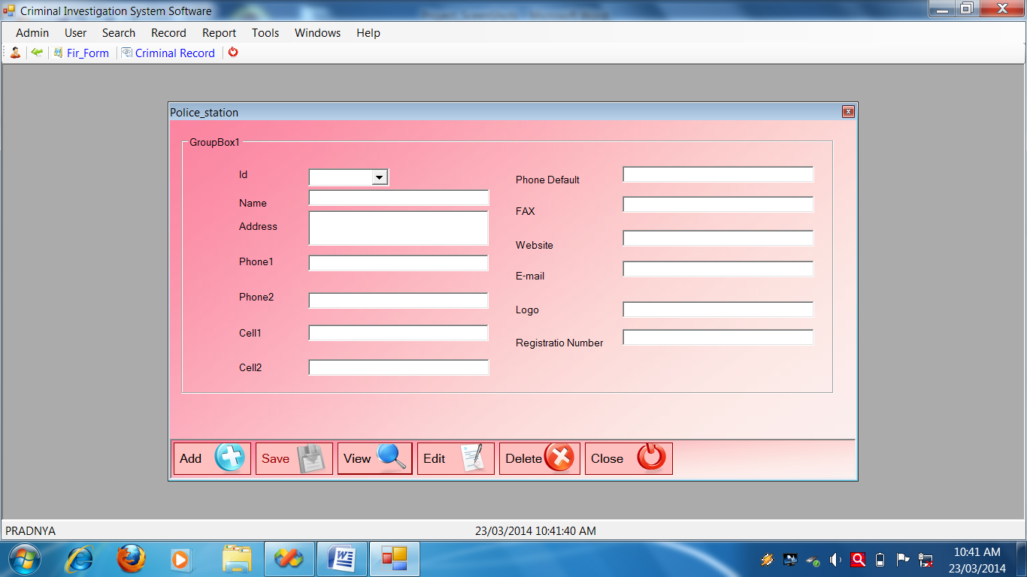**Police Station Form**

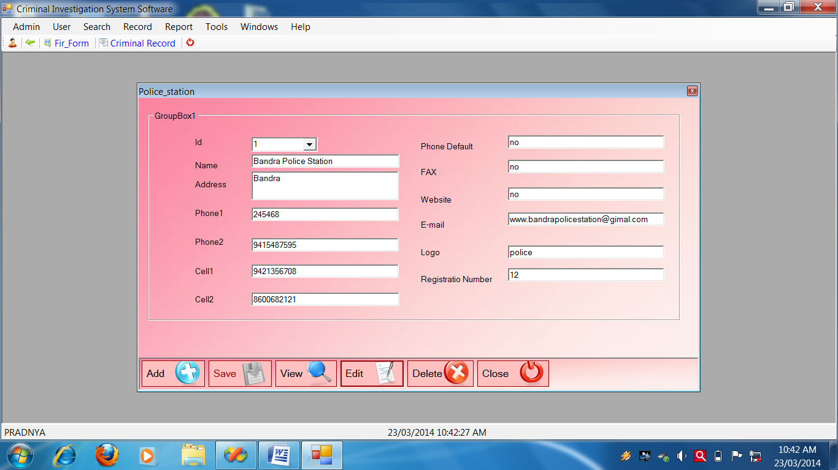

**Police Station Form Source Code**

Public Class Police_station

Private Sub Police_station_KeyPress(ByVal sender As Object, ByVal e As System.Windows.Forms.KeyPressEventArgs) Handles Me.KeyPress

If Asc(e.KeyChar) = 13 Then

SendKeys.Send("{TAB}")

End If

End Sub

'**********************************************************************

Private Sub Police_station_Load(ByVal sender As System.Object, ByVal e As System.EventArgs) Handles MyBase.Load

Call setmode("NoMode")

End Sub

'**********************************************************************

Private Sub btnAdd_Click(ByVal sender As System.Object, ByVal e As System.EventArgs) Handles btnAdd.Click

Call setmode("AddMode")

Call clearall()

'Me.cmbn.ReadOnly = True

Me.cmbid.Text = GenerateNewId("Ps_id", "Ps_Mst")

End Sub

'************************SavePolice_ station Record()*******************

Private Sub SavePolice_station()

Try

Call setmode("NoMode")

Call OpenDB()

Dim SqlString As String

SqlString = "INSERT INTO Ps_Mst(Ps_id,Ps_name,Ps_address,Ps_phone1,Ps_phone2,Ps_cell1,Ps_cell2,Ps_phdefault,Ps_Fax,Ps_Website,Ps_email,Ps_logo,Ps_registrationNo)VALUES('" & cmbid.Text & "','" & txtn.Text & "','" & txtaddr.Text.Trim & "','" & txtp1.Text.Trim & "','" & Me.txtp2.Text.Trim & "','" & txtc1.Text.Trim & "','" & txtc2.Text.Trim & "','" & txtphd.Text.Trim & "','" & txtf.Text.Trim & "' ,'" & txtw.Text.Trim & "','" & txte.Text.Trim & "','" & txtl.Text.Trim & "','" & txtreg.Text.Trim & "');"

MsgBox(SqlString)

Cmd = GetCmd(SqlString)

If Cmd.ExecuteNonQuery Then

MessageBox.Show("Record Save Successflly")

Else

MessageBox.Show("Fail To Save Record")

End If

CloseDB()

Catch ex As Exception

MessageBox.Show(ex.Message)

End Try

End Sub

'*********************************************************************

Private Sub btnSave_Click(ByVal sender As System.Object, ByVal e As System.EventArgs) Handles btnSave.Click

Call SavePolice_station()

End Sub

'**********************View Police_station**********************

Private Sub ViewPolice_station()

Try

OpenDB()

Dim sqlString As String

sqlString = "SELECT * FROM Ps_Mst Where Ps_id='" & Me.cmbid.Text & "';"

Cmd = GetCmd(sqlString)

Dr = Cmd.ExecuteReader

Do While Dr.Read

With Me

.cmbid.Text = Dr.Item("Ps_id")

.txtn.Text = Dr.Item("Ps_name")

.txtaddr.Text = Dr.Item("Ps_address")

.txtp1.Text = Dr.Item("Ps_phone1")

.txtp2.Text = Dr.Item("Ps_phone2")

.txtc1.Text = Dr.Item("Ps_cell1")

.txtc2.Text = Dr.Item("Ps_cell2")

.txtphd.Text = Dr.Item("Ps_phdefault")

.txtf.Text = Dr.Item("Ps_fax")

.txtw.Text = Dr.Item("Ps_website")

.txte.Text = Dr.Item("Ps_email")

.txtl.Text = Dr.Item("Ps_logo")

.txtreg.Text = Dr.Item("Ps_registrationNo")

End With

Loop

CloseDB()

Catch ex As Exception

MessageBox.Show("VIEW Record_Mst:" + ex.Message)

End Try

End Sub

'**********************************************************************

Private Sub btnView_Click(ByVal sender As System.Object, ByVal e As System.EventArgs) Handles btnView.Click

Call FillCombo(Me.cmbid, "Ps_id", "Ps_Mst")

Call setmode("ViewMode")

End Sub

'*******************************EditPolice_station****************

Private Sub EditPolice_station()

Try

OpenDB()

sqlString = "UPDATE Ps_Mst set Ps_id='" & Me.cmbid.Text & "',Ps_name='" & Me.txtn.Text & "',Ps_address= '" & Me.txtaddr.Text & "',Ps_phone1='" & txtp1.Text.Trim & "', Ps_phone2='" & txtp2.Text & "',Ps_cell1='" & txtc1.Text & "',Ps_cell2='" & txtc2.Text & "',Ps_phdefault='" & txtphd.Text & "',Ps_fax='" & txtf.Text & "',Ps_website='" & txtw.Text & "',Ps_email='" & txte.Text & "',Ps_logo='" & txtl.Text.Trim & "',Ps_registrationNo='" & txtreg.Text.Trim & "' where Ps_id='" & Me.cmbid.Text & "';"

MsgBox(sqlString)

Cmd = GetCmd(sqlString)

If Cmd.ExecuteNonQuery Then

MessageBox.Show("Edited successfully")

Else

MessageBox.Show("faild to edit")

End If

CloseDB()

Catch ex As Exception

MessageBox.Show(ex.Message)

End Try

End Sub

'**********************************************************************

Private Sub clearall()

With Me

.cmbid.Text = ""

.txtn.Text = ""

.txtaddr.Text = ""

.txtp1.Text = ""

.txtp2.Text = ""

.txtc1.Text = ""

.txtc2.Text = ""

.txtphd.Text = ""

.txtf.Text = ""

.txtw.Text = ""

.txte.Text = ""

.txtl.Text = ""

.txtreg.Text = ""

End With

End Sub

'**********************************************************************

Private Sub btnEdit_Click(ByVal sender As System.Object, ByVal e As System.EventArgs) Handles btnEdit.Click

Call EditPolice_station()

End Sub

'*********************************************************************

Private Sub DeletePolice_station()

Try

Call OpenDB()

Dim sqlString As String

sqlString = "DELETE FROM Ps_Mst WHERE Ps_id='" & Me.cmbid.Text & "';"

Cmd = GetCmd(sqlString)

If Cmd.ExecuteNonQuery Then

MessageBox.Show("Record deleted successfully")

Else

MessageBox.Show("Fail to delete")

End If

Call CloseDB()

Catch ex As Exception

End Try

End Sub

'**********************************************************************

Private Sub btnDelete_Click(ByVal sender As System.Object, ByVal e As System.EventArgs) Handles btnDelete.Click

If MessageBox.Show("Are you sure?", "Delete?", MessageBoxButtons.YesNo, MessageBoxIcon.Question, MessageBoxDefaultButton.Button2) = Windows.Forms.DialogResult.Yes Then

Call DeletePolice_station()

End If

End Sub

'**********************************************************************

Private Sub btnClose_Click(ByVal sender As System.Object, ByVal e As System.EventArgs) Handles btnClose.Click

Me.Close()

End Sub

'**********************************************************************

Private Sub setmode(ByVal strmode As String)

Select Case strmode

Case "NoMode"

With Me

.GroupBox1.Enabled = False

.btnAdd.Enabled = True

.btnSave.Enabled = False

.btnView.Enabled = True

.btnDelete.Enabled = False

.btnEdit.Enabled = False

End With

Case "AddMode"

With Me

.GroupBox1.Enabled = True

.btnAdd.Enabled = False

.btnSave.Enabled = True

.btnView.Enabled = True

.btnDelete.Enabled = False

.btnEdit.Enabled = False

End With

Case "ViewMode"

With Me

.GroupBox1.Enabled = True

.btnAdd.Enabled = True

.btnSave.Enabled = False

.btnView.Enabled = True

.btnDelete.Enabled = True

.btnEdit.Enabled = True

End With

End Select

End Sub

'*********************************************************************

Private Sub cmbid_SelectedIndexChanged(ByVal sender As System.Object, ByVal e As System.EventArgs) Handles cmbid.SelectedIndexChanged

Call ViewPolice_station()

End Sub

End Class

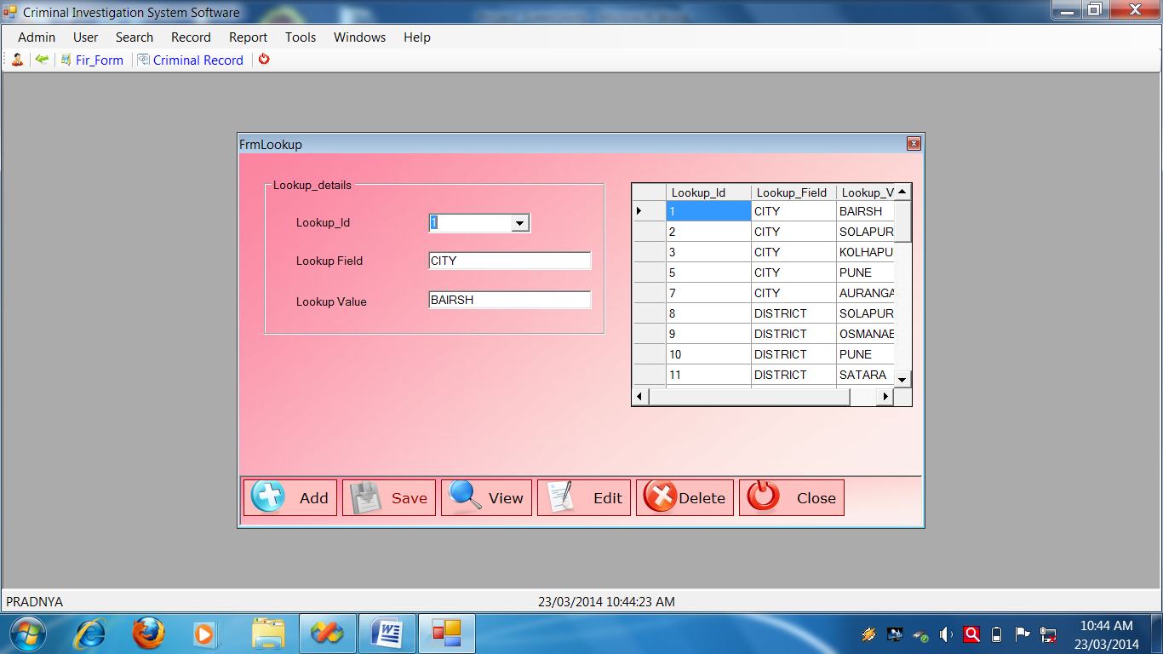**Lookup Form**

**Lookup Form Source Code**

Public Class Lookup_Info

Private Sub Lookup_Info_KeyPress(ByVal sender As Object, ByVal e As System.Windows.Forms.KeyPressEventArgs) Handles Me.KeyPress

If Asc(e.KeyChar) = 13 Then

SendKeys.Send("{TAB}")

Else

e.KeyChar = MakeCapital(e.KeyChar)

End If

End Sub

'**********************************************************************

Private Sub FrmLookup_Load(ByVal sender As System.Object, ByVal e As System.EventArgs) Handles MyBase.Load

Call setmode("NoMode")

End Sub

'*********************************************************************

Private Sub btnAdd_Click(ByVal sender As System.Object, ByVal e As System.EventArgs) Handles btnAdd.Click

Call setmode("AddMode")

Call clearall()

'Me.cmbid.ReadOnly = True

Me.cmbid.Text = GenerateNewId("Lookup_Id", "Lookup_Mst")

End Sub

'**********************************************************************

Private Sub btnSave_Click(ByVal sender As System.Object, ByVal e As System.EventArgs) Handles btnSave.Click

Call SaveLookup_Info()

End Sub

'*********************************************************************

Private Sub SaveLookup_Info()

Try

Call setmode("NoMode")

Call OpenDB()

Dim SqlString As String

SqlString = "INSERT INTO Lookup_Mst( Lookup_Id,Lookup_Field,Lookup_Value)VALUES('" & cmbid.Text & "','" & txtlf.Text.Trim & "','" & txtlv.Text.Trim & "' );"

'MsgBox(SqlString)

Cmd = GetCmd(SqlString)

If Cmd.ExecuteNonQuery Then

MessageBox.Show("Record Save Successflly")

Else

MessageBox.Show("Fail To Save Record")

End If

CloseDB()

Catch ex As Exception

MessageBox.Show(ex.Message)

End Try

End Sub

'**********************************************************************

Private Sub btnView_Click(ByVal sender As System.Object, ByVal e As System.EventArgs) Handles btnView.Click

Call setmode("ViewMode")

Me.cmbid.Focus()

' Me.cmbid.ReadOnly = False

Call FillCombo(Me.cmbid, "Lookup_Id", "Lookup_Mst")

Me.cmbid.Visible = False

Me.cmbid.Visible = True

Call FillGrid("Lookup_Mst", Me.Dgv, "SELECT * FROM Lookup_Mst;")

End Sub

'**********************************************************************

Private Sub ViewLookup_Info()

Try

OpenDB()

Dim sqlString As String

sqlString = "SELECT * FROM Lookup_Mst Where Lookup_Id='" & Me.cmbid.Text & "';"

Cmd = GetCmd(sqlString)

Dr = Cmd.ExecuteReader

Do While Dr.Read

With Me

.cmbid.Text = Dr.Item("Lookup_Id")

.txtlf.Text = Dr.Item("Lookup_Field")

.txtlv.Text = Dr.Item("Lookup_Value")

End With

Loop

CloseDB()

Catch ex As Exception

MessageBox.Show("VIEW Record:" + ex.Message)

End Try

End Sub

'**********************************************************************

Private Sub btnEdit_Click(ByVal sender As System.Object, ByVal e As System.EventArgs) Handles btnEdit.Click

Call EditLookup_Info()

End Sub

'**********************************************************************

Private Sub DeleteLookup_Info()

Try

Call OpenDB()

Dim sqlString As String

sqlString = "DELETE FROM Lookup_Mst WHERE Lookup_Id='" & Me.cmbid.Text & "';"

Cmd = GetCmd(sqlString)

If Cmd.ExecuteNonQuery Then

MessageBox.Show("Record deleted successfully")

Else

MessageBox.Show("Fail to delete")

End If

Call CloseDB()

Catch ex As Exception

End Try

End Sub

'**********************************************************************

Private Sub btnDelete_Click(ByVal sender As System.Object, ByVal e As System.EventArgs) Handles btnDelete.Click

If MessageBox.Show("Are you sure?", "Delete?", MessageBoxButtons.YesNo, MessageBoxIcon.Question, MessageBoxDefaultButton.Button2) = Windows.Forms.DialogResult.Yes Then

Call DeleteLookup_Info()

End If

End Sub

'********************************************************************

Private Sub btnClose_Click(ByVal sender As System.Object, ByVal e As System.EventArgs) Handles btnClose.Click

Me.Close()

End Sub

'**********************************************************************

Private Sub CloseLookup_Info()

Try

OpenDB()

Dim sqlstring As String

sqlstring = "close from Lookup_Mst where Lookup_Id='" & cmbid.Text & " ' ; "

Cmd = GetCmd(sqlstring)

If Cmd.ExecuteNonQuery Then

MessageBox.Show("fail to close")

End If

CloseDB()

Catch ex As Exception

MessageBox.Show(ex.Message)

End Try

End Sub

'**********************************************************************

Private Sub EditLookup_Info()

Try

OpenDB()

Dim sqlstring As String

sqlstring = "update Lookup_Mst set Lookup_Id='" & Me.cmbid.Text & "',Lookup_Field='" & Me.txtlf.Text & "',Lookup_Value='" & Me.txtlv.Text & "' where Lookup_Field='" & Me.txtlf.Text.Trim & "';"

MsgBox(sqlstring)

Cmd = GetCmd(sqlstring)

If Cmd.ExecuteNonQuery Then

MessageBox.Show("Edited successfully")

Else

MessageBox.Show("faild to edit")

End If

CloseDB()

Catch ex As Exception

MessageBox.Show(ex.Message)

End Try

End Sub

'**********************************************************************

Private Sub clearall()

With Me

' .cmbid.Text = ""

' .txtlf.Text = ""

.txtlv.Text = ""

End With

End Sub

'**********************************************************************

Private Sub setmode(ByVal strmode As String)

Select Case strmode

Case "NoMode"

With Me

.GroupBox1.Enabled = False

.btnAdd.Enabled = True

.btnSave.Enabled = False

.btnView.Enabled = True

.btnDelete.Enabled = False

.btnEdit.Enabled = False

End With

Case "AddMode"

With Me

.GroupBox1.Enabled = True

.btnAdd.Enabled = False

.btnSave.Enabled = True

.btnView.Enabled = True

.btnDelete.Enabled = False

.btnEdit.Enabled = False

End With

Case "ViewMode"

With Me

.GroupBox1.Enabled = True

.btnAdd.Enabled = True

.btnSave.Enabled = False

.btnView.Enabled = True

.btnDelete.Enabled = True

.btnEdit.Enabled = True

End With

End Select

End Sub

'**********************************************************************

Private Sub cmbid_SelectedIndexChanged(ByVal sender As System.Object, ByVal e As System.EventArgs) Handles cmbid.SelectedIndexChanged

Call ViewLookup_Info()

End Sub

'**********************************************************************

Private Sub txtlf_KeyPress(ByVal sender As Object, ByVal e As System.Windows.Forms.KeyPressEventArgs) Handles txtlf.KeyPress

If Asc(e.KeyChar) = 13 Then

SendKeys.Send("{TAB}")

Else

e.KeyChar = MakeCapital(e.KeyChar)

End If

End Sub

End Class

**Search Form**

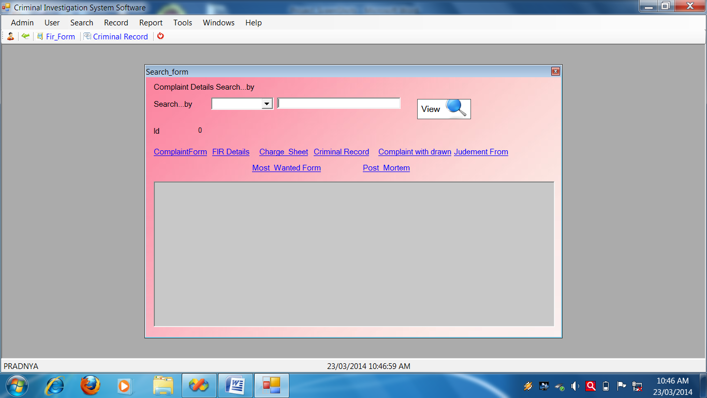

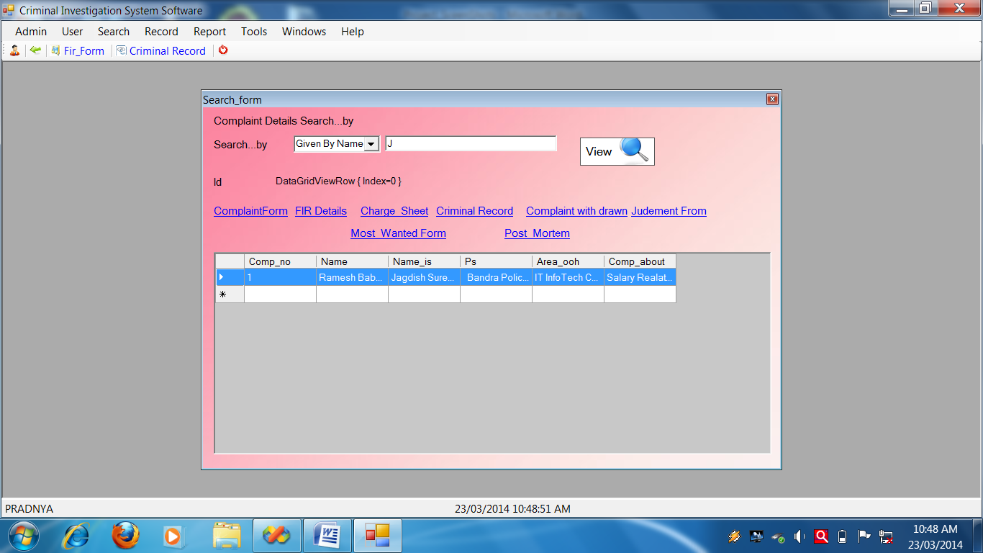

**Search Form Source Code**

Public Class Search_form

Private Sub LinkLabel1_LinkClicked(ByVal sender As System.Object, ByVal e As System.Windows.Forms.LinkLabelLinkClickedEventArgs) Handles LinkLabel1.LinkClicked

Complaint_Form.Show()

End Sub

Private Sub btnview_Click(ByVal sender As System.Object, ByVal e As System.EventArgs) Handles btnview.Click

Dim strSql As String

Select Case Me.cmbSearchBy.Text

Case "Given On Name"

strSql = "SELECT Comp_no,Name,Name_is,Ps,Area_ooh,Comp_about FROM Complaint_Mst Where [Name] like '" & Me.txtsearch.Text & "%';"

Call FillGrid("Complaint_Mst", Me.DataGridView1, strSql)

Case "Given By Name"

strSql = "SELECT Comp_no,Name,Name_is,Ps,Area_ooh,Comp_about FROM Complaint_Mst Where Name_is like '" & Me.txtsearch.Text & "%';"

Call FillGrid("Complaint_Mst", Me.DataGridView1, strSql)

Case "District"

strSql = "SELECT Ch_no,Ps_name,Dist,Acc_name,Witi_name FROM Charge_Sheet Where Dist like '" & Me.txtsearch.Text & "%';"

Call FillGrid("Charge_Sheet", Me.DataGridView1, strSql)

Case "Police Station"

strSql = "SELECT Comp_no,Name,Name_is,Ps,Area_ooh,Comp_about FROM Complaint_Mst Where Ps like '" & Me.txtsearch.Text & "%';"

Call FillGrid("Complaint_Mst", Me.DataGridView1, strSql)

Case "Crime Type"

strSql = "SELECT Crime_no,Crime_nm,Crime_type,Arr_date FROM Criminal_Mst Where Crime_type like '" & Me.txtsearch.Text & "%';"

Call FillGrid("Criminal_Mst", Me.DataGridView1, strSql)

Case "Section"

strSql = "SELECT Fir_Mst2_id,Fir_Mst2_act,Fir_Mst2_type,Fir_Mst2_dist,Fir_Mst2_ps FROM FIR_Mst2 Where Fir_Mst2_act like '" & Me.txtsearch.Text & "%';"

Call FillGrid("FIR_Mst2", Me.DataGridView1, strSql)

End Select

End Sub

Private Sub LinkLabel6_LinkClicked(ByVal sender As System.Object, ByVal e As System.Windows.Forms.LinkLabelLinkClickedEventArgs) Handles LinkLabel6.LinkClicked

FIR_Details.Show()

End Sub

Private Sub LinkLabel2_LinkClicked(ByVal sender As System.Object, ByVal e As System.Windows.Forms.LinkLabelLinkClickedEventArgs) Handles LinkLabel2.LinkClicked

Charge_Sheet.Show()

End Sub

Private Sub LinkLabel3_LinkClicked(ByVal sender As System.Object, ByVal e As System.Windows.Forms.LinkLabelLinkClickedEventArgs) Handles LinkLabel3.LinkClicked

Criminal_Record.Show()

End Sub

Private Sub LinkLabel4_LinkClicked(ByVal sender As System.Object, ByVal e As System.Windows.Forms.LinkLabelLinkClickedEventArgs) Handles LinkLabel4.LinkClicked

Complaint_with_drawn.Show()

End Sub

Private Sub LinkLabel5_LinkClicked(ByVal sender As System.Object, ByVal e As System.Windows.Forms.LinkLabelLinkClickedEventArgs) Handles LinkLabel5.LinkClicked

Judgement_Details.Show()

End Sub

Private Sub LinkLabel7_LinkClicked(ByVal sender As System.Object, ByVal e As System.Windows.Forms.LinkLabelLinkClickedEventArgs) Handles LinkLabel7.LinkClicked

Most_Wanted.Show()

End Sub

Private Sub LinkLabel8_LinkClicked(ByVal sender As System.Object, ByVal e As System.Windows.Forms.LinkLabelLinkClickedEventArgs) Handles LinkLabel8.LinkClicked

Post_Mortem.Show()

End Sub

Private Sub DataGridView1_CellContentClick(ByVal sender As System.Object, ByVal e As System.Windows.Forms.DataGridViewCellEventArgs) Handles DataGridView1.CellContentClick

Me.lblId.Text = Me.DataGridView1.SelectedRows(0).ToString

End Sub

End Class

**FIR Report**

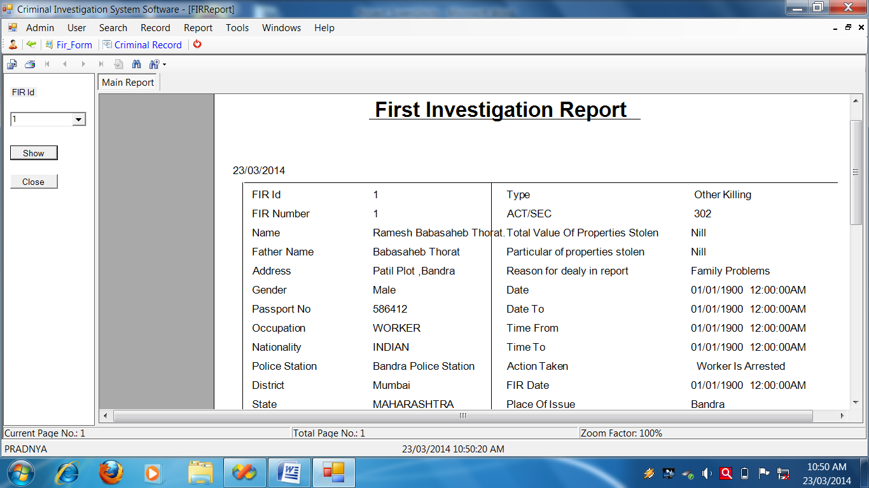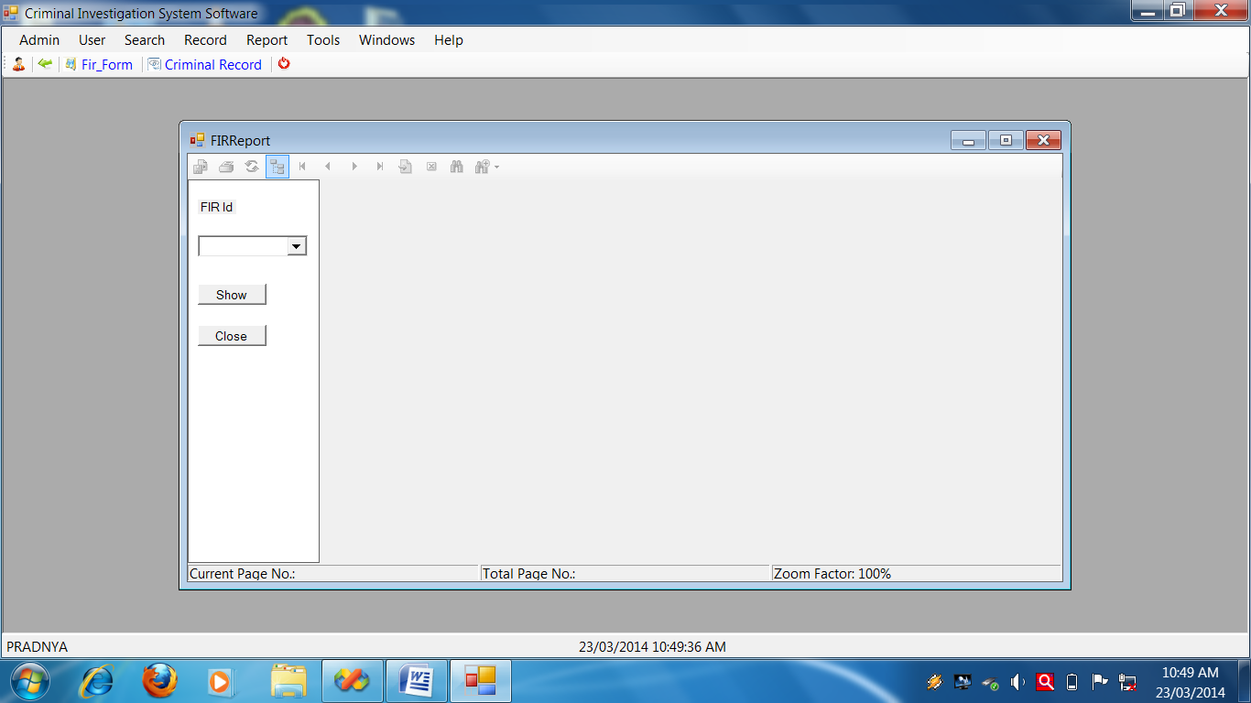

**FIR Report Source Code**

Public Class FIRReport

Public Function ShowFIR(ByVal strFIRId As String)

Try

OpenDB()

Dim SqlString = "SELECT * From View_Fir_Mst where Fir_Mst1_Id='" & cmbfirid.Text & "';"

Cmd = GetCmd(SqlString)

Dim ds As New DataSet

Da = New SqlClient.SqlDataAdapter(Cmd)

Da.Fill(ds, "View_Fir_Mst")

Dim rpt As New RptFir

rpt.Load("C:\CIS\CIS\RptFir.rpt")

rpt.SetDataSource(ds.Tables("View_Fir_Mst"))

Me.CrystalReportViewer1.ShowRefreshButton = False

Me.CrystalReportViewer1.ShowCloseButton = False

Me.CrystalReportViewer1.ShowGroupTreeButton = False

Me.CrystalReportViewer1.ReportSource = rpt

Catch ex As Exception

MessageBox.Show(ex.Message, "Report Error", MessageBoxButtons.OK, MessageBoxIcon.Error)

End Try

Return (0)

End Function

Private Sub btnclose_Click(ByVal sender As System.Object, ByVal e As System.EventArgs) Handles btnclose.Click

Me.Close()

End Sub

Private Sub FIRReport_Load(ByVal sender As Object, ByVal e As System.EventArgs) Handles Me.Load

Call FillCombo(Me.cmbfirid, "Fir_Mst1_Id", "View_Fir_Mst")

End Sub

Private Sub btnShow_Click(ByVal sender As System.Object, ByVal e As System.EventArgs) Handles btnShow.Click

Call ShowFIR(Me.cmbfirid.Text)

End Sub

End Class

**Criminal Report**

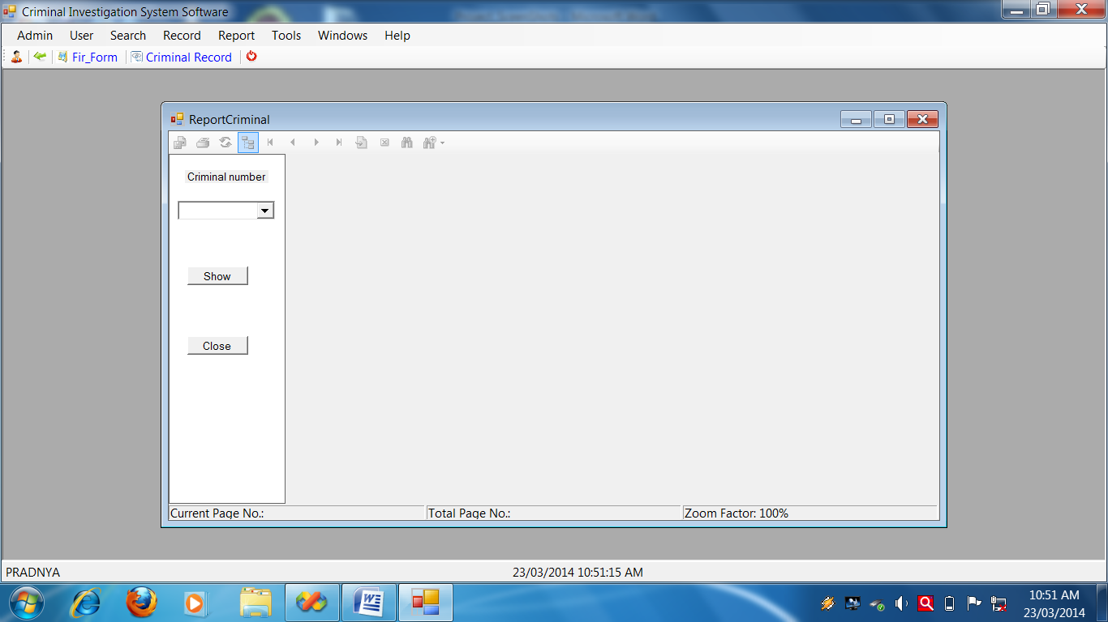

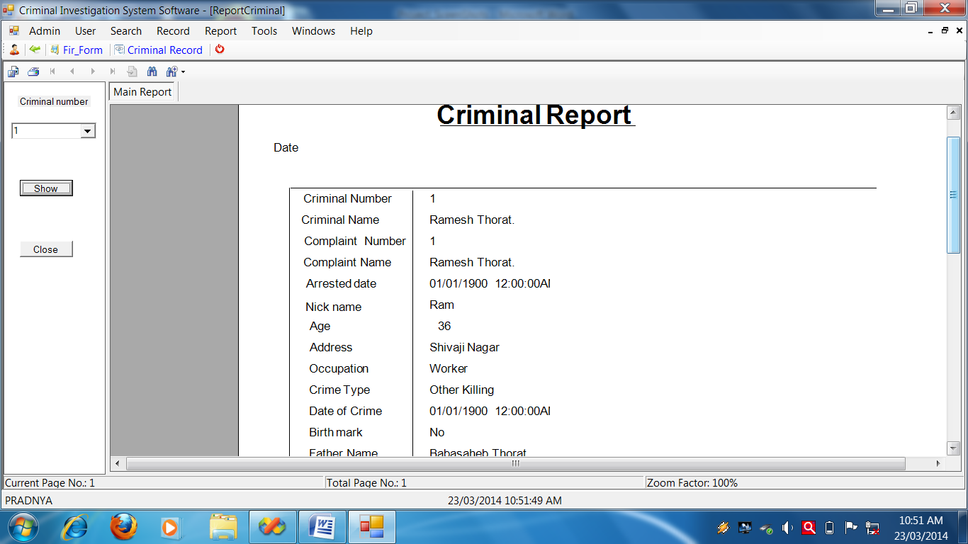

**Criminal Report Source Code**

Public Class ReportCriminal

Public Function ShowReportCriminal(ByVal strno As String)

Try

OpenDB()

Dim SqlString = "SELECT * From Criminal_Mst where Crime_no = '" & Me.cmbcn.Text & "';"

Cmd = GetCmd(SqlString)

Dim ds As New DataSet

Da = New SqlClient.SqlDataAdapter(Cmd)

Da.Fill(ds, "Criminal_Mst")

Dim rpt As New Criminal

rpt.Load("C:\CIS\CIS\Criminl.rpt")

rpt.SetDataSource(ds.Tables("Criminal_Mst"))

Me.CrystalReportViewer1.ShowRefreshButton = False

Me.CrystalReportViewer1.ShowCloseButton = False

Me.CrystalReportViewer1.ShowGroupTreeButton = False

Me.CrystalReportViewer1.ReportSource = rpt

Catch ex As Exception

MessageBox.Show(ex.Message, "Report Error", MessageBoxButtons.OK, MessageBoxIcon.Error)

End Try

Return (0)

End Function

Private Sub btnclose_Click(ByVal sender As System.Object, ByVal e As System.EventArgs) Handles btnclose.Click

Me.Close()

End Sub

Private Sub btnshow_Click(ByVal sender As System.Object, ByVal e As System.EventArgs) Handles btnshow.Click

Call ShowReportCriminal(Me.cmbcn.Text)

End Sub

Private Sub ReportCriminal_Load(ByVal sender As System.Object, ByVal e As System.EventArgs) Handles MyBase.Load

Call FillCombo(Me.cmbcn, "Crime_no", "Criminal_Mst")

End Sub

End Class

**Conclusion**

The need for system is certainly fulfilled. The objectives which were achieved and fulfilled with exact validation, complex cross updating.

The whole system has become user friendly .The user has seen the system got increased and no use of hard coding makes system flexible as per the requirements.

Using the fascinated controls like save, cancel etc. makes the system fascinated and user friendly as well lot of typing work of user got saved.

If user is connected to system and proper messages are provided then user has to correct it then only he can provide changes of upcoming mistakes while working on system.

Thus the system is fulfilling all requirements.



**BIBLIOGRAPHY**

**BIBLIOGRAPHY**

* Complete reference VB.Net
* VB.Net Bible
* Mastering data base management system
* Step by step VB.Net
* Data bases

During completion of the project, I got help from the internet and I also used web browser Google for information.

